Dune NVMe Storage Design
Preliminary – Live Document

Project | DuneNvme
Date | 2020-03-11
Reference | DuneNvmeStorageDesign
Author | Dr Terry Barnaby
Table of Contents
1. Introduction 2
2. Requirements 2
3. Dune Raw Data 3
4. NVMe Storage Requirements 3
5. NVMe Overview 4
6. Dune NVMe Storage FPGA Firmware Design 6
6.1. NVMe Storage Access 9
6.2. NVMe Storage packets 9
6.3. NVMe Storage Module Interfaces 10
6.3.1. NVMe Storage Clocking 10
6.3.2. NVMe Reset 10
6.3.3. NVMe Physical interfaces 10
6.3.4. NVMe Data Stream 11
6.3.5. NVMe Control Interface 12
6.3.5.1. Control Register 12
6.3.5.2. Status Register 12
6.4. NVMe Control and Shared Data Buffers 13
6.5. NVME PCIE Configuration 15
6.6. To be Done 15
7. NVMe Development and Test System 15
7.1. KCU105 Setup 17
7.2. AB17-M2FMC Setup 17
7.3. Test FPGA resources 17
8. NVMe Experimentation 19
8.1. Some points on the test system 20
8.2. Notes on test system’s NVMe accesses 21
8.3. NVMe Configuration and usage 22
9. Linux Host Testing 23
9.1. Basic Tests 23

Introduction
This is a live document holding information and notes on the design of the Dune NVMe Storage System. The user level manual is DuneNvmeStorageManual which covers use of the FPGA core and testing of that core.

Requirements
The overall requirement is to store, real-time, the raw data stream from the Dune system and be able to, with a slower access rate, read that data.
The system is able to store 120 TeraBytes of incoming data at a rate of 600 GigaBytes per second.
The source data consists of fixed sized chunk (bursts) of data that are from 20 to 200 GBytes in size. The data is streamed to the FPGA NvmeStorage firmware over an AXI4 Stream. These data chunks are stored, round robin fashion, into the NVMe devices with a new chunk overwriting the oldest chunk written. On a host computer’s command a particular chunk will be locked for subsequent writes as it contains data of interest. The data from this chunk can then be read out by the host computer.
The Dune Neutrino experiment has two neutrino detection chambers. Each chamber has a matrix of wires and electronics to amplify and digitise signals captured from neutrino interactions in the chambers. The digitised data is passed through optical fibres to 300 FPGA data processing engines installed in conventional x86 computer servers. The fibres to each FPGA carry around 60 GBits/s of data plus extra bits for encoding overheads.
The Dune project will be designing a custom FPGA board to be installed into multiple host server computers. This FPGA board will convert the optical data stream to electrical signals and compress this data. Currently a simple compression algorithm is proposed that provides around a 2:1 compression ratio. The resulting 3.5 GBytes/s, approx, data stream will be stored in a DDR4 RAM based buffer that can store up to 10 seconds worth of data.
The FPGA processes this data looking for signals. If there are signal patterns above a programmable signal level a chunk of data (between 20 and 200 GBytes) will be written to the NVMe storage. This is likely to occur from once per day to once per week but the actual rate is unknown at the moment. The endurance of the NVMe drives is a factor in this.
The host computer controls the operation of the system via a PCIe interface.
This project involves the design and implementation of the FPGA NVMe storage “firmware”.

Dune Raw Data
For information, the raw data from the Dune sensors consist of 2560 wires sampled with 12 bits resolution. A packet containing 64 sets of this data will likely be generated, that includes a start time field and other control information. This will yield data packets of a size near 128 kBytes after compression.

NVMe Storage Requirements
The overall requirements of the NVMe storage system are thus:
- To be able to write up to 200 GByte chunks of data at 3.5 GBytes/s to NVMe storage. The data rate should match, or be better than the system buffers incoming data rate so that no incoming data is lost.
- There will be some latency in writing the data to the NVMe storage. As well as processing latency, there will be some latency in the NVMe devices themselves caused by their block erasing and error recovering systems. It is not known what the peak latency will be as yet, this will be subject to experiments later in the project. However the NVMe should limit the latency to a maximum, losing stored data if necessary. The system main buffer will take up this latency. A figure for the maximum about of buffer space that can be used needs to be define. Lets say for now this will be 1 seconds worth of data so 10% of the buffer space.
- The NVMe system should be able to store at least two separate 200 GByte chunks of data so that the system can be storing new data while reading.
- The NVMe system should provide the ability to read the data from the inactive data chunk while the data write occurs. The reading of data is lower priority than writing the data and the read data rate is not critical.

NVMe Overview
NVMe FLASH storage devices use a register with DMA type API over a multi-lane PCIe physical interface. The NVMe devices thus look like a conventional PCIe device to a host system. The NVMe PCIe device presents the standard PCI configuration registers and a small set of its own registers for control. Data passing is accomplished by shared memory queues and data areas and a set of doorbell registers to indicate queue updates.
Current NVMe devices are based around the PCIe Gen3 physical interface (although there are some Gen4’s becoming available) and generally implement the NVMe 1.3 protocol. We will base the Dune NVMe design around the PCIe Gen3/NVMe 1.3 interface standards although PCIe Gen4 and higher NVMe standards should work fine if the FPGA’s physical PCIe lane interfaces used, NVMe devices and the PCB tracking support this.
NVNe API specification is in: NVM_Express_Revision_1.3.pdf
In essence:
- The NVMe implements a standard set of PCIe configuration registers.
- The NVMe has a set of controller registers.
- Most of the control is performed using shared memory based command submission and completion queues and uses a doorbell register for each queue to indicate the queues state. The command queues have 64 Byte fixed entry slots and can be configured for up to 64 k entries each. We will likely implement only a small number, say 8 entries, to reduce FPGA fabric overheads whilst still allowing the NVMe a queue of requests for its efficiency.
PCIe Configuration registers
For the most part we will not need to configure any of the NVMe’s PCIe registers. The only register we need to change is the command register to enable memory accesses and bus master accesses. NVMe devices normally have one BAR address range. We can leave this set to 0. If they have multiple BAR addresses we might have to set the second BAR although this is normally only used for IO rather than Memory based accesses.
Register | Setting
PCIe Command register | 0x06

Do we need to set some MSI-X registers ?
The NVMe PCIe root complex implemented by the Xilinx PCIe hard block doesn’t need any configuration space registers set for our usage.
NVMe Queues
There can be up to 64000 separate command submission and completion queues, although particular NVMe devices limit this. Each request queue entry is a fixed 64 Bytes in size, the reply/completion queue has 16 Byte fixed size entries. The submission queue entry defines the command and the pointer to data etc. For the Dune system we only need to use two or three queues:
- Queue0: Admin control queue. The FPGA will need to use this to initialise the IO queues needed. We can use FPGA ROM to send the initialisation sequence of packets or allow the host CPU access to these queues so host software can set these up.
- Queue1: Data write queue. NVMe write and trim (deallocate) commands will be sent over this queue. NVMe read commands could also use this queue if wanted.
- Queue2: Data read queue. NVMe read requests to fetch the data would be sent over this queue. Note that queue priority is based on the queue number with queue 1 (the write queue) having the highest priority.
In each NVMe command, the data can be defined as a direct 64 bit memory page pointer or a scatter gather list. For our simple streaming needs, the direct 64 bit memory page pointer is sufficient. It is likely we won’t use random access memory, but simple FIFO’s.
Current NVMe devices can support around a 2 GByes/s write speed over Gen3 PCIe. Very new NVMe devices are reported to support up to 4 GBytes/s over Gen4 PCIe. We will implement the system for Gen3 PCIe devices with a maximum write speed of 2 GBytes/s. In this case we will need to write to 2 NVMe devices in parallel to support the 3.5 GBytes/ data rate required. The system will be designed so that future Gen4 PCIe, 4 GByte/s devices can be used.
One major issue with SSD storage as used in NVMe devices is that they wear out when writing data to them. The devices are normally specified with an endurance value to define this. With the very fast and large streaming data writes the Dune system uses the NVMe endurance has to be carefully considered. There are three basic structures of SSD device available: SLC, MLC and TLC. SLC stores 1 bit per cell, MLC normally 2 bits per cell and TLC 3 bits per cell. The SLC has a greater endurance than the MLC and in turn is greater than the TLC type. The overall lifetime of the NVMe storage is thus defined by:
- The amount of data per second that is written to the drive on average. If the data chunk size is 200 GBytes and this is written once per day this is 200 GBytes/per day.
- The size of the storage drive. Larger storage means each storage cell will be written to less often.
- The type of SSD cell is use SLC, MLC or TLC.
- Temperature of the NVMe may be a factor. Cooling the NVMe’s has to be considderd.
So the NVMe type and size will need to be carefully chosen for the expected chunk duty cycle.
For a typical commodity Samsung 970 Pro MLC 512 GByte device the wear rating is 600 TByte. This can store roughly 600T / 200G = 3000 data chunks before failure. So the lifetime of these drives will be approximately:
- One data chunk per day = 8 Years.
- One data chunk an hour = 125 days
- Continuous data storage = 3 days
If instead 1T Byte NVMe’s are used (so that 4 x 200 GByte data chunks can be stored) then the NVMe lifetime would be doubled.

Dune NVMe Storage FPGA Firmware Design
The expected overall FPGA firmware design for the system is shown below. This aspect is being designed and developed by other parts of the Dune project.
The main blocks of interest here are:
- PCIe Device interface. PCIe interface to host computer. Provides PCI configuration and FPGA control registers. Will likely be based on the Xilinx DMA/Bridge Subsystem’s IP core and use the Xilinx XDMA or Beam BFpga Linux driver on the host side.
- Bus Multiplexor. Provides access to both the general FPGA system control registers and the NVMe control registers by simple address based segmentation.
- NVMe storage. This implements the NVMe Storage system that this project is involved with.
The following is a basic block diagram of the NVMe Storage block:
The Test modules implement a test interface to closely match the final FPGA system. The host computer controls the sending of test data and provides access to the NVMe devices via the NvmeStorage core.
The NVMe storage subsystem uses two separate NVMe devices to handle the 3.5 GBytes/s overall data rate. The incoming data is split into two paths for the two NVMe devices into chunks of perhaps 64 kBytes or maybe alternate 4k blocks (will be determined during the development). Each NVMe device will receive alternate data chunks.
- Data Split: Splits the incoming AXI4-Stream into two with a fixed chunk size. Also performs clock domain crossing.
- Control Split: Performs overall control split to the two NVMe Storage cores. Also performs clock domain crossing. This uses a set of registers driven through an AXI4-Lite bus interface. A one way AXI4-Stream interface is used for data read allowing for DMA read of the NVMe storage over the standard Xilinx PCIe DMA/XDMA system.
- NVMe Control and Shared Buffers: This implements the actual NVMe control system.
- NVMe PCIe Root: This implements the PCIe interface to the NVMe devices. It will likely use a Xilinx PCIe UltraScale Devices Gen3 Integrated Block core and 4 x PCIe physical lanes to communicate with the NVMe device. However a PCIe PHU softcore interface based on the Xilinx PCIe PHY IP may be considered. It will configure the raw NVMe PCIe device configuration as needed.

NVMe Storage Access
The NVMe devices used will likely have a block size of 4 kBytes. The NVMe storage will use a simple integer block number to address the individually stored blocks. The NVMe storage will be split into data chunk areas of between 20 and 200 GBytes in size. There will be, a register settable, fixed size for these and up to 16 data chunks will be supported.
A certain amount of storage at the end of the NVMe will be reserved for additional free blocks to assist with the NVMe’s wear bad blocks system. The data chunks will align to a 4 kByte boundary. It might be good to align them to an NVMe erase block boundary (possibly 1 MByte depending on NVMe), we will determine this later in the project.
The NVMe storage registers indicate which chunk number is currently being written to and have a set of lock bits to lock (prevent overwrite) a data chunk. If a data chunk is locked the system will move over this chunk and start writing to the next available chunk.

NVMe Storage packets
The NVMe devices used will likely have a block size of 4 kBytes. If an NVMe error occurs the system will continue storing data, if it can, keeping the block numbers consistent. This means that there could be a set of blocks with in-valid data. So some method of determining if a packet of data is corrupt is needed. The compression algorithm used will provide variable length blocks. We suggest using a variable length packet with CRC checksum padded to a 4 kByte boundary. So a data packet for 64 * 2560 x 12 bit wire samples could look line:
Item | Length | Notes
Length | 32 bits | The compressed data length in bytes (packet length is this field + timestamp + misc header length + CRC length)
Timestamp | 64 bits | Timestamp for data
Misc | ? | Extra header information as needed
Compressed samples | ~122 kBytes | The compressed data for 64 samples of 2560 wires at 12 bit resolution.
CRC | 32 bits | CRC32 checksum
Padding | ? | Padding to next 4 kByte boundary

The actual packet format is irrelevant to the NVMe storage system. It simply stores data in blocks to a 4kBye boundary.

NVMe Storage Module Interfaces
We assume here that the FPGA systems master clock is 250 MHz, possibly generated from the hosts 100 MHz PCIe card slots clock. The NVMe Storage module will take its clock for the external NVMe PCIe 100 Mhz clock that also drives the two NVMe devices. The NVMe PCIe root complex will produce a 250 MHz user clock for the NvmeStorage logic. We will base its operation on that 250 MHz clock frequency and we will target timings for that clock speed. It maybe that the FPGA systems master clock will run at a different speed to this in the future. We will endeavour to design the system to have a good tolerance on the timings to support a faster clock if needed.
The NVMe FPGA module presents the following interfaces to the physical interface and the rest of the FPGA fabric.

NVMe Storage Clocking
The NVMe devices and their PCIe interfaces will need to be driven by a low jitter, PCIe compatible, external clock. The FPGA’s NVMe PCIe hard blocks will be driven by this clock. We will likely drive the NVMe Storage’s core from a 250 MHz clock driven from this clock interface (The PCIe hard block can provide this).
To simplify the usage of the NVMe Storage core, the interface will be driven from external PCIe compatible clock of 100 MHz. The NVMe Storage core will perform the necessary clock domain crossing work between the external systems clock and the local NVMe PCIe driven clock.
We will base the design on the two external NVMe’s sharing a single 100 MHz external PCIe clock (could be 125 or 250 MHz instead). However as each NVMe will have its own core logic, it would be possible to modify the clock domain crossings (have two) in the future so that each NVMe could be driven by a separate clock if this was needed

NVMe Reset
There will likely be the following reset sources in the final system:
Source | Usage
Pcie_host.reset_n | Hardware driven PCIe edge connectors reset

The NVMe Storage block’s internal reset will be passed through to the NVMe devices reset lines.

NVMe Physical interfaces
The system will use two NVMe devices operating in parallel to achieve the data rate required. It may be possible in the future to use a single NVMe device operating over a Gen4 PCIe interface if Ultrascale+ FPGA’s are used. The overall design will handle that eventuality.
The NVMe PCIe devices will require a low jitter PCIe clock for operation. We will base our design on there being a single external 100 MHz PCIe clock chip driving both NVMe devices and the FPGA’s differential reference clock inputs next to the GTH/GTY transceivers that will be used for NVMe PCIe communications. The GTH/GTY transceivers used will have to be located near the PCIe hard blocks used for NVMe communications in the FPGA so they can be used by the PCIe core. See the Xilinx information on the particular FPGA that will be used. For the xcku040-ffva1156-2-e, as used on the XKU105 development board, the pins to be used are fixed and described in the “Test FPGA resources” section of this document. The pin interfaces will thus be:
Item | Bits | Notes
nvme_clk_p | 1 | 100 MHz PCIe clock plus input
nvme_clk_n | 1 | 100 MHz PCIe clock neg input
nvme_reset_n | 1 | Output driving external NVMe’s reset
nvme0_exp_txp | 4 | PCIe TX lanes plus
nvme0_exp_txn | 4 | PCIe TX lanes neg
nvme0_exp_rxp | 4 | PCIe RX lanes plus
nvme0_exp_rxn | 4 | PCIe RX lanes neg
nvme1_exp_txp | 4 | PCIe TX lanes plus
nvme1_exp_txn | 4 | PCIe TX lanes neg
nvme1_exp_rxp | 4 | PCIe RX lanes plus
nvme1_exp_rxn | 4 | PCIe RX lanes neg

NVMe Data Stream
This accepts the Dune data on an AXI4-Stream interface at up to 4 GBytes/s. Its specification is:
Item | Info | Notes
Clock | 250 MHz
Bus width | 128 bits | 4 GBytes per second interface
Data length | Multiple of 4k | The NVMe will expect a stream of data which is a multiple of 4 kBytes

AXI4-Stream Interface
Item | Bits | Notes
AxiStream.ready | 1 | Ready for data output. Holds data input for some maximum time
AxiStream.valid | 1 | Data is valid input
AxiStream.last | 1 | Last byte of data chunk input
AxiStream.data | 128 bits | The data input

NVMe Control Interface
The NVMe control interface is implemented using an AXI4-Lite bus interface. It is designed for host computer setup and control of the NVMe storage system. The interface implements the following registers.
Item | Bits | Notes
ID register | 32 bits | The NVMe storage core type (Top 8 bits) and the version number (8.8.8 bits)
Control | 32 bits | The control register
Status | 32 bits | The status register
Data Chunk Size | 32 bits | The data chunk size in 4k blocks
ReadControl | 32 bits | Read data control
ReadBlock | 32 bits | The starting 4 kByte read block number
ReadNumBlocks | 32 bits | The number of blocks to read

The read block system will send the block data over a AXI4-Stream interface that can be connected to a Xilinx PCIe DMA core and be read using the Linux XDMA driver.

Control Register
Item | Bits | Notes
Initialise | 0 | Set high to reset/initialise the system
ClearError | 1 | Set high to clear the Error status bit
ClearBlocksLost | 2 | Set high to clear the BlocksLost status bit
DataChunkLocks | 12:27 | Each bits locks a data chunk area for write storage. Up to 16 data chunk areas are supported

Status Register
Item | Bits | Notes
Initialised | 0 | When high the system has completed initialisation
Error | 1 | An error has occurred
BlocksLost | 2 | Some data blocks have not been written correctly due to timeouts or other reasons
DataChunkNum | 8:11 | The current data chunk area being written to
DataChunkLocks | 12:27 | Indicates the data chunk areas that are locked for write

AXI4-Lite Bus Interface
This follows the AXI4-Lite interface standard.
Item | Bits | Notes
clk | 1 | 250 MHz data clock
reset_n | 1 | Reset
axiBus.awready | 1 | Write address ready
axiBus.awvalid | 1 | Write address valid
axiBus.awaddr | 4 bits | Write address, address
axiBus.wready | 1 | Write data ready
axiBus.wvalid | 1 | Write data valid
axiBus.wdata | 32 bits | Write data, data
axiBus.wstrb | N/A | Not used
axiBus.bready | 1 | Write response ready
axiBus.bvalid | 1 | Write response valid
axiBus.bresp | 2 | Write response, “00” is Ok.
axiBus.arready | 1 | Read address ready
axiBus.arvalid | 1 | Read address valid
axiBus.araddr | 4 bits | Read address, address
axiBus.rready | 1 | Read data ready
axiBus.rvalid | 1 | Read data valid
axiBus.rdata | 32 bits | Read data, data
axiBus.rresp | 2 | Read response, “00” is Ok.

NVMe Control and Shared Data Buffers
Most of the functionality of the NVMe storage system is implemented in this FPGA block. It performs the following functions:
- Initialises the NVMe device
- Buffers the incoming data into chunks for writing.
- Implements the host to device request and reply queues.
- Provides NVMe to host request and reply queue.
- Creates the NVMe commands for writing the data.
- Creates the NVMe commands for reading the data and passes the received data back through the AXI4-Stream.
- Handles errors.
TBD From Here
A basic block diagram of the module is shown below.
The system will use one dual ported NVMe submission/completion queue pair for setup/control, 1 pair for writing the data to the SSD and one pair for reading. The write queue will have around 8 possible entries the exact number being a trade off of data buffer memory usage vs NVMe write performance. The values used will be optimised during testing. Each write queue entry has a pointer to a particular data buffer chunk.
The Registers and Control block adds write queue entries on each data buffer chunk fill. When the completion entry for this transaction is received the data buffer and is queue entry is released. To simplify the system it is likely that the write queue entries will be initialised to a particular data buffer. So that write queue entry 0 points to data buffer entry 0 etc. This will simplify the necessary operational logic.
The dual ported write data buffer will be split into perhaps 8 chunks of data, one chunk per write queue entry. the exact number of chunks and chunk size will be determined during performance testing. This data buffer will likely be implemented in BlockRAM for testing, but will be able to use UltraRAM on Xilinux Ultrascale+ devices.

NVME PCIE Configuration
Each NVME device is connected to a separate PCIe 4 lane Xilinx hard IP PCIe block configured as a root complex. As there is only one device per root complex little PCIe enumeration and configuration needs to be done. NVMe devices appear to have a single BAR address range and so we will keep that at address 0.
The only items that may need configuring is the power enable and possibly interrupts.

To be Done
- Configuration of NVMe device at system startup. This may be implemented in the NVMe storage modules logic or be handled by the host computer over the AXI4-Lite bus interface and NVMe storage module’s register set.
- Data read system using a DMA stream or otherwise.
- Error handling and reporting.

NVMe Development and Test System
The test system comprises of:
- Xilinx evaluation board KCU105 with XCKU040-2FFVA1156E FPGA. All switches and jumpers to default except SW15.1 was set to on so the Xilinx FPGA would only be configured over the USB JTAG lead. This was powered from one of the PC’s 4-pin disk power connectors. NOTE the PC 6-pin PCI power connector is NOT compatible!!
- Xilinx NVMe adapter board, AB17-M2FMC, with two NVMe M2 locations. For testing one NVMe unit was installed into the Drive1 connector nearest the auxiliary 12V power connector. The board was set as defaults, then the 4pin jumper was set: 1-2 and 3-4 so the FPGA generates NVMe resets.
- 6 x 500 GByte NVMe devices (2 installed at a time in final system each with around 2000 MBytes/s write speed). (Each set of two is from a different vendor and would have a different NVMe controller type).
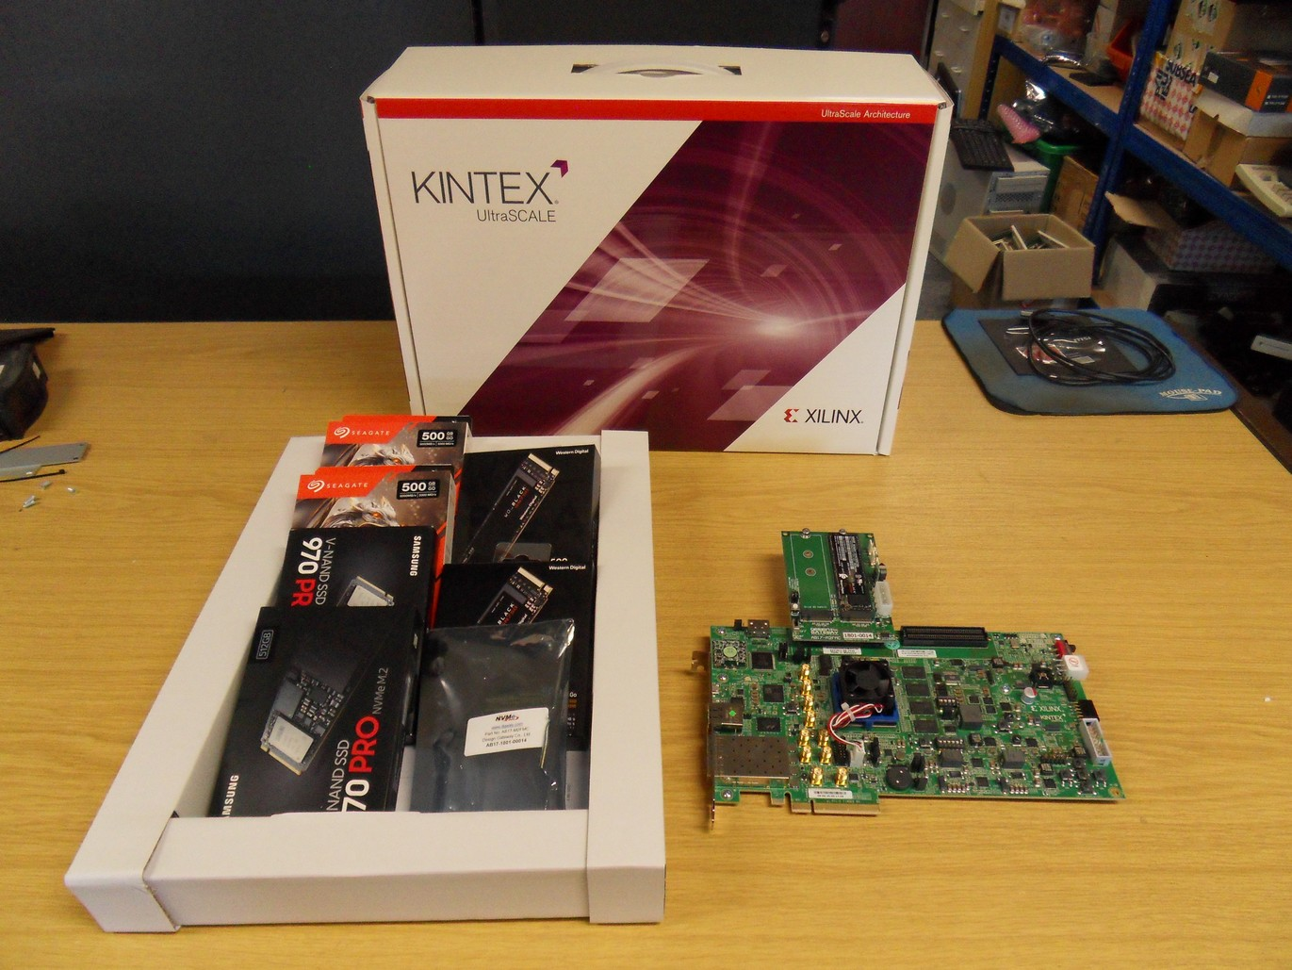
These were installed into a simple PC unit built using the following components:
- Motherboard: Asus PRIME Z390M-PLUS LGA 1151 DDR4 mATX
- CPU: Intel Core i5 9400F 6 Core 2.9 GHz Processor
- RAM: 2 x Crucial 8GB DDR4-2666 UDIMM
- DISK: WD Blue SN550 250GB NVME M.2 2280 PCIe Gen3 SSD
- Power: Kolink Core Series 300W 80 Plus Certified Power Supply
- Case: AvP Viper Mini Tower Black USB 3.0 case
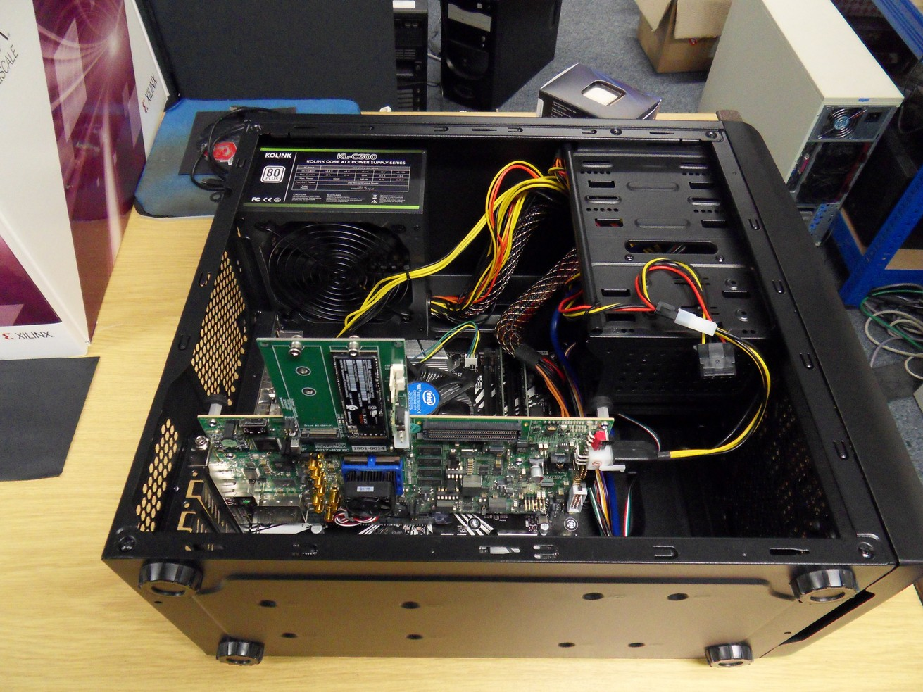
We used Linux Fedora31 as the host OS setup with all of the packages that BEAM normally uses

KCU105 Setup
This is configured as per standard factory defaults (All jumpers, switches etc) except SW15.1 was set to on so the Xilinx FPGA would only be configured over the USB JTAG lead. It is plugged into a PCIe 16 lane graphics slot on the PC motherboard. Power is supplied using the PC 4 way disk power connector to KCU105 adapter lead (NOT directly from a PC’s 6 way power connector!!).

AB17-M2FMC Setup
This is configured as per standard factory defaults (All jumpers, switches etc). For testing one NVMe unit was installed into the Drive1 connector nearest the auxiliary 12V power connector. The board was set as defaults, then the 4pin jumper was set: 1-2 and 3-4 so the FPGA generates NVMe resets. Power for the unit comes from the KCU105 but an extra 4 way PC disk power lead can be connected as well and may be needed for 2 x NVMe usage.

Test FPGA resources
The test environment uses the following FPGA resources on the KCU105 board:
Item | Value | Notes
Host PCIe Gen3 block | PCIE_3_1_X0Y0 | Host PCIe interface
Host PCIe Clk | MGTREFCLK0P_225_AB6  MGTREFCLK0P_225_AB6 | Host PCIe 100 MHz clock
Host PCIe Lanes | MGTHTXP0_225_AH6  MGTHTXN0_225_AH5  MGTHRXP0_225_AH2  MGTHRXN0_225_AH1  MGTHTXP1_225_AG4  MGTHTXN1_225_AG3  MGTHRXP1_225_AF2  MGTHRXN1_225_AF1  MGTHTXP2_225_AE4  MGTHTXN2_225_AE3  MGTHRXP2_225_AD2  MGTHRXN2_225_AD1  MGTHTXP3_225_AC4  MGTHTXN3_225_AC3  MGTHRXP3_225_AB2  MGTHRXN3_225_AB1 | PCIe 4 lanes
NVMe0 PCIe block | PCIE_3_1_X0Y2 | NVME CN2
NVMe0 PCIe Clk | MGTREFCLK0P_228_K6  MGTREFCLK0N_228_K5 | FMC HPC Connector J22, D4,D5
NVMe0 PCIe Reset | FMC_HPC_LA00_CC_P, H11 | FMC HPC Connector J22, G6
NVMe0 PCIe Lanes | MGTHTXP0_228_F6  MGTHTXN0_228_F5  MGTHRXP0_228_E4  MGTHRXN0_228_E3  MGTHTXP1_228_D6  MGTHTXN1_228_D5  MGTHRXP1_228_D2  MGTHRXN1_228_D1  MGTHTXP2_228_C4  MGTHTXN2_228_C3  MGTHRXP2_228_B2  MGTHRXN2_228_B1  MGTHTXP3_228_B6  MGTHTXN3_228_B5  MGTHRXP3_228_A4  MGTHRXN3_228_A3 | R0: C6,C7, R1: A2,A3, R2: A6,A7, R3: A10,A11  T0: C2,C3, T1: A22,A23, T2: A26,A27, T3: A30,A31
NVMe1 PCIe block |  | NVME CN3
NVMe1 PCIe Clk |  | FMC HPC Connector J22, D4,D5
NVMe1 PCIe Lanes | MGTHTXP0_227_N4  MGTHTXN0_227_N3  MGTHRXP0_227_M2  MGTHRXN0_227_M1  MGTHTXP1_227_L4  MGTHTXN1_227_L3  MGTHRXP1_227_K2  MGTHRXN1_227_K1  MGTHTXP2_227_J4  MGTHTXN2_227_J3  MGTHRXP2_227_H2  MGTHRXN2_227_H1  MGTHTXP3_227_G4  MGTHTXN3_227_G3  MGTHRXP3_227_F2  MGTHRXN3_227_F1 | R0: A14,A15, R1: A18,A19, R2: B16,B17, R3: B12,B13  T0: A34,A35, T1: A38,A39, T2: B36,B37, T3: B32,B33

NVMe Experimentation
We setup a simple test system to allow us to communicate with the FPGA connected NVMe device to allow us to easily experiment with the protocols to configure and access the NVMe. This test system is in the test009-nvme software directory. In here there is a simple FPGA firmware design that allows the NVMe to be accessed from a Linux program over the hosts PCIe bus. The FPGA firmware has been designed to mimic the final system to a degree. It uses the following components:
- PCIe DMA/IP: This is the standard Xilinx PCIe endpoint IP configured for an AXI-Lite bus and 2 x bidirectional DMA streams. This is clocked from the 100 MHz PCIe connector and provides a user clock from this.
- NvmeStorage: This simple core has an API similar to the final systems NvmeStorage core. It implements a simple set of test registers driven from the AXI-lite bus and passes the two bidirectional DMA streams through to the NVMe PCIe root complex. It performs the necessary clock comain crossings to do this.
- Nvme PCIe Root Complex: This implements a PCIe root complex that the external NVMe device is connected to. It only uses one PCIe lane at a slow speed to simplify the system. This is clocked from the 100 MHz NVMe carrier boards FMC connector and provides a user clock from this.
- NVMe device: One of the example NVMe’s was installed in the carrier board.
- Bfpga Driver: This is a simple Linux driver of our own design. It supports memory mapped access to the AXI-lite bus and up to 4 x blocking bi-directional DMA channels accessed via simple read/write calls. The Xilinux XDMA driver could be used, but we found this has issues with supporting the latest 5.x Linux kernels, possible bugs and was generally very complex for our requirements where we wanted to make sure other components of the system over the FPGA were not causing unintended issues.
- Test-nvme: This is a simple test program that allows us to communicate with the NVMe drive over the FPGA fabric. It configures the NVMe’s PCIe configuration registers, the NVMe registers and bus master queues and performs operations on them. It allows us to test the most simple method of NVMe configuration and access prior to implementing this on the FPGA.

Some points on the test system
- There are two clock sources used: The host’s 100 MHz PCIe bus clock for the PCIe DMA/IP that provides a user clock for the AXI-lite bus and streams, and the NVMe card’s 100 MHz PCIe bus clock that drives the NVMe PCIe Root Complex and provides a user clock for the NvmeStorage core. The NvmeStorage core performs the necessary clock domain crossing logic for the data paths.
- The system reset is driven from one of two sources. The hosts PCIe connector and a timed pulse from FPGA design start. This reset is also used to reset the Nvme PCIe Root Complex and the external NVMe devices. This reset can be driven from the Linux host.
- When the Linux host boots the FPGA PCIe design is not present. The Linux host has to be rebooted so the BIOS and Linux kernel allocates the PCIe resources correctly. Once done the FPGA PCIe design can re reloaded again and again. It might be possible to not do the reboot on some Motherboards.
- When re-loading the FPGA bit file you should:
  - Program the FPGA over the USB-JTAG cable using Vivado.
  - Unload the bfpga driver. “rmmod bfpga”;
  - Rescan the PCIe bus: “echo 1 > /sys/bus/pci/rescan”
  - Reset the PCIe device: “echo 1 > /sys/bus/pci/devices/0000:01:00.0/reset”
  - Re-install the bfpga driver: “insmod bfpga.ko”
  - The command “make load” in the test software directory will perform these commands.
- The nvme-test program will communicate with the NvmeStorage core and NVMe using the bfpga driver. It accesses the NvmeStorage cores registers and sends PCIe transactions back and forth over the DMA links.

Notes on test system’s NVMe accesses
The main documentation for this is:
- NVM_Express_Revision_1.3.pdf
- pg156-ultrascale-pcie-gen3.pdf
- pg195-pcie-dma.pdf
- The Xilinx PCIe 3.1 hard block adds a protocol layer above the PCIe TLP packets. This involves using different packet headers to the standard TLP packets and also it separates the host requests/completions from the NVMe requests/completions providing two bi-directional streams to deal with. It also then has tags and other signals to manage where the packets go and the byte/dword enables bits etc. All of this complicates things for us. A simple PCIe interface block that provided the raw PCIe TLP packets would have been much better and simpler like the Virtex-6’s implementation. It might be possible and better to use the Xilnx soft PHY IP core instead.
- The Xilinx PCIe 3.1 hard block’s s_axis_rq_tuser signals need to provide the last_be signals at the start of the packet and they need to be set to “0000” when only one DWORD is sent. This is tricky without buffering the packet to determine its actual length prior to send the packet on. In the test system we use bit 31 of a control register to set these last_be bits and the test-nvme software sets this based on the packet length sent.
- The maximum packet size appears to be 128 bytes in this system. This means there is a fair degree of overhead with the packet header size. It might be possible to increase this. The Xilinx PCIe hard block supports up to 1024 Byte packets. This needs to be looked at as the packet size should have been 512 bytes, but TLP header size may be within this 512 bytes. There is both the host’s PCIe and the NVMe’s interfaces to be looked at wrt to this. When a block write of 512 bytes is made this results in 4 separate packets of 128 bytes (data) each with 12 bytes of header (10% data overhead + 4 x write processing overhead).
- The NVMe protocol is based around DMA reads and writes. However this can be extrapolated to simple command and data FIFO’s.
- When an error occurs, the error handling and reporting is not that good. Some commands return a status value, but often this is just a standard error value. Asynchronous error reporting is available but this requires an Asynchronous read command to be called prior to getting the error message. We have also found that often a command such as a write, will return a status of say 6 (internal error) but there is no asynchronous error response and other information as to what actually the error was.

NVMe Configuration and usage
From our testing, the simplest and most basic configuration and usages is as follows:
- Most of the accesses are by an address. Although 64bit addresses are used we only use the lower 32bits and use the top 4 bit nibble (bits 28-31) to define where the data is to be read from/received from for simplicity. This could link to a memory address or a FIFO queue.
- Write to the PCIe command register the value 0x06 to enable memory accesses and bus master accesses.
- Setup the NVMe control register to set the IO queue request and reply entry sizes (64 and 16 bytes).
- Setup an address to Admin Queue request fetches. Say 0x10000000.
- Setup an address to Admin Queue reply storage. Say 0x20000000.
- Start the controller running by setting bit 0 of the control register. Note that clearing bit 0 and setting it to 1 appears to do a soft reset of some things.
- Setup one or more IO request/reply queues by sending commands via the admin request/reply queues. Their memory addresses can be set to 0x20000000, 0x30000000, ...
- Optionally send a GetAsynchronousEvent message so that asynchronous events will be reported.
- Optionally find the block size and number of blocks in namespace 1. Namespace 1 seems to be present on new NVMe devices.
- When the NVMe device has sent something into its request queue it should send a MSI-X interrupt message.
- When responding to memory read requests, if the required data is greater than 128 bytes (including packet headers?) then return multiple responses with 128 bytes in each. Note the usage of the nbytes parameter within the packet headers to accomplish this.
- Queued requests are 64 bytes or 16 Dwords (32 bits) in size. Queued replies are 12 bytes or 3 Dwords in size.
- The NVMe queues and data reads could be implemented using block ram organises as random accessed memory or simpler FIFO queues. The FIFO queues sound like the simplest solution as the data needs to be send in a stream anyway.
- If we use the Xilinx PCIe 3 hard block we will have to handle/implement the packet headers that this system uses and multiplex across the two bidirectional streams. If we use a PCIe PHY soft core we can just send/receive PCIe TLP packets across a single bidirectional stream.

Linux Host Testing

Basic Tests
Install package nvme-cli for these commands.
lspci -s 01:00.0 -vvvx | Show PCIe details of a specific NVMe device
nvme list | List NVMe devices
nvme list-subsys | List NVMe sub systems
nvme id-ctrl /dev/nvme0 | Identify controller
nvme id-ns /dev/nvme0n1 | Identify Namespace, display structure
Nvme raw data read command | nvme io-passthru /dev/nvme0 --opcode=0x02 --namespace-id=0x1 --data-len=512 --read --cdw10=0 --cdw11=0 --cdw12=0 -b > blk0

PCIe Interface
01:00.0 Non-Volatile memory controller: Samsung Electronics Co Ltd NVMe SSD Controller SM981/PM981/PM983 (prog-if 02 [NVM Express])
Subsystem: Samsung Electronics Co Ltd Device a801
Flags: bus master, fast devsel, latency 0, IRQ 16, NUMA node 0
Memory at f7c00000 (64-bit, non-prefetchable) [size=16K]
Capabilities: [40] Power Management version 3
Capabilities: [50] MSI: Enable- Count=1/1 Maskable- 64bit+
Capabilities: [70] Express Endpoint, MSI 00
Capabilities: [b0] MSI-X: Enable+ Count=33 Masked-
Capabilities: [100] Advanced Error Reporting
Capabilities: [148] Device Serial Number 00-00-00-00-00-00-00-00
Capabilities: [158] Power Budgeting <?>
Capabilities: [168] Secondary PCI Express <?>
Capabilities: [188] Latency Tolerance Reporting
Capabilities: [190] L1 PM Substates
Kernel driver in use: nvme
Kernel modules: nvme

