Instruction manual for Blacknest Data System

4th draft, January 2012, for v. 1.2.11 “production version”

Sheila Peacock, AWE Blacknest, Terry Barnaby, BEAM Ltd.

The Blacknest Data System was written under contract to AWE Blacknest by BEAM Ltd.

This manual is supplemental to the manuals produced by BEAM Ltd.

Table of Contents
1. Quick data export 2
1.1 GUI 2
1.2 AutoDRM 4
1.3 Instrument Responses 5
1.4 Trouble? 7
1.5 “Full Blocks” and “Segment Merge” boxes 9
2. Overview of BDS 9
2.1 Database 10
2.2 Calibrations 11
2.3 Stations and Arrays 12
2.4 Duplicate Data 13
2.5 Time codes on digitised data 14
3. Data Export 15
3.1 Graphical User Interface 16
3.1.1 Using Data View window 18
3.2 Web interface 19
3.3 AutoDRM 19
3.4 bdsDataAccess command-line program 20
3.5 Warning messages at export 25
3.6 Failure to export 26
3.7 Other points about BDS BKNAS format 26
4. Instrument Response Export 27
4.1 From the GUI 28
4.2 From the AutoDRM 28
4.3 Instrument responses from bdsDataAccess command-line program 28
5. Station and Channel Metadata Maintenance 29
5.1 Changing a channel name after data have been imported with the old name 29
5.2 How to do a horizontal-component orientation change 29
5.3 How to do an instrument change 32
5.4 How to change a station or array name 35
5.5 How to create a new (3-component) station 36
5.6 How to create a new Array 40
5.7 How to extend a channel back in time 41
6. Importing Data 42
6.1 bdsImportData options 43
6.1.1 “-ignoreMissingBlocks” 43
6.1.2 “-source” 43
6.1.3 “-array” 43
6.1.4 Other general flags 43
6.2 Multiplexed formats (BDRS, WRA40, WRA64) 44
6.3 GCF (Güralp compressed) 45
6.4 SEED and tarred SEED 45
6.5 TapeDigitiser 46
7. Adding notes and warnings to data 48
7.1 “-addWarning” option 49
7.2 Adding note via Notes tab 51
7.3 bdsNoteAppend 52
8. User administration 52
8.1 Access Groups – restricting access to data 53
9. bdsMetadata command-line interface to database 56
9.1 Introduction 56
9.2 Invocation 56
9.3 Commands 57
9.3.1 Backup and restore 57
9.3.2 Variables 57
9.3.3 Object types recognised by bdsMetadata 58
9.3.4 Defaults 58
9.3.5 Creating a new Station 59
9.3.6 Creating channels: Channel, Sensor, Digitiser and ChannelInstrument 60
9.3.7 Creating a new Calibration 61
9.3.8 Creating a new Response: PoleZero 61
Creating a new Response: FAP 62
Cloning channels 63
References 64

1. Quick data export

1.1 GUI
The graphical user interface (GUI) is started either from an icon in a desktop menu or by the command “bdsUserGui -host bds”, after which you are prompted for your user name and password. A user with administrative privileges can use “bdsAdminGui”, which for data export is the same as the User GUI. If the environment variable “BDS_HOST” is set to the name of a default host, e.g. “bds”, then the “-host” can be omitted.
Figure 2: AdminGui Sensor Data tab showing UKNET broadband channels selected ready to download in IMS2-CM6 format. Red labels show items that have to be selected by the user.
Figure 1: DataSelect window of User GUI showing broadband channels from UKNET about to be downloaded in IMS-2 CM6 format. Superimposed notes in red show points where user selection is required before download.
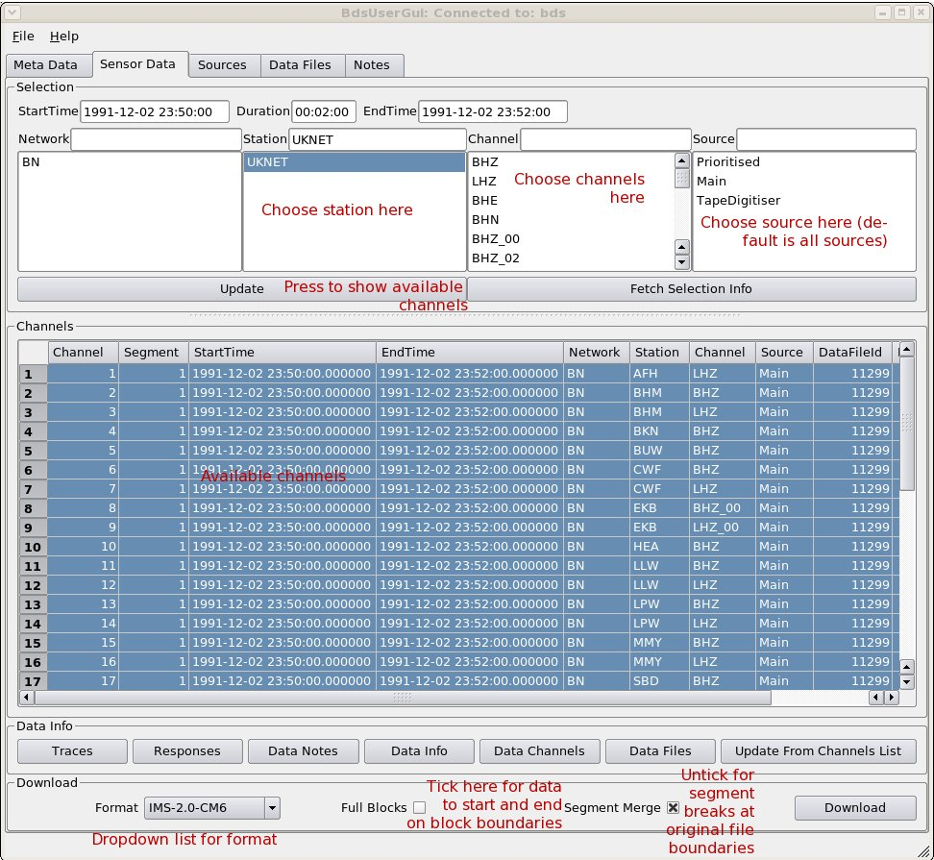
- Go to “Sensor Data” tab (Figure 1);
- In top box, set start date/time and duration or start and end dates/times;
- Choose network (default “BN” includes all data from Blacknest archive) and station or array name (use shift or ctrl+mouse left button to choose a range of stations),
- Choose channels or leave the upper “Channel” box blank for all available (note that the location code is appended to the channel name after an underscore – the most important ones are for WOL, “00” is the borehole seismometer and “20” is the surface seismometer) ;
- Choose “source” - for almost all digital data this is “Main”; for most digitised analogue data it is “TapeDigitiser”, for EKA SP data from the 40-Hz DMOD digitiser it is “EkaDig2”, and for EKA/EKB data from the backup CD-ROMS it is “EkaCD”. If you do not specify a “source” then all available “sources” will be exported, but since the output data formats lack any means to distinguish the “source”, it is sensible to export data from each different “source” separately and edit the source name into the export data filename;
- Press the “Update” button. The list of channels to be exported, with timespans, is displayed with all the channels selected (in blue). If you want to export only some of these channels, select these with ctrl+mouse left button and shift+left mouse button to mark out a range of channels (unfortunately you cannot in this version of the GUI select them all then un-select a few);
- When all the channels you want to export are selected (blue), choose the format of the exported data from the drop-down list at the bottom of the frame. IMS-2.0-CM6 (IDC 2004) is the most commonly used format (use this if you want to process the data with SAC). BKNAS (v. 1.0, Blacknest 2008) will work only for fewer than 32 channels of synchronously sampled data (including TapeDigitiser data) with no missing blocks. Usually (and definitely for BKNAS) you want the “Segment Merge” box TICKED and the “Full Blocks” box UNTICKED - see below;
- Press the “Download” button. In the File Save dialogue box, choose the directory and, if necessary, modify the default file name for the data file, then press “Save”. For SEED output, beware that the default file name does not distinguish between SEED, miniSEED and dataless SEED formats, so you should modify it, particularly to distinguish miniSEED and dataless SEED file pairs from the same timespan.
- The file is then saved, and if the timespan includes missing blocks, or there are other data warnings associated with these data, they will be displayed in a pop-up window after the file has been saved (Figure 3).
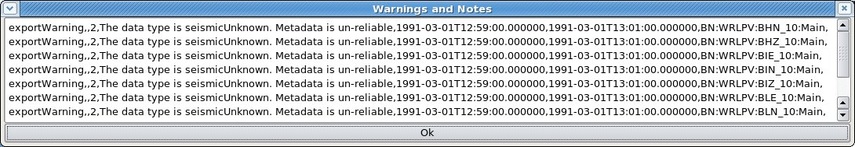Figure 3: Export warning window showing warning of missing metadata for channels of station WRLPV (for which we lack definitive metadata).

1.2 AutoDRM
Standard messages (IDC 2004) received by the AutoDRM at bdsautodrm@blacknest.gov.uk will cause data to be emailed to you or put into the FTP directory for your collection (anonymous FTP from bds.blacknest.gov.uk) – the return message will tell you which. A blank message with “help” on the subject line will get you the AutoDRM help file.

A standard message for the export of all EKA array data from 1980-03-01 19:00 to 19:02 is shown. This particular message will cause both digital and digitised analogue data to be returned, in IMS 2.0 CM6 compressed format – there will be 20 channels of digital data and 24 channels of digitised analogue data. The dates may have slashes or dashes as separators.
BEGIN GSE2.0
MSG_TYPE REQUEST
MSG_ID EKA tapedig wildcard chan slashdates
E-MAIL sheila@blacknest.gov.uk
TIME 1980/03/01 19:00:00 TO 1980/03/01 19:02:00
STA_LIST EKA
CHAN_LIST *
WAVEFORM IMS
STOP
You can ask for “BKNAS” or “SEED” in place of “IMS” in the “WAVEFORM” line (with the same caveat as for the AdminGUI about BKNAS data). SEED data will not be emailed but filed in the FTP directory and an email sent to direct you to the file.

All AutoDRM messages are processed as if “Full Blocks” had not been set (see above).

1.3 Instrument Responses
The AutoDRM serves instrument responses if you replace “WAVEFORM” with “RESPONSE” in the example above. You can use “RESPONSE SAC” to get the seismometer response in SAC pole-zero format. “RESPONSE IMS” returns the response in IMS pole-zero format, not IMS FAP format.
The GUI provides responses for the currently selected channels if you press the “Responses” button at the bottom of the “Sensor Data” tab. The responses appear in a new window in a native format (Figure 4), and may be downloaded in SAC pole-zero, IMS pole-zero or IMS FAP format. When more than one channel is selected, then in either IMS format they will all be saved in one file, but in SAC format they will be saved in a separate file for each channel, and the file save dialogue (Figure 5) will offer the user a generic filename in which the station and channel name are denoted “{station}” and “{channel}” and are permuted for the channels selected in the parent “Sensor Data” tab.
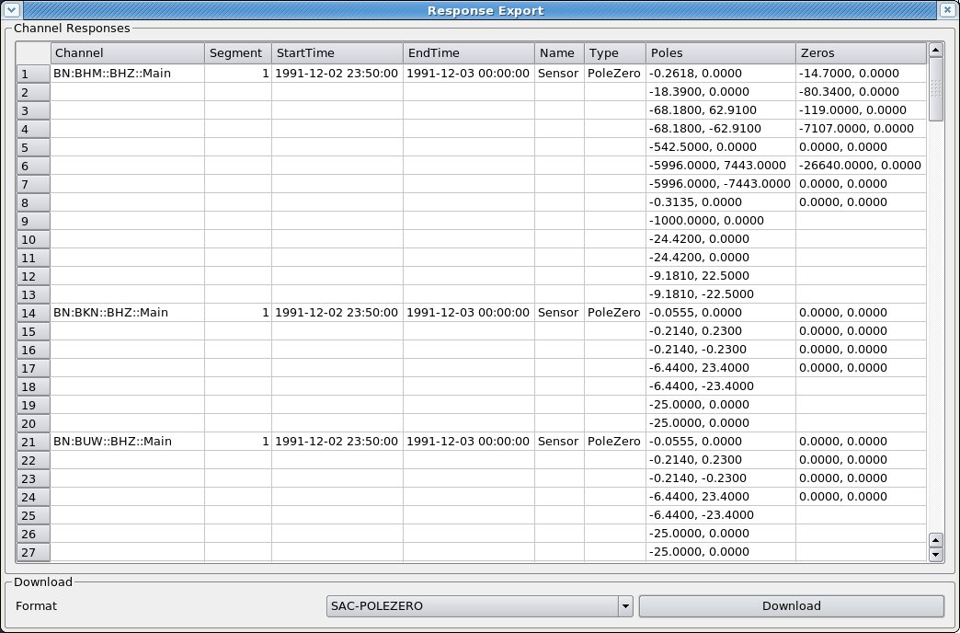Figure 4: Response Export window showing pole-zero responses for some UKNET stations, ready to download in SAC-pole-zero format.
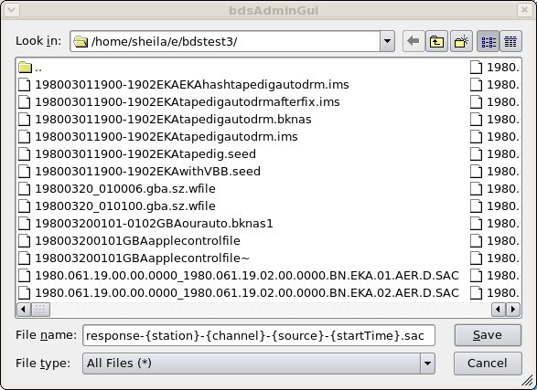Figure 5: "Save" window for SAC pole-zero response file, showing the default filename template with permutable elements between curly braces. Only the characters outside the braces should be edited to vary the filename from the default.

1.4 Trouble?
In the AdminGUI Sensor Data tab, if no channels are displayed when you press “Update” after entering the correct timespan, station and channels, then possibly there are no data, or none for the “source” that you have selected. Go to the Data Files tab (Figure 6) and enter the day (not the time) from which you wanted data, and the name of one of the stations, and press “Update”. A list of the data files available will appear in the upper pane, and a list of the channels available from those files in the lower pane. Check particularly that the start and end times of the channels you want encompass the timespan you asked for. Data missing because a file started late or ended early are not flagged as “missing blocks”, which refer only to gaps within a file.
If no files at all appear for your day for any of the stations you want, try widening the timespan at the top of the Data Files window (press “Update” again). If files for days on either side exist, then it is probable that data for your day were not recorded, or have been corrupted and could not be imported into the BDS system (particularly older digital data).

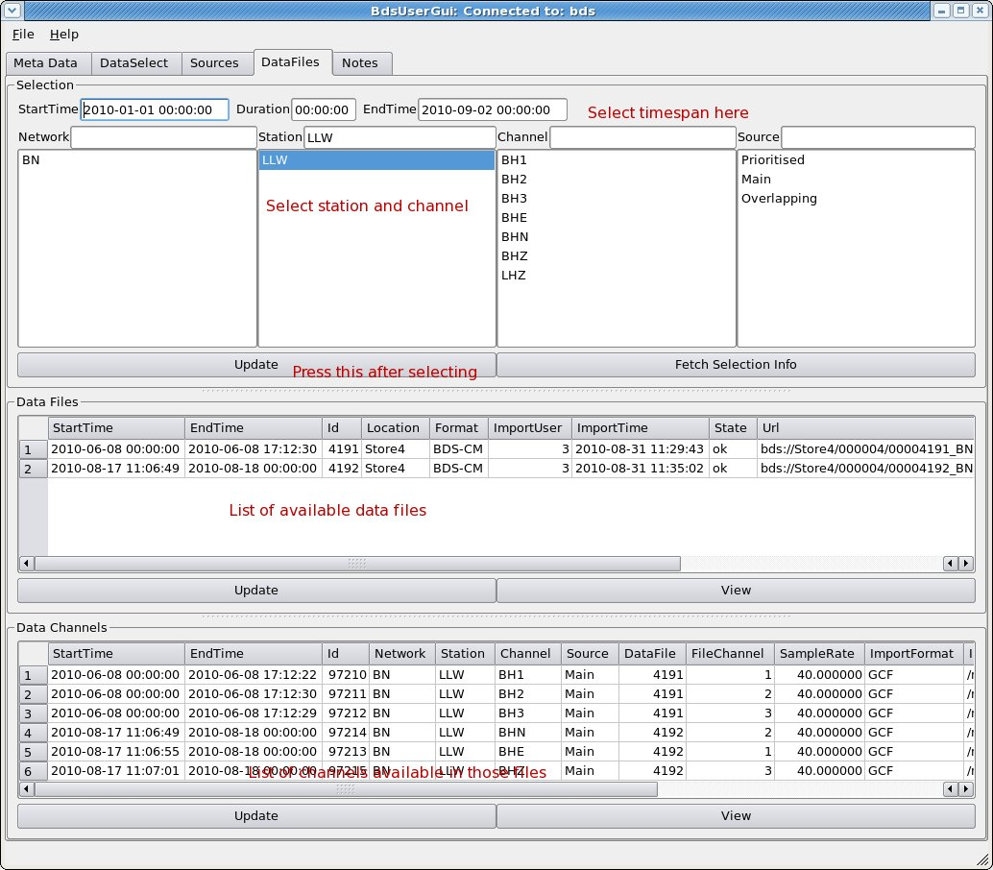Figure 6: Data Files tab showing list of available files for station LLW for 2010-01-01 to 2010-09-02 (upper subwindow) and channels available in those files (lower subwindow). Red labels are not part of the GUI. NEEDS REPLACING WITH V1.2.11 IMAGE BUT CAN'T UNTIL LLW DATA FOR THIS TIMESPAN ARE LOADED – SP 18/1/2012

If the data channels are displayed but exporting them fails with an error message of “no metadata”, then try again with the channel(s) that lacks metadata de-selected. You can inspect the metadata by going to the “Channels” tab and entering the channel name and timespan. Versions from 1.2.8 on should export data from channels labelled “SeismicUnknown”, i.e. channels that we know come from a seismometer but for which we lack the instrument response parameters (e.g. WRLPV, YKC), with dummy parameters. Problems of lack of metadata for commonly-used channels should be referred to the database manager.

1.5 “Full Blocks” and “Segment Merge” boxes
When the “Full Blocks” box is not ticked, your data should start and end at exactly the times that you specified. When it is ticked, the data start at the nearest block boundary before the requested start time and end at the next block boundary after the requested end time. For multichannel data this can mean that individual channels have different start times or end times. If your desired start or end time falls within a timespan of missing data on any of the channels, the data for that channel will start (or end) at the nearest time for which data are available within your timespan. If you need to use “Full Blocks” AND have all channels start and end at the same time, then this will happen automatically for all original formats except GCF, and can be made to happen for GCF by specifying the start and end times to be on the hour.

The “Segment Merge” box should be ticked to prevent the output from having a segment break (in SEED and IMS formats) at seamless boundaries between adjacent data files in the original data format, e.g. at midnight, unless there are actually data missing between the adjacent files. There is always a segment break i.e. a new header, following timespans of missing data. BKNAS data cannot be served over missing blocks, but will automatically have segments merged over seamless boundaries between original data files, whether or not this box is ticked.

2. Overview of BDS
The principle of the Blacknest Data System (BDS; BEAM 2010a) is that digital data stored in the BDS data store are combined with station and channel metadata from a database and served to users on request, where the request specifies stations, channels and timespan. The data in the store have been imported from the original archive and are in a common format, BDS version 1.1.0 (BEAM 2010d). The importing process noted gaps in the data (missing blocks) and re-ordered any data blocks that were out of chronological order as a consequence of backfilling after station-to-base transmission breaks. It did not try to repair other data problems, e.g. header block corruption – these were repaired before import, where possible, and the repairs noted in the imported files. Each stored data file has a substantial header including notes of missing blocks and any corrective processing applied. These and further notes are stored in the database and can be modified.

A primary aim of the BDS project was to make available the data stored on analogue FM tape in the Blacknest archive. These data were digitised in a separate project led by BEAM Ltd. (Bowers et al. 2008) and now exist in “TapeDigitiser” format, sampled at 100 Hz.

Where the original data were per-sample multiplexed (BDRS, WRA40, WRA64 and TapeDigitiser data formats) the data in the store are also per-sample multiplexed (format “BDS-SM”) and may be exported in multiplexed BKNAS-1 format, provided there are no missing blocks in the requested timespan. Other multichannel data that have been synchronously sampled but stored in separate files for each channel, i.e. three-component data and broadband EKA array data in GCF format and YKA data in SEED format, are stored with all channels combined into a single (hour, 12-hour or day-long) file in channel-multiplexed format (“BDS-CM”), and may be served in BKNAS-1 format provided they were imported with the “-synchronous” option to indicate that they were synchronously sampled. The non-multiplexed SEED and IMS formats may be used to serve all types of data. BKNI infrasound data from the experimental site at Blacknest, for which the channels are not synchronously sampled, are also stored with all four channels in a single file per day or hour, in channel-multiplexed form. These cannot be exported in BKNAS-1 format.

2.1 Database
The database is the source of all information in the headers of exported data from the BDS, except times. It was populated from the database used by the 2006 AutoDRM and instrument response PHP program, which is derived from information in file “array_changes.dat” used by the “robby” AutoDRM and is up to date to September 1997, and manufacturers' calibration sheets and operators' reports for instruments introduced since then. Station locations are taken from the IDC database where possible, otherwise from our own records.

Some non-intuitive points about the database:
- The concept of a “channel”, and hence the channel's start and end time, is separate from the concept of the sensors (seismometers, infrasound sensors, etc.) and digitisers attached to the channel, and these again are separate from both the calibration factor and frequency response of the channel. A channel might have start time at time zero and end time at infinity, but it is a valid seismic channel only for the timespans for which a calibration exists, and then only providing that instrument, sensor and response also exist for that time. Hence it is possible for a station to have, say, a BH2 and a BHN channel with overlapping timespans, representing output from the same seismometer at different orientations, provided there is a distinct calibration entry for each, with non-overlapping timespans.
- Channel order of data in multiplexed original format files stored in the 2006 AutoDRM database has not been imported into the BDS database, so the channel order has to be specified at import for all data except SEED format data, for which the channel order is extracted from the SEED header;
- For those stations with location codes, the BDS stores these along with the channel code in format CCC_LL, e.g. BHZ_10. In most circumstances it is essential to specify this “full” channel name to access your data. The AutoDRM does not recognise the “_LL” or any other means of specifying a location code, and will expand a channel code to include all associated location codes;
- Times are all assumed to be UTC and are stored as character strings representing the time in ISO 8601 format, not “DateTime” entities, because of the lack of support for fractions of a second in MySQL “DateTime” entities. The string format is “YYYY-MM-DDTHH:MM:SS.FFFFFF”, e.g. “2009-07-09T00:07:59.484595” and all times input on command lines of BDS programs have to be in this format. The time part (the uppercase “T” and everything after it) can be omitted, and it is not necessary to specify fractions of a second (i.e. the “.FFFFFF” part) if these are zero;
- Searches for station and channel names are case-sensitive, so “eka” is not the same as “EKA”.

2.2 Calibrations
The database contains instrument information for “sensors” (mostly seismometers, but also infrasound and other sensors) and digitisers. A digitiser is associated with a serial number, sampling rate and gain, all optional. A seismometer is associated with a serial number, number of channels and a gain, also all optional. Stored separately are a “response” (usually a set of poles and zeros, though a FAP table might be accommodated in the future) and one or more timestamped “Calibrations” (Figure 7) consisting of a calibration factor, corresponding calibration frequency, and sampling frequency. These are associated with the channel not the sensor. All units for these in the underlying database are basic SI, e.g. metres per count for calibration factors of seismometers, but on output they are converted to the units required by the output format, e.g. nanometres per count for IMS format.
Figure 7: Calibration edit window for station EKB, channel BHZ, location code “01” (i.e. the 3-component broadband set in the vault at EKA, now taken to be part of AS104 EKA by the IDC), showing “Name” field (“Main” here because data are taken from manufacturer's data sheet) and Calibration Factor in metres per digital count.
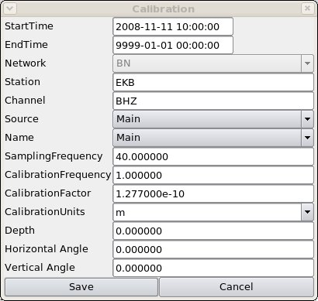

The calibrations are labelled with “Name” as “Main” if the data are from the manufacturer's data sheet or theoretical calculation, or “Measured” if they are from field measurements. Units of calibrations are stored, and in general are in the displacement domain (pressure for infrasound sensors) because this was assumed for calibrations in the 2006 AutoDRM database.

2.3 Stations and Arrays
The list of stations in the database (Figure 8) includes the latitude, longitude and elevation of each, and for array stations, the x- and y-offsets from the array centre point. The database does not correct inconsistencies between latitudes/longitudes and x/y offsets.
Figure 8: Station Edit window showing array station BAE (Brasilia). Note that the array is specified as a list of channels, not stations, and only the centre-point location is given in the lower pane. East and north offsets are in km, elevations in m.
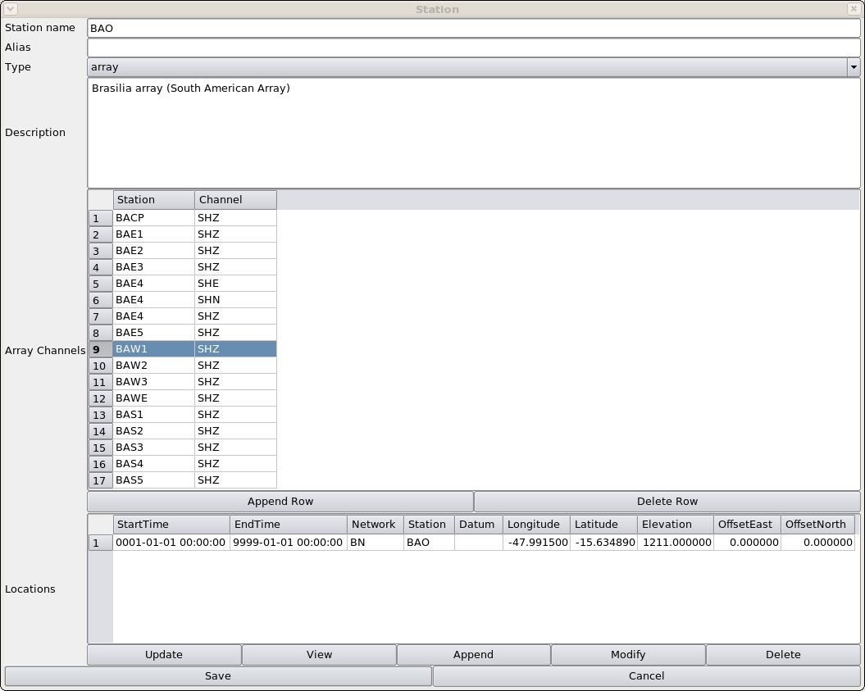

An array is specified as a list of channels (Figure 8). The array centre point is stored as if it were a single station, although none of the output data formats has a provision for showing the array centre position if that is not occupied by one of the array stations. An array can be named in a data request, in which case data from all the available channels listed in the array will be supplied if available. While any station can be listed as part of an array, the policy has been to list all the channels that were recorded on the 24-track analogue tapes from each of the four “UKAEA” arrays, including the time-code and “error” and any supplemental seismic channels such as the “velocity broadband” seismometer (actually at the EKB site) routinely recorded alongside the EKA array but not included in array processing. The BDS does not do any array processing (e.g. beamforming).

2.4 Duplicate Data
Data in the Blacknest archive come from a number of sources and there are consequently some duplications. These are faithfully stored in the BDS data store. Some, but not all, the duplicate data streams are distinguished by a value of “source” in the BDS database. Where there is no distinction of “source”, or the user request does not specify the “source”, e.g. an AutoDRM request, data from all available “sources” are served. This can cause problems, because the IMS and BKNAS output formats lack any means of distinguishing the “source” of data. Also, if array data from more than one “source” are available, none of the data can be served in BKNAS format, because the number of channels is (at least) doubled, exceeding the 31-channel maximum for that format.

Duplications are
- Those for which no separate “source” is specified
  - TapeDigitiser data where digitising was stopped and re-started after rewinding (partially or fully) the tape. The overlapping segments are not identical because of slight differences in tape speed and tape-head cleanliness between passes;
  - Digital data in BDRS format that were transcribed from 1/2-inch reel tape to Exabyte tape in the mid-1990s. Overlapping data occur where the 1/2-inch tape was replayed. They should be identical but differences in tape-head cleanliness sometimes caused different bit-level errors to occur in the two overlapping files.
- Those for which a separate “source” is specified
  - EKA SP data from FMDC (20 Hz) and DMOD (40 Hz, but poorer quality) (Bowers 2004) digitisers – the latter have “source” value “EkaDig2”;
  - EKA broadband and EKB data arriving by satellite link and by DVD posted from EKA – these are identical except that the satellite stream is prone to dropouts (missing blocks), whereas the DVD data occasionally have whole files missing because of problems with the computer at EKA on which they are stored before being written on to the DVD. Data from the DVDs have “source” name “EkaCD” and “EkbCD” respectively, and are identical to the satellite data except at the gaps. THIS MIGHT CHANGE WHEN A BULK IMPORTER FOR THE CD DATA IS WRITTEN.

During import and export, “source” is used to relate data to metadata. Data form a particular “source” are associated with metadata for the “source” name given by the value of “sourceMeta” associated with that “source” (Figure 9). For the EKA SP data, the metadata for the DMOD are different from those for the FMDC because the DMOD has a different sampling rate, so “sourceMeta” for data of “source” = “EkaDig2” is also “EkaDig2”. For EKA broadband data from satellite and DVD the metadata are the same, so the satellite data have “source” “Main” and the DVD data have “source” “EkaCD”, but both have “SourceMeta” value “Main”.

Where there are data from more than one “source”, it is possible to use the “Source Priorities” table (Figure 5) to assign one source higher priority than another. This means that data from the preferred source will be served, wherever data are available, when the user does not express a desired “source”. In the Data Select window (Figure 1), choosing the “source” value “Prioritised” causes only data for the highest priority source to be exported.

2.5 Time codes on digitised data
All the data digitised from analogue tape in the TapeDigitiser project have “source” value “TapeDigitiser”. Time stamps for the TapeDigitiser data are derived from the time code (mostly in VELA format, though some tapes have time codes in Hutchins format, Key 1968; Holdsworth 1969), which was read by a program that required two complete minutes of flawless time code to read a valid time. For tapes where the time code was corrupt, times for data block timestamps are interpolated between times successfully read by the decoder. Users are advised not to rely on the interpolated times but read the time code by eye.

The only other data digitised from analogue tape in the BDS data store are five months of YKA data from January to May 1989, digitised on Blacknest equipment nominally at 20 Hz. Block timestamps for these are estimated from tape play times, so the user should always read the VELA code.
Figure 9: "Sources" tab showing association of "SourceMeta" with "source" (upper frame) and list of priorities for sources (lower frame).
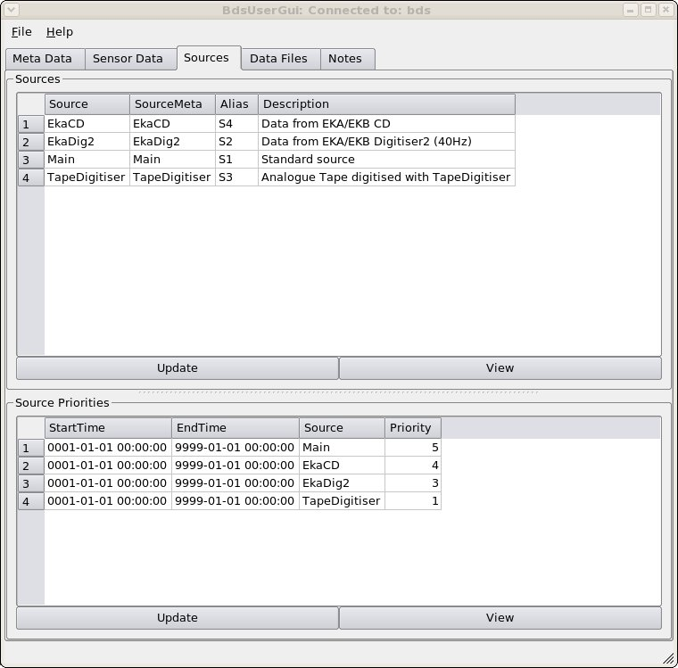

3. Data Export
Data may be exported by (a) the graphical user interface (AdminGui or UserGui), (b) the Web interface, (c) the AutoDRM, or (d) the command line program bdsDataAccess.

3.1 Graphical User Interface
Basic instructions were given in Chapter 1. Data export is carried out from the “Sensor Data” tab (Figure 1).

- Date-time entry - The start time and end time or time duration must be specified in the date/time box at the top of the page. The date/time interface is based on a text editor and is easiest to use if you place the cursor at the beginning of the box and type the number of a valid date, e.g. type “19870331154530”, without separators, to get the date “1987-03-31 15:45:30”. If you make a typing error just press the backspace button and retype (it will overtype the error). To alter an individual digit, place the cursor to the left of the digit (use cursor keys or mouse) and type the new value. The backspace acts as a backwards cursor, as in the “Vi” editor. The mouse drag “select” is ineffective – it merely positions the cursor.

Entering an invalid date causes the box to turn pink. This might happen while you are overtyping a date, since it tests the validity after every keystroke. Keep typing until you have entered the full date, at which the box should revert to white (unless you made a typing error). Occasionally the date appears in an invalid format, e.g. a year with five digits. In this case, place the cursor at the beginning and type the date in the correct format, WITH the dashes.

The tab key moves the cursor to the next box. You may type a duration, or type an end time into the third box. If the end time is more than 24 hours after the start time, you should type the end time into the third box, and the duration box will show zero. The maximum data length that can be exported is given by the parameter “MaxTimePeriod” in the file /etc/bdsServer.conf on the server computer. During testing it has been at 86460 s (one day and one minute).
- Specifying network, station, channel and “source” - The boxes for specifying network, station, channel and “source” are below the time entry box. There are two boxes for each, the one-line upper box, into which you can type the name you want or a partial (e.g. “BH*”) or full (i.e. “*”) wildcard; and the lower box, in which the list of stations or channels matching your selection is displayed. When the upper box is blank, the lower box displays all possible values. You can select one value or a range of values with the left mouse (followed by ctrl+left mouse to highlight more than one entry, or shift+left mouse to highlight the range of entries between the nearest highlighted entry and the entry at the mouse cursor).
The “network” box offers “BN”, which is the Blacknest network, and “IN”, which will be the International Monitoring System data in a future release.
In the “station” box, choosing an array such as EKA will get you the list of channels associated with that array. For digitised analogue data these include the “error” and time-code channels and any additional seismometer channels recorded along with the array. If you don't want all the channels listed, select the ones you do want with the mouse and shift and Ctrl keys. For EKA digital data after November 2008, where both broadband and short-period array data exist, it is sensible to separate them, so choose channel “SHZ” or “BHZ” as desired. The list of channels associated with an array can be viewed in the “Stations” tab (Figure 8), but it is better to keep this list as inclusive as possible and select channels to be exported case-by-case.

In the “source” box the default is no source specified. If data from more than one “source” exist for your station and timespan, it is sensible to save them in a different file for each “source” because there is no means to distinguish data segments from different sources in the output file formats. For BKNAS, furthermore, there is a 31-channel limit, so it is not possible to export data from an 18 or 20-channel array from more than one “source” in that format.

- Press the “update” button - If you do not press the “update” button after choosing your timespan, stations and channels, the previously chosen timespan, stations and channels are retained in the lower pane, and when you press the “download” button an error message is likely to be displayed because of the confusion between the newly selected timespan and the previous one (the error message might be “Error: data does not overlap across all channels for data time clipping”, or “Internal error: no actual data segments are available from file although database says there should be some”).

- Choosing the channels - After pressing “update”, check the list of channels displayed in the lower pane (Figure 1). By default they are all selected to be downloaded (blue). If you do not want them all, select the first one you want by clicking on it with the mouse (which de-selects all the others) then press the shift or Ctrl key while clicking with the mouse to select the others that you want. It is not at present possible to de-select just one or two. THIS MIGHT CHANGE IN QT4

- Select the format and press “download”
Available formats:
  - ASCII – data in single-column ASCII, channel by channel, with simple header. Digital sample values have been multiplied by “calib”. Default filename tag “.txt”
  - ASCII-SM – data in ASCII with no. of columns = no. of channels (e.g. 20 for EKA) and header. Digital sample values have been multiplied by “calib”. Default filename tag “.txt”
  - ASCII-CM – same as “ASCII”
  - BKNAS, BKNAS-1.0 – data in BKNAS-1.0 format. Default filename tag “.bknas”
  - BDS – disabled – for test only
  - BDS-SM - ditto
  - BDS-CM - ditto
  - IMS, IMS-2.0, IMS-2.0-CM6 – data in IMS 2.0 format with CM6 compression. Default tag “.ims”
  - IMS-2.0-INT – data in IMS 2.0 format as integers without compression. Default tag “.ims”
  - SEED – data in IRIS SEED format. Default filename tag “.seed”
  - SEED-MINI – data in IRIS mini-SEED format. Default filename tag “.seed”
  - SEED_METADATA – metadata only in SEED format – to be used along with miniSEED file. Default filename tag “.seed” (this will give you the same default filename as for the miniSEED data accompanying it, so it is best to change the filename).
The default filename for the downloaded data has the prefix “data-STN1-STN2-YYYYMMDD-HHMMSS” and the tag given above denoting the format. “STN1” and “STN2” are the first and last, alphabetically, stations from which data are downloaded, e.g. “EKB1-EKR9”. For a single channel, only “STN1” appears. When the station name includes a “#” (in dummy station names for timecode, error and disconnected channels in array data), the “#” is replaced by a “~” to avoid Unix shell filename problems. “ YYYYMMDD-HHMMSS” is the start time, e.g. 19810315-145200 for 1981-03-15 14:52:00. You can modify the filename, and should do so for SEED metadata. When you press “save”, if the file already exists, a query whether to overwrite it will appear.

3.1.1 Using Data View window
After Item 3 above, if you press the “Traces” button, the “Data View” window appears, showing parts of some of the traces you have selected from the “Channels” list. All of all the traces you have selected can be seen by working the scroll sliders. Further selection of the data to be exported can be done:
- individual traces can be selected or de-selected by ticking or un-ticking the “Select” box at the right of each trace (Figure 10);
- A timespan can be selected by moving the cursor into position and pressing the left mouse button, then moving it again and pressing the right mouse button – the cursor positions will appear in the “Start Cursor” and “End Cursor” slots below the trace display;
- While the “Data View” window is open and traces and cursors are set, if you press the “download” button, then only the selected timespan from the selected traces will be exported (and the default export filename will be set accordingly with the cursor start time).

Other features on the Data View window are:
- “pixel = sample” button, which increases magnification until each screen pixel represents one digital sample. This allows the trace to be displayed without aliasing;
- X in, X out buttons – change time scale of display;
- Y in, Y out buttons – change amplitude of display – only on selected traces;
- Y up, Y down – change Y shift (DC shift) of traces – only on selected traces.
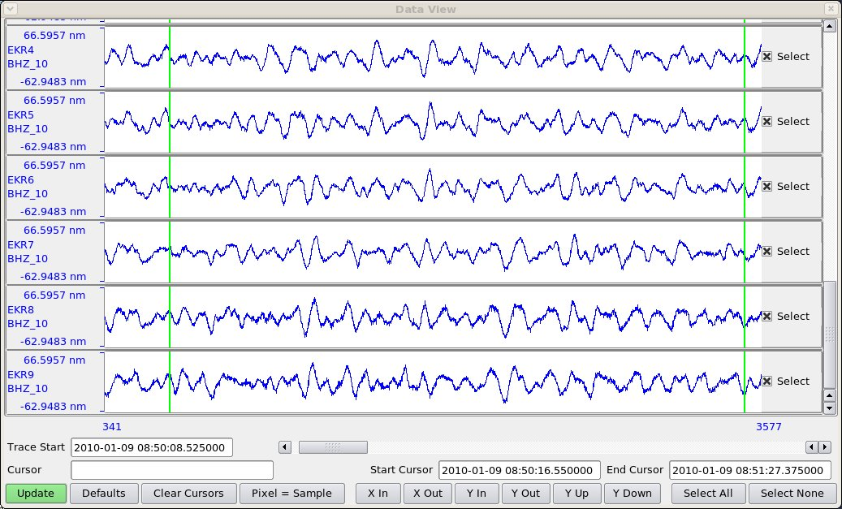Figure 10: Data View window showing a few traces from EKA with start and end cursors set (vertical green lines) and all traces selected (boxes to right of traces ticked).

3.2 Web interface
Yet to be written.

3.3 AutoDRM
Instructions for the AutoDRM were given in the first section. Besides data in SEED format, data that cause the email to exceed about 1 Mb total length (the exact value is stored in the parameter file /etc/bdsAutodrm.conf on the BDS server as “EmailMaxLength”) are not emailed but stored in a temporary FTP directory to be obtained by anonymous FTP. The details of the FTP site and file are emailed in IMS format, for instance:

BEGIN GSE2.0
MSG_TYPE DATA
MSG_ID BDS_2010-11-08_11:48:57
REF_ID EKA tapedig
DATA_TYPE FTP_LOG
FTP_FILE bds bdsdata /pub/bds bdsAutodrm-kUHwUz.gz

Bds AutoDRM Version 1.2.10 Nov 4 2010

This autodrm imposes a limit of 1048576 bytes on the
quantity of data that can be returned via e-mail
Also it can only return ACCII formated data within an email

Your request has exceeded the size limit or is binary data.

If it is ASCII data, to get the data by e-mail, try requesting
smaller time segments.
The data will be stored on our server for 3 days
before being removed automatically. During this time
you should copy the data from our anonymous FTP server
using the information in the above FTP_FILE line.
Refer to the User Guide for more information on this.

Warnings
doc,testAdd,0,EKAlogsheets1977-1990,1977-03-23T00:00:00.000000,1990-09-08T0
0:00:00.000000,BN:EKA:SHZ:TapeDigitiser,tape logs
STOP
The FTP instructions follow the keyword “FTP_FILE” in the format “net-address login-mode directory file” (IDC3.4.1Rev6 p. 185). Warnings accompanying the data are also emailed with the instructions. The data file is compressed with “gzip” (GNU version of “zip”) and should be uncompressed with “gunzip” before use. On a Windows system a program such as ZipGenius can be used.

3.4 bdsDataAccess command-line program
The BEAM manual (BEAM 2010c) describes the options for this program. To export data the option “-command dataGetFormatted” is used. The “-select” command must be repeated for each channel to be exported; but note that the channels are exported in alphabetical order, not in the order in which you specify them. “-format IMS” causes the output to be in IMS CM6 format. “-fullBlocks” has the same effect as ticking the “full blocks” box in the AdminGui “Sensor Data” tab (see above). The bdsDataAccess program defaults to merging segments, i.e. as if you had ticked the “merge segments” box in the AdminGui (see above).

A sample command for exporting is:

bdsDataAccess -host bds -user sheila:<password> \
-startTime 2010-01-27T03:58:00 -endTime 2010-01-27T03:59:00 \
-select BN:EKR1:BHZ:Main \
-select BN:EKR2:BHZ:Main \
-select BN:EKR3:BHZ:Main \
-select BN:EKR4:BHZ:Main \
-select BN:EKR5:BHZ:Main \
-select BN:EKR6:BHZ:Main \
-select BN:EKR7:BHZ:Main \
-select BN:EKR8:BHZ:Main \
-select BN:EKR9:BHZ:Main \
-select BN:EKR10:BHZ:Main \
-select BN:EKB1:BHZ:Main \
-select BN:EKB2:BHZ:Main \
-select BN:EKB3:BHZ:Main \
-select BN:EKB4:BHZ:Main \
-select BN:EKB5:BHZ:Main \
-select BN:EKB6:BHZ:Main \
-select BN:EKB7:BHZ:Main \
-select BN:EKB8:BHZ:Main \
-select BN:EKB9:BHZ:Main \
-select BN:EKB10:BHZ:Main \
-command dataGetFormatted -format IMS -o 201001270359-0000EKABBv.1.2.6.ims

The “-select” option is capable of taking wildcards in a format similar to a Unix “regular expression” (regexp). It has four parts, Network:Station:Channel:Source, and if any is omitted it will respond providing all the possible values, using the three colons as placeholders (so “:::” would be all networks, stations and channels – not a good idea). “*” has its usual non-regexp wildcard meaning of “all values”. A selection of values can be enclosed in square brackets, e.g. “EK[RB]” meaning “EKR or EKB”.

The “host” and “user” may be omitted if “BDS_HOST” is specified and the user's name on the BDS system is the same as their login name.

When TapeDigitiser data are exported, the warning “TapeDigitiser Digitisation quality warnings/errors list in infoExtra” is always displayed. This information can be accessed by the option “-command dataInfoFull” on the command bdsDataAccess – see manual (BEAM 2010c) for full description. A sample command is

bdsDataAccess -host bds -user sheila:<password> -startTime 1978-08-17T23:50:00 -endTime 1978-08-17T23:52:00 -select BN:EKR1:SHZ:TapeDigitiser -command dataInfoFull

The option “-command dataPlot” produces a png-format plot of the first data block of waveforms in a file specified by the “-o filename” option (Figure 11).
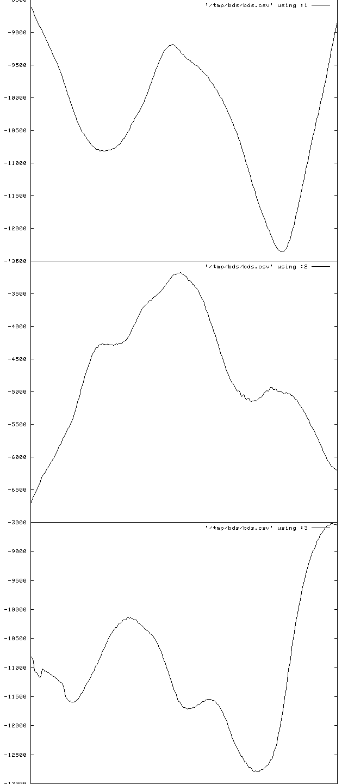Figure 11: Plot, from “png”-format raster image, of first block of three-component data from FLK starting at 03:00 on 2008-07-01, obtained from "-dataPlot" option of bdsDataAccess program. The plot has been stretched widthways by image-processing software before inclusion in this manual. The traces are, from top to bottom, BHE, BHN and BHZ channels.
The options “-command listNetworks”, “-command listFormats”, “-command listStations” and “-command statistics” need no other parameters than the host and user names, e.g. “bdsDataAccess -host bds -user sheila:<password> -command listStations ”. If your parameter list does include stations specified with “-select” then “listStations” lists only those stations.

The options “-command dataSearch”, “-command dataInfo”, “-command dataInfoFull”, “-command channelInfo”, “-command channelInfoFull” and “-command responses” require a timespan to be defined with “-startTime”/”-endTime”, and one or more channels with “-select”. See below for more about obtaining instrument responses with bdsDataAccess. “channelIinfo” provides information on channels with the following headings:
#Chan (the “#” indicates a header line, not an abbreviation of “number”),
Segment,
StartTime,
EndTime,
Network,
Station,
Channel,
Longitude,
Latitude,
Elevation,
Depth,
Source,
Sensor,
SampleRate,
CalibFactor (calibration factor)

“channelInfoFull” gives the same information (but not “Source”) and additionally:
SensorId (database ID number of sensor),
SensorType,
SensorSerial,
DigitiserId (database ID number of digitiser),
Digitiser,
DigitiserType,
DigitiserSerial,
SensorHAng (horizontal angle),
SensorVAng (vertical angle),
CalFreq (calibration frequency),
ResponseId (database ID number of response information for sensor)

“dataInfo” and “dataInfoFull” provide output listing:
- warnings associated with the data (the examples here are warnings attached by the importing user with the option “-addWarnings” in the command “bdsImportData”, but warnings generated by “bdsImportData” itself, e.g. about missing blocks, are also shown);
- the original filenames from which the data were imported into the BDS;
- sample rate, start and end time of each channel;
- for TapeDigitiser data, information from the jobInfo file written during digitisation, including an overall quality measure of the data;
- for TapeDigitiser data, “dataInfoFull” also lists errors in time-code decoding and deviations in the FM carrier frequency on the analogue tape, detected during digitisation.
An example of output from “dataInfo” is:
Warning, DummyWarning,/ remote/london/asm/blacknest/EKA/BHZ/2010/2010027_EKB1BHZ.gcf,,599,right-file-untimed-dummy-error-message
Warning, DummyWarning,/ remote/london/asm/blacknest/EKA/BHZ/2010/2010028_EKB1BHZ.gcf,,499,wrong-file-untimed-dummy-error-message
startTime, 2010-01-27T03:57:36.000000
endTime, 2010-01-27T03:59:21.000000
array, EKA
description,
channels.number, 20
channels.synchronous, 1
importWarning0, DummyWarning,/ remote/london/asm/blacknest/EKA/BHZ/2010/2010027_EKB1BHZ.gcf,,599,right-file-untimed-dummy-error-message
importWarning1, DummyWarning,/ remote/london/asm/blacknest/EKA/BHZ/2010/2010028_EKB1BHZ.gcf,,499,wrong-file-untimed-dummy-error-message
importWarning2, DummyWarning,/ remote/london/asm/blacknest/EKA/BHZ/2010/2010028_EKB1BHZ.gcf,2010-01-27T23:59:30,699, wrong-file-right-time-dummy-error-message
importFile0.fileName, /remote/london/asm/blacknest/EKA/BHZ/2010/EKR4/2010027_EKR4BHZ.gcf
importFile1.fileName, /remote/london/asm/blacknest/EKA/BHZ/2010/EKR5/2010027_EKR5BHZ.gcf
… (list of all 20 imported file names for EKA BB followed here)
bds.version, 1.1.0
bds.format, BDS-CM
channel1.startTime, 2010-01-27T03:57:40.000000
channel1.endTime, 2010-01-27T03:59:20.000000
channel1.network, BN
channel1.station, EKB1
channel1.channel, BHZ_10
channel1.source, Main
channel1.numBlocks, 4
channel1.numSamples, 4000
channel1.sampleRate, 40.000000
channel1.sampleFormat, 2
channel1.importFormat, GCF
channel1.importFilename, /remote/london/asm/blacknest/EKA/BHZ/2010/EKB1/2010027_EKB1BHZ.gcf
channel1.importStartTime, 2010-01-27T00:00:00.000000
channel2.startTime, 2010-01-27T03:57:51.000000
channel2.endTime, 2010-01-27T03:59:06.000000
channel2.network, BN
channel2.station, EKB10
channel2.channel, BHZ_10
channel2.source, Main
channel2.numBlocks, 4
channel2.numSamples, 3000
channel2.sampleRate, 40.000000
channel2.sampleFormat, 2
channel2.importFormat, GCF
channel2.importFilename, /remote/london/asm/blacknest/EKA/BHZ/2010/EKB10/2010027_EKB10BHZ.gcf
channel2.importStartTime, 2010-01-27T00:00:00.000000
… (for the remaining channels)

TapeDigitiser-specific messages containing information from the jobInfo file written by the digitisation program are of the form:

tapedigitiser.jobNumber, 142
tapedigitiser.tapeDigitiserName, Tape1
tapedigitiser.tapeDriveName, Metrum1
tapedigitiser.softwareVersion, 1.1.11
tapedigitiser.operatorName, PF
tapedigitiser.array, YKA
tapedigitiser.tapeNumber, 3247
tapedigitiser.processingDate, 2008-04-16T00:00:00.000
tapedigitiser.tapeStartTime, 1988-11-14T16:00:00.000
tapedigitiser.tapeEndTime, 1988-11-18T15:59:00.000
…

TapeDigitiser-specific messages about errors reading the time code track during import of the digitised data into the BDS system with program “bdsImportTapeDigitiserData” are of the form:

tapedigitiser.jobSession0.errorList[0].num, 12
tapedigitiser.jobSession0.errorList[0].str, 2008-04-16T13:40:12 1988-11-15T03:43:44.237 VELA Bit Errors: 1.000000secs
…

TapeDigitiser-specific messages about deviations in the analogue-tape carrier frequency (the data are recorded as FM on the analogue tape) detected during digitisation are of the form:

tapedigitiser.jobSession0.errorList[72].num, 12
tapedigitiser.jobSession0.errorList[72].str, 2008-04-16T20:32:07 1988-11-18T16:35:19.824 FM Carrier Frequency deviation: (241.606430) 2.471020secs
…

TapeDigitiser-specific messages about quality of signal during digitisation - the final number (here 0.797737, between “TapeDigitiser” and “sheila”) is the fractional quality, a number between zero and one, where one is best:
Warning, 27,QualitySignalLevel, /remote/archive/1987/EKA/Array/ALL/EKA3011_Tape2_00000923//data-000000.bs,1987-09-24T15:30:28.955000,1987-09-24T22:33:19.763000,BN:EKA::TapeDigitiser,0.797737,sheila

3.5 Warning messages at export
Warnings pertaining to the data that you have downloaded or the original file from which they came appear in a popup window (with scroll bars – do not overlook warnings that are initially out of sight), or in the return email for AutoDRM requests. These include:
- Missing blocks – Data will not be exported in BKNAS format if they contain missing blocks on any channel. In IMS and SEED formats the data are served in segments separated by the missing blocks, each segment with its own header;
- Re-ordered blocks – where data blocks were not stored in chronological order in the original files, usually because of backfilling after data transmission interruptions, the BDS system re-orders them. This occurs only for formats in which backfilling was possible, i.e. gcf and CD-1.1. Usually blocks are correctly reordered, but it is remotely possible that re-ordering takes place when it shouldn't, because of bit-level corruption of block timestamps;
- Unknown metadata – where seismometer responses are unknown, default values are inserted;
- “TapeDigitiser Digitisation quality warnings/errors list in infoExtra” - this warning appears for all data originally digitised from analogue in the TapeDigitiser project. “infoExtra” can be viewed by issuing the bdsDataAccess command with option “-command dataInfoFull” (see below). Note that some, but not all, of this information is visible in the “DataViewInfo” tab (after pressing “Update” while the data timespan and channels are selected in the DataSelect tab);
- Notification of accompanying log files, e.g. scanned tape-logsheets from the original analogue tapes for TapeDigitiser data. At present there is no way to access these log files.

3.6 Failure to export
If the data are not exported after you have chosen the filename and pressed “save” then an error message appears. The most common errors include:

- Failure to export in BKNAS format – this is for one of four reasons:
  - the data are (apparently) not synchronously sampled across all the channels to be exported. The message for non-synchronously sampled data is “Error: Time stamps not aligned across all channels”.
  - there is a gap (missing blocks) in one or more of the channels being exported. The error message is “Error: Can only export consecutive data segments in BKNAS format. The data set has n segments”
  - more than 31 channels have been selected;
  - the selected channels do not all have the same sampling rate. The error message is “Error: data channel sample rates are different”.

- Pressing “Download” before pressing the “Update” button. The error messages for this do not point clearly to the cause, and might be “Error: data does not overlap across all channels for data time clipping”, or “Internal error: no actual data segments are available from file although database says there should be some”;
- File reading errors – these are caused by bugs in the BDS program and should be reported to the administrator. The message might be of form “Error: BdsDataFile: end of data reached on seek...” Changing the requested timespan to avoid missing blocks (which can be identified in the “Data Notes” and “Data Info” button windows on the “Sensor Data” tab of the User GUI and Admin GUI) might overcome the problem;
- File writing errors – unlikely unless you lack permission to write in the nominated directory. The program will prompt for permission to overwrite if a file with the same name as your chosen output file exists in the current directory;
- Metadata error – the message is of form “Control::channelGetList: no information on channel XX for time period TT”. This might mean that the data file has been labelled with a channel that does not exist in the metadata, e.g. “BH1” when the channel in the metadata is called “BHZ”. It might be caused by changes having been made to the metadata after import of the data. Metadata errors should be corrected by the database administrator.

3.7 Other points about BDS BKNAS format
It is NOT RECOMMENDED to export in BKNAS format any data that might have digital sample numbers more than 6 digits long. This is because the column width is 6 digits long (including sign). The BDS ignores the 6-digit limit and writes the numbers to full length, pushing the number in the next column rightwards; the Fortran programs that read BKNAS (Blacknest 2008) are hard-wired to 6-digit-wide columns and will attribute digits in excess of 6 to the next channel, or ignore them in one-channel output. If you need data with sample numbers more than 6 digits long in BKNAS format, download them in IMS format and convert them with “conv” (which will write numbers more than 6 digits long as six stars, preserving the column widths). Data originally in BDRS, WRA40 and WRA64 formats were digitised on a digitiser incapable of producing numbers greater than 6 digits long. TapeDigitiser and GCF-format data samples are more than 6 digits long. SEED data from YKA from after ????1999-12-16 have samples greater than 6 digits long.

All data that were imported with “-synchronous” as an option to the “bdsImportData” command can be exported in BKNAS format. This includes TapeDigitiser data, EKA broadband array data (in which the channels are synchronously sampled but stored separately) and data from 3-component seismometers connected to a single digitiser. Beware that it is possible to export data from two or more 3-component stations in a single BKNAS file, giving the misleading appearance that the different stations are synchronous with each other.

Infrasound data from BKNI are not synchronously sampled, but infrasound data from IMS infrasound array stations I49, I51 and I52 (channels BDF and BDA) are assumed to be so. Hydrophone data from the separate subarrays at IMS hydroacoustic stations H08 and H10 are synchronous within the subarray but not between subarrays, so it is possible to export the three H08N channels together as BKNAS, separately from the three H08S channels.

Where possible the instrument number in the BKNAS header corresponds to the correct instrument number in Blacknest subroutine “inst” (ref). The pit names are given in full, e.g. “EKR1” rather than “R1” as the “Robby” AutoDRM gives them, but the instrument name is the truncated “type” from the BDS table “Sensors”, e.g. “CMG-3T”, rather than the truncated “name” output by “Robby”, e.g. “EKA DSP”.

BKNAS has no provision for the two-digit location code, so this is written in the otherwise unused columns 73-74 of the first row of the two-row station header. When the channel is of reversed polarity (upwards motion giving a negative-going signal), IMS uses a negative calibration factor. The BKNAS-1 format description states that the calibration factor should be positive and a “-” inserted in column 71 of the first row of the two-row station header. Some BKNAS data have a negative calibration factor as well as or instead of this “-” sign, and “Apple” takes note of the sign of the calibration factor, so the BDS BKNAS-1 data have both the “-” in column 71 and negative calibration factors where appropriate.

4. Instrument Response Export
Instrument responses are output in six formats: a BDS native format seen in the GUI response window; IMS pole-zero format; IMS frequency-amplitude-phase table (FAP) format; SAC pole-zero format, and in the headers of BKNAS-format data (Blacknest 2008) and SEED-format data and dataless headers (FDSN/IRIS/USGS 2006) . The IMS formats are described in IDC (2004) and SAC pole-zero format in the SAC manual (IRIS 2010a) for the SAC command “transfer”. Instrument responses in SAC and “RESP” format can be extracted from the SEED header with program “rdseed” (IRIS 2010b).
The amplitude column of the IMS FAP table is normalised to one at the calibration frequency of the sensor. The pole-zero normalisation factor (“CONSTANT” in SAC pole-zero files) is equal to 1/[(calibration factor) x (real part of ratio of polynomial formed from zeros over polynomial formed from poles at the calibration frequency)]. The calibration factor is in SI units (metres or pascals, usually) for this purpose.

4.1 From the GUI
A quick guide to instrument response output from the UserGui and AdminGui is given in the first part of this manual.

4.2 From the AutoDRM
A quick guide to instrument response output from the AutoDRM is given in the first part of this manual. The AutoDRM does not serve responses in IMS FAP format.

4.3 Instrument responses from bdsDataAccess command-line program
See above for description of the bdsDataAccess program. The option “-command responses”, if no format is specified with “-format”, puts out the responses on the terminal in approximately the format in which they appear in the “responses” window in the GUI. The responses appear on the terminal even if an output filename is specified with the “-o” option – the output filename is ignored. The terminal output can be redirected to a file with “>” or a pipe “|”. This format does not include the pole-zero normalisation factor (“constant”) or the calibration factor or calibration frequency.

When the format is specified (“-format IMS-POLEZERO”, “-format IMS-FAP” or “-format SAC-POLEZERO”) but no output file name is given with “-o”, default output files are written:
- for “-format IMS-POLEZERO” or “-format IMS-FAP”, “response.ims”, containing all the responses;
- and for “-format SAC-POLEZERO”, files with names of form “response-SSS-CCC-SOU-YYYYMMDD-HHMMSS.sac”, one per channel - see the manual for bdsDataAccess (BEAM 2010c) (SSS = station code, CCC = channel code, SOU = source name, and YYYMMDD-HHMMSS is the specified “startTime”).
You can change the output filename for IMS output with “-o filename”, but not for SAC output if there is more than one channel. This is because the filename that you specify with “-o” is re-opened for each channel, and the program will fail if (as usually) there is an operating-system injunction against overwriting pre-existing files.

An example command to obtain instrument responses with bdsDataAccess can be constructed from the example command for data export in the previous section by replacing “-command dataGetFormatted” with “-command responses” and “-format IMS” with “-format IMS-POLEZERO” or “-format IMS-FAP”. If you want SAC poles and zeros, use “-format SAC-POLEZERO”, delete the “-o” filename and let the program permute the default filename.

5. Station and Channel Metadata Maintenance

5.1 Changing a channel name after data have been imported with the old name
Do this only if you want to change the channel name for all data at all times at present on the BDS system. For changing channel names retrospectively because of an orientation change when there are data on the system from before and after the change, see below.

In the “Meta Data” tab of the AdminGui choose the channel you want to change, and change the channel name i.e. the 3-letter channel name or the location code, or both, at the top of the window. Press the “Channel info Add/Update” button and answer “Yes” to the “are you sure?” prompt. Then press “Save” and again answer “Yes” to the “are you sure?” prompt. The channel name has now been changed in both the metadata and the individual data files, in ALL the places where the old channel name appears. Note that changing the start or end date at the same time as changing the channel name does NOT limit the change of channel name to only those files within the new date span.

5.2 How to do a horizontal-component orientation change
When you find out that the horizontal components at a station were mis-oriented at installation time, the channels that had been called “BHN” and “BHE” have retrospectively to be renamed “BH2” and “BH3”, and (optionally but usually) the vertical component previously called “BHZ” renamed “BH1”. When the seismometer is re-oriented by the field crew, you have to update the database so that data before the re-orientation are served with the correct orientation (horizontal angle) and channel names “BH1/2/3” and data after the re-orientation are served with channel names “BHZ/N/E” and horizontal angles 0 (N) and 90 (E).

Firstly, are there no data on the BDS system from AFTER the orientation change? And does the mis-orientation extend right back to the instigation of the channel (beware for UKNET stations such as SBD, for which the vertical channel BHZ extends back for many years before the horizontal ones were instigated)? If the answer to both questions is “no”, then:
- start by following the instructions in the previous section, “Changing a channel name after data have been imported with the old name”. Change the three channel names from BHZ to BH1, BHN to BH2 and BHE to BH3;
- Change the end dates of the newly renamed BH1, 2, 3 channels to the time at which the seismometer was re-oriented;
- In the “Calibrations” section of the Channel Edit” window for the BH2 and BH3 components, change the “horizontal angle” to the orientation of the seismometer horizontal components before re-orientation (the BH3 orientation should be 90 degrees clockwise from the BH2 orientation, when looking down on the seismometer), and change the end time of the Calibration entry to the time of re-orientation.
- Now you have to re-create channels BHZ, N, E for the post-reorientation seismometer. Go to “Channels” tab and select the BH3 channel for the station. Under “Options” choose “Clone the channels”;
- In the “Clone a Channel” popup window, change the channel name at the top centre from “BH3” to “BHE”. Make sure that only the following checkboxes are crossed: “Clone channel”, “Clone calibrations”, “Clone Instruments” and “Clone Responses”, i.e. NOT “Clone Sensors”, “Clone Digitisers” or “Use Lastest Data” (sic). This will prevent the duplication of the instrument and digitiser, allowing the existing instrument and digitiser to be used for the new channel. If the field crew changed the instrument and/or digitiser as well as re-orienting it, then it is still better not to duplicate the instrument or digitiser, because the “new” seismometer and/or digitiser might already be in the database;
- Select the newly created BHE channel and press “Modify” button. You need to change the following dates: startTime at top of “Channel Edit” window to date of re-orientation, startTime of most recent Calibration and startTime of most recent Response to date of re-orientation (the latter because the channel name is a primary key to the Responses database table, although you are not changing the responses i.e. the poles-and-zeros). You also need to change the “Horizontal Angle” in all the Calibrations entries to the orientation of the BHE component (90 degrees). You should not need to alter anything in the “Instrument” entries unless the field crew changed the seismometer or digitiser, in which case look at the following section, “how to do an instrument change”;
- Delete all entries from “Calibrations” that have dates totally outside the timespan between the re-orientation and the present;
- Save the changes to this channel, then select the “BH3” channel from the list of channels and press the “Modify” button. You need to change the following times: endTime at the top of the “Channel Edit” window to the date of re-orientation, and the endTime for the most recent Calibration and Response to the date of re-orientation. You also need to delete any Calibrations that are totally after the date of re-orientation. Then save the changes.
- If the field crew changed the digitiser or seismometer as well as re-orienting it, you need to make new entries in the “BHE” channel for “Instrument”, and one or both of its sub-parts, “Digitiser” and “Sensor”, for the new equipment. You will also have to modify the current Calibration (the one for which you changed the start time in part 5) to show the new calibration value. See “How to do an instrument change”, below.
- Repeat 3-8, and 9 if necessary, for the “BH2” and “BH1” channels (creating cloned channels “BHN” and “BHZ” respectively), remembering to change the “horizontal angle” in the Calibrations of the “BHN” channel to the correct value (0 degrees);

If there are data on the system from before and after the re-orientation, or before the mis-orientation, then do NOT edit the channel names from BHZ/N/E to BH1/2/3 but create new channels, starting on the date of installation (or mis-orientation) and ending on the re-orientation date, called “BH1”, “BH2” and “BH3”. Only if the mis-orientation dates from the first installation of the station, change the start date of the existing “BHZ”, “BHN” and “BHE” channels to be the re-orientation date. The procedure is:

- Go to “Channels” tab and select the BHE channel for the station. Under “Options” choose “Clone the channels”;
- In the “Clone a Channel” popup window, change the channel name at the top centre from “BHE” to “BH3”. Make sure that only the following checkboxes are crossed: “Clone channel”, “Clone calibrations”, “Clone Instruments” and “Clone Responses”, i.e. NOT “Clone Sensors”, “Clone Digitisers” or “Use Lastest Data” (sic). This will prevent the duplication of the instrument and digitiser, allowing the existing instrument and digitiser to be used for the new channel (if the field crew changed the instrument and/or digitiser as well as re-orienting it, you still want to use the existing instrument/digitiser, because the new channel you are about to create is for the time before the change);
- Select the newly created BH3 channel and press “Modify” button. You need to change the following dates: endTime at top of “Channel Edit” window to date of re-orientation, endTime of most recent Calibration and endTime of most recent Response to date of re-orientation (the latter because the channel name is a primary key to the Responses database table, although you are not changing the responses i.e. the poles-and-zeros). If the mis-orientation does not date from the first installation of the station, you need to change the startTime to the start of the mis-orientation at all the places where you have just changed the endTime. You also need to change the “Horizontal Angle” in all the Calibrations entries to the orientation of the pre-correction BH3 component. You should not need to alter anything in the “Instrument” entries;
- Delete all entries from “Calibrations” that have dates totally outside the timespan of the mis-orientation;
- Save the changes to this channel, then select the “BHE” channel from the list of channels and press the “Modify” button. If the mis-orientation dates from the installation of the station, you need to change the following times: startTime at the top of the “Channel Edit” window to the date of re-orientation, and the startTime for the most recent Calibration and Response to the date of re-orientation. Then save the changes. If there was a period of time before the mis-orientation when the seismometer was correctly oriented, then do not change the start time at the top. Set the startTime of the most recent Calibration and Response entries to the date of re-orientation, but also ensure that there are valid Calibration and Response entries for times before the mis-orientation, with endTimes at the time of mis-orientation. This usually requires that the endTime of a calibration and response that is during the timespan of the mis-orientation has to be changed backwards to the date of mis-orientation.
- If the field crew changed the digitiser or seismometer as well as re-orienting it, you need to make new entries in the “BHE” channel for “Instrument”, and one or both of its sub-parts, “Digitiser” and “Sensor”, for the new equipment. You will also have to modify the current Calibration (the one for which you changed the start time in part 5) to show the new calibration value.
- Repeat 1-5, and 6 if necessary, for the “BHN” and “BHZ” channels (creating cloned channels “BH2” and “BH1” respectively), remembering to change the “horizontal angle” in the Calibrations of the “BH2” channel to the correct value;
- In the “Data Files” tab, enter the start and end date of the mis-orientation and the original names of the channels (BHZ/N/E) and press “update” to get a list of all channels in all files affected by the mis-orientation. In the lower, channel edit, pane, change ALL the channel names from “BHZ” to “BH1”, “BHN” to “BH2” and “BHE” to “BH3”.
- If the re-orientation occurred in the middle of a data file, then you must delete the file and re-import it twice, using the time of re-orientation as “endTime” for the first re-import and “startTime” for the second.

Test by exporting data from before and after the change, in IMS format, and inspecting the “hang” and “vang” values and the channel names in the WID2 line (“grep WID2 datafilename”).

5.3 How to do an instrument change
When a seismometer or digitiser at a station is changed, generally the calibration changes. It is also necessary to show the change of “sensor” or “digitiser”, because the serial number changes even if the other characteristics are identical. The channel names will not change unless the seismometer is re-oriented at the same time (see above). The procedure is:
- In the Channels tab, choose the station and press “Update”. Then choose the first channel to be affected by the instrument change (e.g. BHE) and press “Modify”;
- In the Channel Edit window, select the most recent calibration in the Calibrations subwindow and choose “Options – Split at time”. Enter the date and time of the instrument change at the prompt, then, when the “Calibration Edit” window appears, enter the new Calibration Factor and anything else that has changed;
- In the Instruments subwindow, select the most recent instrument and press “Options – Split at time”, then enter the date and time of the instrument change;
- In the “Instrument Edit” window, you have choices:
  - If the new seismometer or digitiser has never been used before but is similar to one that has, then you can “Clone this Sensor” (or digitiser) or “Clone an Existing Sensor” (or digitiser), then choose a similar one from the list, and then edit it to change the serial number. Possibly useful at this stage is the column “old ID” in the list, which refers to the “inst_id” value of the seismometer in the original 2006 AutoDRM database, which, if less than 99, is equal to the value of “inst” used by the “robby” AutoDRM and old Blacknest programs that used subroutine “inst” from the Blacknest library, a list of which is below;
  - For a totally new type of sensor or digitiser, you can press “Create new Sensor” (or digitiser) and enter all the details from scratch (Figure 12) (if the “new” sensor is one from the “inst” collection – see below – please enter its “inst” number as “Sensor Old Id”);
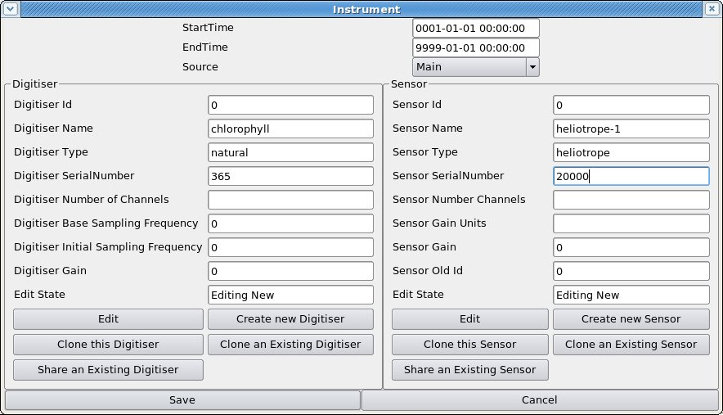Figure 12: Instrument edit window with new digitiser and new sensor entered. Note “Edit State” slot, showing “Editing New”, which shows that we have created brand-new digitiser and sensor. The system will automatically provide the “Digitiser Id” and “Sensor Id”. It is not necessary to fill in any of the four entries from "Number of Channels" down.
  - If the seismometer or digitiser is one that has already been used elsewhere and is in the database, then press “Share an Existing Sensor” and choose it from the list Figure 14) (you can always press “Cancel” on the list if you can't find it). For a brand-new three-component seismometer, once you have entered the details in “Create new sensor” for one of the components, you should use “Share an Existing Sensor” to associate the same seismometer with the other two components.
- When one or other, but not both, of the seismometer and digitiser has been changed, check that the unchanged one says “View Shared” in the “Edit Status” slot (Figure 13) and don't alter anything about it.
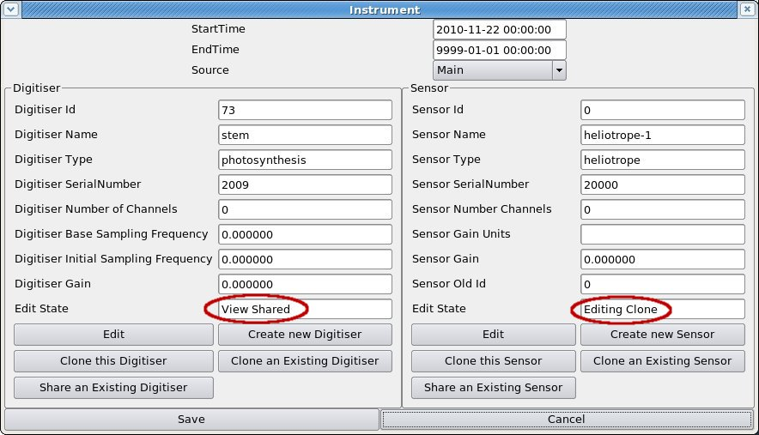Figure 13: Instrument edit window showing entry of a new sensor based on cloning an existing sensor (“Edit State” is “Editing Clone”), and a digitiser shared between this sensor and others (e.g. in an array) (“Edit State” is “View Shared”).
- Press “Save” when you have finished.

List of old instrument IDs used by “robby” and other old Blacknest programs
CNo Code No Code No Code No Code No Code
C 1 YKA LP 21 LRSM SP 41 LPNB Z 61 CMG-5T VEL 81 KS54M VBB
C 2 LRSM LP 22 NORSAR SP 42 LPNB HOR 62 CMG-40T DISP82 KS54I VBB
C 3 WWSSN LP 23 YKA SP 43 VBB Z 63 CMG-40T VEL 83 KS36I VBB
C 4 GBA LP 24 WOOD-AND/SON 44 VBB HOR 64 CMG-3ESP VBB84 STS-2 VBB
C 5 EKA LP6 25 WWSSN SP 45 FLK LPNB Z 65 SP KIRNOS 85 STS-1V VBB
C 6 UKN LPNB(LP2) 26 GBA SP(WRA SP) 46 FLK LPNB N-S 66 LP KIRNOS 86 STS-1H VBB
C 7 SPARE LP 27 EKA SP2 (SP) 47 FLK LPNB E-W 67 YKA VEL 87 BB-13 VBB
C 8 SRO LP 28 SPARE SP 48 FLK VBB Z 68 NORESS SP 88 GS-13 SP
C 9 UKN LPNB (LP) 29 SRO SP 49 FLK VBB N-S 69 SPARE 89 S-13 SP
C10 BB DISP (DBB) 30 DUM DUM DUM 50 FLK VBB E-W 70 BEN BOG 90 S-13 H
C11 BB VEL (VBB) 31 LP (IDEAL LP) 51 FLK VBB Z AA 71 DWWSSN SP 91 EKA SP
C12 OLD BB (DBB) 32 DBB (IDEAL BB) 52 FLK VBB N AA 72 DWWSSN SP2 92 SPITS SP
C13 OLD KIRNOS 33 SP (IDEAL SP) 53 FLK VBB E AA 73 DWWSSN -1 93 ANTIFILT
C14 RED KIRNOS 34 GBA DSP 54 USSR VBB 74 RSTN SP Z 94 SPARE
C15 SPARE BB 35 EKA DSP 55 SWL LPNB Z 75 IDC BUTT 95 BKN BUTT
C16 UKN VBB2 36 WRA DSP 56 SWL LPNB N-S 76 IDC BUTT 96 3B93
C17 YKA VBBX 37 YKA DSP 57 SWL LPNB E-W 77 HFS LPWB 97
C18 YKA VBB 38 YKA DSP II (2) 58 SWL VBB Z AA 78 SRO SP ANTI 98
C19 UKN VBBW 39 WRA DSP II (2) 59 SPARE 79 ASRO SP 99
C20 SASP SP 40 DUM DUM DSP 60 CMG-5T DISP 80 CAN SP 100

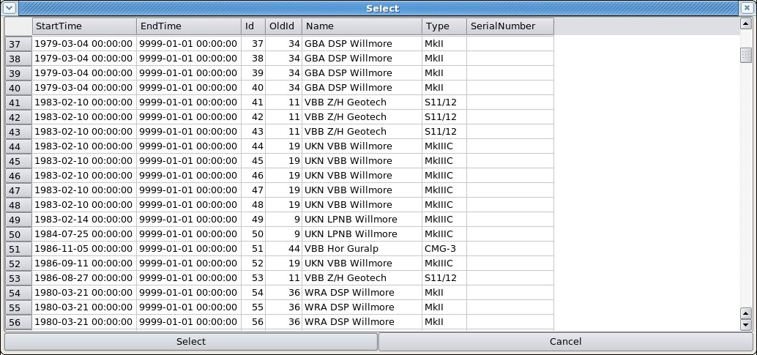Figure 14: (part of) List from which to choose an existing seismometer to be "shared" or "cloned".
- In the Responses subwindow, select the most recent response, then press “Options – Split at time”, and enter the date and time of the instrument change. In the “Responses Edit” window, enter the new poles and zeros (unfortunately you have to do this even if they are the same as the old ones).
- Press “Save” at the bottom of the “Channel Edit” window, then select the next channel to be affected by the instrument change. Go through stages 2-7 above.

5.4 How to change a station or array name
The station name has to be changed in the list of stations, then each channel that was attached to the old station has to be found and the station name on it changed to the new name (rather than creating new channels for the new station name, duplicating the old ones). Otherwise the channels are left “orphaned” in the database. Changing the station name unfortunately causes the station location to be lost, so this needs to be noted and re-typed.
- In the Meta Data tab, enter the old station name in the Station box and press “Update”;
- Go to the Stations tab and make a note of the station location (latitude, longitude, elevation) ;
- For a single station only – this is not necessary for an array - go to the Channels tab and make a note the names of all the channels associated with that station (don't forget the location codes – the part after the underscore);
- Select the old station name from the list of stations in the Stations tab below and press “Modify”;
- In the “Station” window, change the station name to the new value. If there is an alias, change that to reflect the new station name. Press “Save”;
- At the top of the Meta Data tab, first press “Fetch Selection Info” (to update the display to account for the change to the database that you have just made), then select the new station name from the list of stations and press “Update”;
- In the “Stations” tab, select the new station and press “Modify”;
- In the “Station” window, press “Append” beneath the “Location” subwindow and enter the latitude, longitude and elevation of the station (or array centre), then “Save” the “Station” window;
- For an array you have now finished, but for a single station you now have to re-attach the associated channels. Put a single asterisk into the “Station” box at the top of the Meta Data tab and enter the name of the first channel that was associated with the old station name. Press “Update”;
- In the Channels tab, choose the channel that has the old station name and press “Modify”;
- Change the station name in the “Channel” window to the new name and press “Channel Info Add/Update”, and then “Save”, answering “Yes” to the resulting “Are you sure?”-type prompts;
- Repeat 9-11 for all the other channels associated with the station, then select the new station name from the list of stations at the top of the “Meta Data” tab and enter “*” for the channels and press “Update”. Check that all the channels previously associated with the old station name are present for the new station name.

5.5 How to create a new (3-component) station
- Create the station in the “Stations” tab by pressing the “Append” button at the bottom. In the “Station Edit” window (Figure 15), enter the name of the station and any description you want, but don't try to enter the station location yet. Press “Save” (if you enter the station location before pressing “Save” then it will return with the error that the station does not exist).
- Select your newly created station from the stations list and press “Modify”. Back in the Station Edit window, you can now enter its location by pressing the “Append” button beneath the “Locations” subwindow. “OffsetEast” and “OffsetNorth” are for stations that form part of an array, and can be left at zero for non-array stations.
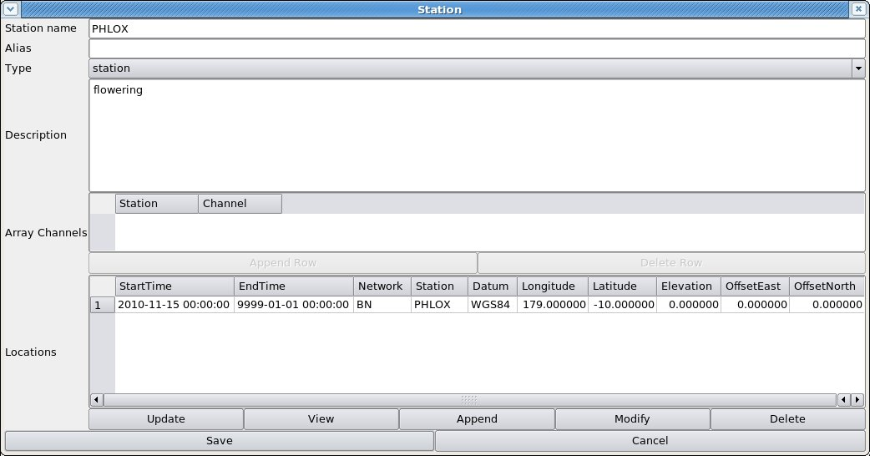Figure 15: Station Edit window for single station, with location added.
- Create the channels in the “Channels” tab. Press “Fetch Selection Info” (to bring the displayed station list up to date with the newly added station) then choose your new station and press “Update”. Then press “Append”.
- In the “Channel Edit” window enter “BHZ” (or “SHZ” or similar channel designation – SEED manual, ISDN/IRIS/USGS, 2006, Appendix A, contains the rubric) as the “ChannelType”, and the location code, if any, in the “ChannelAux” slot, and any description you want in the “Description” box, then press “Channel Info Add/Update”.
- Press the “Append” button beneath the “Calibrations” subwindow and enter the appropriate values in the “Edit Calibrations” popup window. The minimum entries in this window are the sampling frequency, calibration frequency and calibration factor. Since for a new station the latter two come from the manufacturer's data sheet, the “Name” should be set to “Main” (the default).
- Press the “Append” button beneath the “Instruments” subwindow (Figure 16). If your digitiser and/or sensor are similar to those already installed at another station, then you can save effort by pressing the “Clone an Existing Digitiser” and/or “Clone an Existing Sensor” buttons, and choosing the digitiser or sensor of the other station from the resulting lists. The details of the existing digitiser or sensor are displayed, and you should then change the serial number, and anything else that is different, to the values for your new digitiser and/or sensor. Then press “Save”.
- Press the “Append” button beneath the “Responses” subwindow and enter the poles and zeros in the “Responses Edit” window (Figure 17). Unfortunately the cloning of the sensor does not copy the poles and zeros, so you have to enter these from scratch. They may be read from a SAC- or IMS internal format poles-and-zeros file (the “IMS internal” format is used in the files of instrument responses used internally by IDC analysis programs and Geotool, and downloadable from the IDC server in a subdirectory “station_specs/rsp” - it is NOT the format in which pole-zero responses are output by the IDC or BDS AutoDRMs) by pressing the “Load from File” button at the bottom of the window, or you can type them in. When typing them in, note that after typing both parts in, you have to press “return”, “tab” or the left or right cursor arrow, to move the highlight away from the window in which you just typed, before pressing the “Append Row”, “Add Duplicate” or “Add Conjugate” button, otherwise the part you just typed will be ignored and come out as zero. The “Add Duplicate” and “Add Conjugate” buttons work on the currently highlighted pole or zero in the list. When you press “Save” it warns of any poles with positive parts (acausal filter) and will not save if any pole/zero with non-zero imaginary part is not one of a complex conjugate pair.
- Once Calibrations, Instruments and Responses sub-windows are displaying the correct values, press “Save” at the bottom of the “Channel Edit” window. Your newly created channel will not appear in the “Channels” tab (disconcertingly), until you press “Fetch Selection Info”, re-select your station from the station list at the top of the page, then press “Update”.

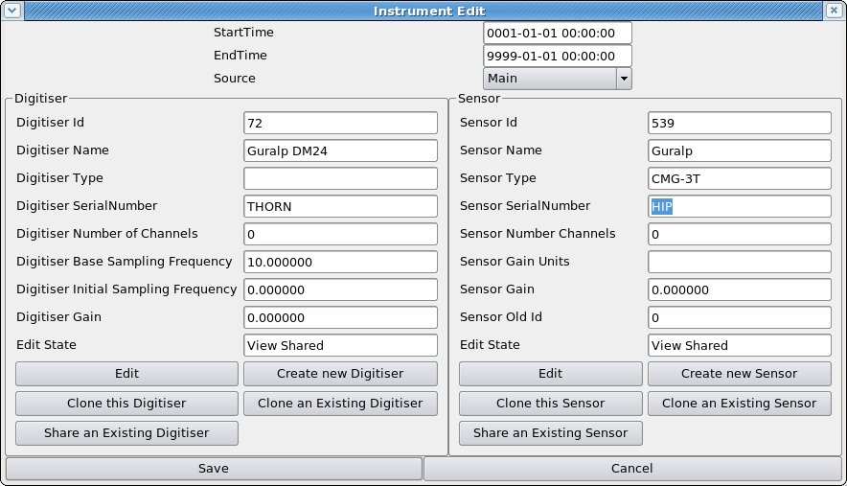Figure 16: Instrument Edit window with Digitiser and Sensor sub-windows. Note "Edit State" slot, now showing that we are viewing the parameters of a digitiser and a sensor that are shared between this and other "instruments".
- Once you have created one channel, the others are created most quickly by selecting the new channel in the “Channels” tab, then press the “Actions” button and choose “Clone the channels”. In the “Clone a Channel” box, enter the next channel name (e.g. “BHN”) at the top, then UNtick the boxes “Clone Sensors” and “Clone Digitisers” (Figure 18). This allows the digitiser and sensor to be “shared” rather than “cloned” between the two channels (Figure 16 – see “Edit State” slot), which is what is required for a 3-component seismometer using a single digitiser.
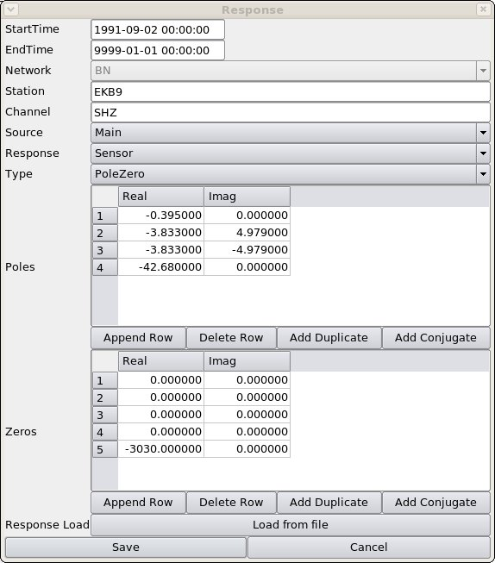Figure 17: Response Edit window. The "Load from file" button allows you to load poles and zeros from a file in SAC or “IMS” format. The "Add Duplicate" and "Add Conjugate" buttons add a pole or zero that is the duplicate or conjugate of the currently highlighted pole or zero in the list. If you press "Save" on this window it will warn about the poles with positive real parts (acausal) and refuse to save poles/zeros not in complex-conjugate pairs.
- Select the newly created channel in the “Channels” tab and press the “Modify” button. You need to modify the cloned “Calibration” entry to have the calibration values and horizontal and vertical orientation angles for the new channel (e.g. Vertical Angle 90 degrees, horizontal angle 0 degrees, for a “N” component). You might need to alter the cloned “Responses” entry if the new component does not have the same poles and zeros as the one from which it was “cloned”.
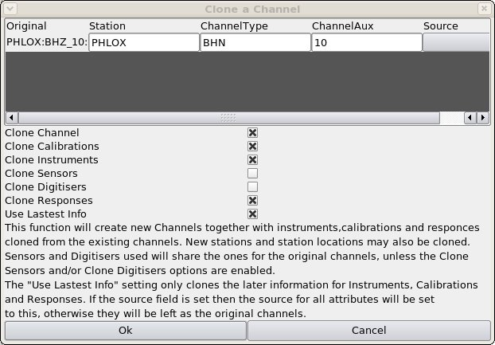Figure 18: "Clone a Channel" window showing the creation of new channel "BHN_10" from the previously entered "BHZ_10". Note that "Clone Sensors" and "Clone Digitisers" are NOT ticked, so that the sensor and digitiser are "shared" rather than "cloned" between the channels.

5.6 How to create a new Array
An array consists of individual stations but you can create the array and stations independently. To create an array, do:

- In the Stations window, press the “Append” button. In the resulting “Station Edit” window (Figure 8), enter the name of the array at “Station Name”, choose “Type” to be “Array”, and add any description you want.
- Add the Array Channels, i.e. the station name and channel name of each channel in the array. After typing the channel name you must hit Return, Tab or a cursor key, otherwise it does not save the channel name. The program makes no check that the station and channel exists, so type carefully if your array contains already-entered stations. Do not forget to include the location code, if any: it should be typed after the channel name with an underscore in between, e.g. “BHZ_10”. When all are added, press “Save” (don't try to insert the location for a brand-new array or you will get the message that it does not exist).
- Press the “Fetch Selection Info” button then select your new array from the Stations list and press “Update”.
- Then select the array in the Stations tab and press “Modify”;
- When the Station Edit window re-opens, press “Append” below the “Locations” subwindow and enter the array centre latitude, longitude and elevation in the “Location Edit” box (Figure 19). Press “Save” in the Location Edit box, and “Save” again in the Station window.
- If the individual stations of your array do not already exist in the database, create them – see “How to create a new Station” above.
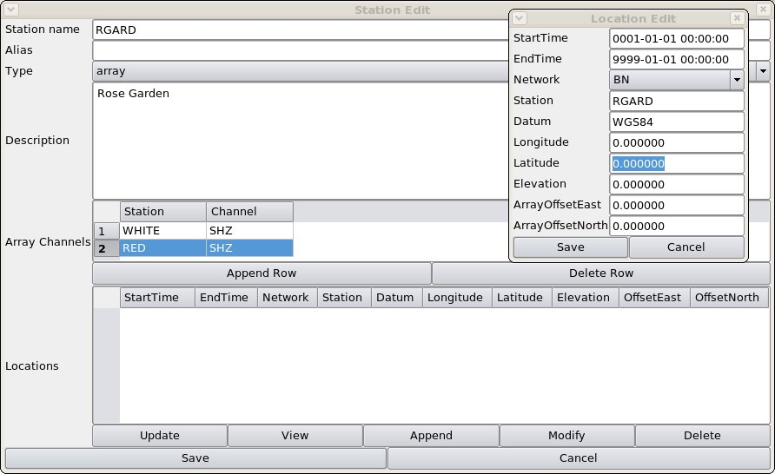Figure 19: Station Edit window for an array, with Location Edit popup window into which array centre co-ordinates should be typed.

5.7 How to extend a channel back in time
If data older than any that were previously available are to be imported into the BDS, they will require metadata with a timespan covering them. If the channel start date is later than the date of the new data, you will need to backdate the channel start date AND either backdate the current Calibration, Instrument and Response values or create new ones with the older date. The BDS “split at time” function is intended for creating new Channel, Calibration, Instrument and Response entries at later dates, and will not accept a “split time” less than the start time of the entry: to make it do entries for earlier dates requires some editing.
1. Select the desired station, then the desired channel, in the Metadata tab, and press the “Modify” button;
2. Modify the channel start date (at the top of the “Channel” window) to the new, earlier start date;
3. If the oldest “Calibration” entry does not have a start date as early as the new date, select it and choose “Split at time” from the list under the “Actions” button. When the “Split at time” popup appears, set the splitting time to be a short time (one second is good) AFTER the current start time of the “Calibration” entry;
4. When the new “Calibration” entry appears in an “edit” window, SAVE IT WITHOUT EDITING IT – this will remain as the existing Calibration for the original timespan for which it was valid, and so you don't want to change it;
5. There are now two “Calibration” entries with start times one second apart. Choose the earlier one and press “Modify”, then change its start date to the new, earlier start date and its end date to the original start date, i.e. remove the one second, then save. You may also make other modifications, e.g. to the “calibration factor” or sampling frequency, and in particular, if you are extending the channel back in time to accommodate TapeDigitiser data, then all the new, backdated entries must have “Source” changed from “Main” (or whatever they are at present) to “TapeDigitiser”;
6. Choose the second “Calibration” entry and modify its start date back to the original start time, i.e. remove the one second. You have to do this after modifying the earlier entry, otherwise the two entries will overlap in time and you will get an error message;
7. Follow the same procedure for the “Instrument” and “Response” entries;
8. Press “save” at the bottom of the “Channel” window to save all your changes.

6. Importing Data
Data are imported into the BDS by the command-line programs bdsImportData and bdsImportTapeDigitiserData, manuals for which are available on the BEAM website (BEAM 2010b). Those manuals list the options available for each command. This manual focuses on the options required to import the particular formats of data available in the Blacknest archive.

Data can be imported in the following digital formats:
- BDRS (SDAT) (Trodd 1986), including the extended BDRS containing multi-multiplexed long-period data in Channels 19 and 20;
- WRA40 and WRA64 (A. Arcidiaco, ANU, pers. comm., 30/06/2009);
- WRA_AGSO (K. Muirhead, ANU, pers. comm. 03/12/1996);
- TapeDigitiser (BEAM 2008a, b);
- Güralp Compressed Format (GCF) (Güralp 2010);
- SEED (IFDSN/IRIS/USGS 2006);

6.1 bdsImportData options

6.1.1 “-ignoreMissingBlocks”
All seismic data in the Blacknest archive have gaps, caused by instrument, telecommunication or storage failures. All the data formats have the data stored in blocks of a few hundred or thousand digital samples, each with a timestamp and known sampling rate. Gaps within data files take the form of one or more missing blocks, which are identified by the break in succession of timestamps. The flag “-ignoreMissingBlocks” should be set for all imported formats, since otherwise the import will fail wherever there are missing data. The timespans and channels for which blocks are missing are noted during import and this information is stored in two places: the BDS file header and the Notes table in the database. Gaps between the end of one data file and the next are not flagged as “missing blocks” and can be detected on import only by scrutiny of the actual start- and end-times of files. This is most likely to be necessary for short data files, e.g. 10-minute SEED files.

6.1.2 “-source”
The “source” value of the imported data should always be set. For most data this is “Main”; the common exceptions are: “TapeDigitiser” for all TapeDigitiser data, “EkaDig2” for all EKA short-period data digitised with the 40-Hz DMOD digitiser, “EkaCD” and “EkbCD” for EKA broadband and EKB data from CDs posted from EKA, and “Scream” for GCF-format data continuously imported straight from the SCREAM data stream.

6.1.3 “-array”
Whenever data from one of the arrays, EKA, YKA, GBA, WRA, BKNI, BAE/SAAS, UKNET or any newly created array are imported, “-array” should be set to the correct array name. This allows the BDS to name the data files accordingly and associate them with the metadata.

6.1.4 Other general flags
“-ignoreFilenameTime” prevents the import program from checking the start time of a file extracted from block headers with the time deduced from the filename (e.g. filenames such as 2008213_0000.EKA for a file beginning at midnight on day 213 of year 2008). For BDRS format files in which the year of the file is not encoded in the header, import will fail if “-ignoreFilenameTime” is set. The BDS is not aware of all the possible formats of file names, and this flag should be set for unusual data , e.g. on a CD-ROM, from which it cannot deduce a time from the file name.

“-warnings” and “-verbose” are useful for testing, but also for bulk importing when it is necessary to determine why a particular import failed, or whether there were data missing from beginning or end of files. “-dryRun” can be set so that import will not take place but all actions short of import will be carried out and the resulting warnings and errors shown (if “-verbose” and “-warnings” are set).

“-startTime” and/or “-endTime” can be used to import part of the data from a file, if, for instance, it is known to be corrupt beyond or before a certain time. They may also be used to import, in two passes, data for which there was a change of station name, or, more usually, channel name in the middle of a data file. Beware that import ceases at the end of the last block before “endTime”, or starts at the beginning of the first block after “startTime”, so if data from the same file are imported in two passes, with “startTime” for one pass and “endTime” for the other both set to the same time, there will be a one-block gap between the two parts of the imported data.

“-ignoreMetaData” should not be set, because failure to import data through lack of metadata is a fault that should be investigated and repaired. For a new station or channel, this flag could be set but you will not be able to export the data until you introduce the required metadata to the database. The advantage of entering the metadata before importing the data is that the check against already installed metadata during import is useful for detecting errors. See the instructions above on creating a new station and new channels. The only place where “-ignoreMetaData” must be set is when you use “-endTime” and “-startTime” to import data from a single file in two passes because of a station or channel name change in mid-file. If the metadata are correctly set up with the time of the station/channel change in mid file, importing will fail with a no-metadata error for the remainder of the file even though it is not being imported because it is after “endTime” or before “startTime”.

“-description” can be set to a user-supplied string. “-addWarning” can be set to add a line to the Notes database with entries in its columns – see Section 7, below.

6.2 Multiplexed formats (BDRS, WRA40, WRA64)
The flag “-synchronous” should always be set, because these sample-multiplexed data are all, by definition, synchronously sampled. “-allowOverlaps” should be set because there are a number of places where (nominally) the same data are repeated in two overlapping files. The data might not be exactly the same because of differences in tape head cleanliness during transcription from 1/2-in tape to Exabyte, hence we keep both copies.

Do not set “-ignoreCorruptions”, “-ignoreAll” or “-ignoreTimeBackwards”, because block timestamp corruptions should be fixed by pre-processing, otherwise the importing program ignores these “corrupt” blocks. Also, do not set “-deleteDuplicates” or “-reorder”, because BDRS/WRA40/WRA64 data blocks are always in chronological order and never have backfilling – it is only corruption of timestamps that makes them appear otherwise. “-ignoreFilenameTime” should never be set for BDRS data, because the program needs to use the year encoded in the filename to supplement the deficient information in the block headers.

The channel names should be specified in the order in which they are multiplexed, which can be determined from the variable “offset”, and for UKNET multi-multiplexed 1-Hz LP data, “suboffset”, in the 2006 AutoDRM database. The BDS database does not contain “offset” or “suboffset”, so the program must be told the correct channel order. For UKNET data the 10-Hz sampled broadband channels should be specified in the order given by “offset”, then the LP channels with offset “18” (which are multi-multiplexed on to channel 19) should be specified in the order given by “suboffset”, followed by the LP channels with offset “19”, again in order of “suboffset” - 38 channels in all.

6.3 GCF (Güralp compressed)
GCF data are stored in one trace per file and have block boundaries occurring at different times in different channels from the same station. GCF data are never per-sample multiplexed. Nevertheless, data that come from the same digitiser, e.g. all 20 channels of EKA broadband array, and the three channels from each three-component set, are synchronously sampled and hence should be imported with “-synchronous” set. These data are best exported with the “Full Blocks” switch not set, otherwise the exported traces all start and end at different times. Note that BKNI (infrasound array) data are NOT synchronously sampled, although the four stations are designated as an array, because they have separate digitisers and GPS units, so these should not have “-synchronous” set during import.

After breaks in transmission, the SCREAM system tries to backfill missing data. This causes data blocks not to be in chronological order, and occasionally data blocks are transmitted twice. The flags “-reorder” and “-deleteDuplicates” should always be set for GCF data. “-deleteDuplicates” operates only when it encounters two blocks that are bitwise identical. Sometimes two blocks with identical timestamps but different data are transmitted, for instance after a GPS clock reset, and when this happens, the import will fail. Pre-processing is then required. “-ignoreTimeBackwards” should never be set while “-deleteDuplicates” and “-reorder” are in force, although the program does carry out the reordering and deleting of duplicate blocks before checking for blocks that are still not in chronological order.

Multichannel GCF data e.g. the entire EKA broadband array, or a whole three-component set, should be imported with a single command. Take care to specify the channels in the “-channels” list in the same order as the filenames at the end of the command.

6.4 SEED and tarred SEED
SEED is the one data format for which it is not necessary to specify the channel order, i.e. no “-channels” list is required. The order given in the SEED header is considered to be trustworthy. “-synchronous” should be set for YKA SEED data, although the data are not multiplexed and strictly only the array channels, not the broadband and high-frequency channels stored in the same SEED files, are synchronously sampled.

“-ignoreCorruptions” and “-ignoreTimeBackwards” should not be set, because corruptions should be solved by pre-processing. “-reorder” and “-deleteDuplicates” should not be set, because backfilling is not expected.

“Tarred SEED” files consist of (up to) 144 ten-minute SEED files combined into a Unix Tape Archive (“tar”) file, representing 24 hours' worth of data. The data were originally received from Canada as separate 10-minute files and were combined into the tar files by a Blacknest-written program. For tarred SEED data the options “-sequential” should be set, as well as the above options (set or not set) for SEED data. This causes all of the 10-minute SEED files in a single daily tarfile to be combined into a single daily BDS file. Importing will fail if one of the 144 10-minute files is corrupt, at which point you have to decide whether to discard it and import all the remaining 10-minute files.

“-ignoreTarErrors” should be set for the first few files of tar SEED data, from 1991-07-10 (day 191) to 1991-09-20 (day 263), for which the tar files do not have a proper End-of-File. This does not affect the data nor the ability of the tar program to read the data, but the BDS importer fails on detecting the error message, unless “-ignoreTarErrors” is set. After that time a new version of the tar-file writer program was used, which did not have this problem, hence tar errors in subsequent tar SEED files are more serious and should be considered case-by-case.

6.5 TapeDigitiser
TapeDigitiser data are stored in subdirectories containing the data files (with names ending in “.bs”) and a file “jobInfo.tdi” (BEAM 2008b), written during the digitising process, and optionally, a file “jobInfo.tdim”. The program bdsImportTapeDigitiserData reads the start- and end-time and data file name information from the jobInfo file, preferring “jobInfo.tdim” (“modified jobInfo.tdi”) to allow the user to supply a modified version of “jobInfo.tdi” for one that was incorrectly written during the digitising process. The channel order of the data has to be supplied by the user in the “-channels” statement and must include the two “error” channels and the VELA or other time code channel, and dummies for any dead channels, up to a total of 24 channels.

An example “-channels” parameter list is:
-channels
BAW3:SHZ,BAW2:SHZ,BAW1:SHZ,BAE#:ODD_91,BAE1:SHZ,BAE#:AER_01,BAE2:SHZ,BAE3:SHZ,B
AE4:SHZ,BAE5:SHZ,BAE#:ODD_92,BAE#:AOT,BACP:SHZ,BAS1:SHZ,BAS2:SHZ,BAS3:SHZ,BAS4:S
HZ,BAE#:AER_02,BAS5:SHZ,BAWE:SHZ,BAE4:SHN,BAE4:SHE,BAE#:ODD_93,BAE#:AVT

The name of the subdirectory (one per run), not the files within it, is given as the parameter for bdsImportTapeDigitiserData. The options “-ignoreSessions” and “-includeSessions” allow individual data files within that directory to be ignored, or included, in the import. Each analogue tape was digitised in a single session whenever possible, with all the data going into a single output file data-000000.bs. There are more than one files for those tapes where digitisation had to be stopped in mid-tape, for instance for cleaning of tape heads. The tape was usually rewound a short distance before digitising was resumed into a new output file. Sometimes where there were problems, a number of short test sessions were recorded. The session numbers (starting at zero) correspond to the data file names e.g. data-000000.bs is from the zeroth session and data-000001.bs from the first session. Very short sessions can sometimes be ignored, especially if the jobInfo.tdi file gives zero start- and end-times for them. Substantial overlapping sessions should both be imported, unless one is known to be hopelessly corrupt, so that the end user of the data has the final choice about which to use.

“-synchronous” need not be set because it is assumed as the default for TapeDigitiser data.

“-ignoreMissingBlocks” needs to be set for some TapeDigitiser data, but the reason for the missing blocks should be investigated, so a pass without “-ignoreMissingBlocks” but with “-verbose” and “-warnings” should be made first, and then the data around the reported missing blocks viewed in TapeView (BEAM 2010e) to check for errors in reading of the timecode track. Gaps in recording of the original analogue tapes are caused by power failures and glitches, sometimes attributed to lightning storms. Apparent gaps also occur when the clock was reset forwards. The time track decoder used by bdsImportTapeDigitiserData does not directly detect the break in the time code. It requires two full minutes of perfect timecode following a break before it can read a valid time and recognise that a break has occurred. It then flags “missing blocks”, but the nominal time of these is two minutes (or more, if the time code track is poor) after the actual break. The data can be imported with “-ignoreMissingBlocks”, and the end user is expected to read the time code and find the exact time of the break (usually evident from a spike on all channels, Figure 20).
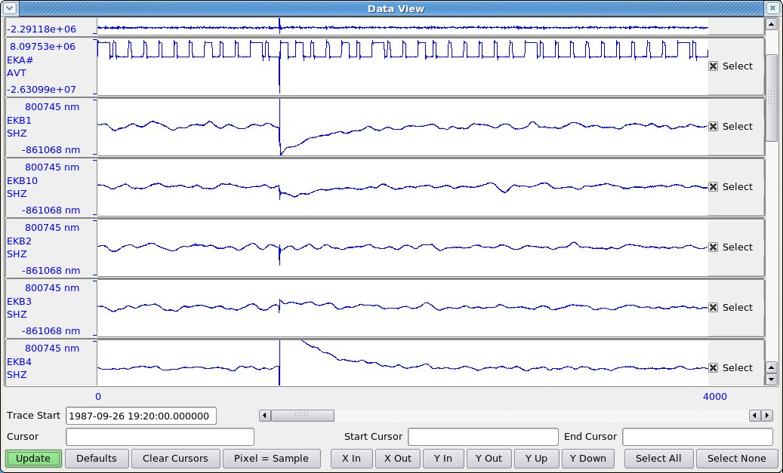Figure 20: Trace display of break in data from TapeDigitiser tape EKA3011. 12 s of data are missing at the spike. "Missing blocks" are flagged at 19:22:32, over 2 min later, since the program has to read 2 min of time code before it recognises that a break has occurred.
A clock reset can occasionally cause a “time backwards” error. The reset is required because of (forwards) clock drift or problems with the time-code generator, particularly just after the turn of a year, where the Julian day value sometimes carries on beyond 365/366 for a day or more until it is re-set manually.

Data causing this error can be viewed with “TapeView” to decide whether the “time backwards” error is genuine, not due to the program misreading the time code. If there is a gap or disturbance in the data about two minutes before the reported “time backwards” error then the error might safely be assumed to be connected with the disturbance. The data can be imported with “-ignoreTimeBackwards”. As a check, a timespan including the “time backwards” error might be exported in IMS format (with “full blocks” ticked) and compared with the same timespan exported from “TapeView” (although the channels are in different order in the two outputs) to check that no data have been lost. The start times on the IMS WID2 lines of the two data files will not be identical even when the actual data samples are (you might need to uncompress the CM6 with “uncmpgse” to carry out a sample-by-sample comparison). This is because the TapeView output has block timestamps determined by a different time-code reading program (BEAM 2010f).

The “-ignoreTimeBackwards” flag does not cause data from blocks with backwards timestamps to be discarded, so no data are lost on import. When exported in IMS or SEED/miniSEED format the data are split into segments with the second segment starting at the first block with a backward timestamp. Beware that if you read the IMS data into Geotool, it will “merge” the two data segments (because they have identical station and channel names), discarding the overlap. SAC, either with “readgse” or after running “gsetosac” on the IMS file, or after “rdseed” on the SEED file, will show the two overlapping segments as separate traces. The two segments are likely to have slightly different sampling rates, so if you wish to merge them into a single trace, by using “chnhdr” to change the start time of the second to make it contiguous with the end of the first, you will have to use “chnhdr” to make the sampling rates equal.

Time-backwards errors due to problems with the time-code generator … (to be written!)

The jobInfo.tdi file may report “signoffComment Tracks x, y and z disabled” (where x, y and z are numbers), and you will see this in the Data Info button window under the “Sensor Data” tab in the AdminGui. The tracks on the analogue tape listed here have not been disconnected and were digitised along with the other tracks; “disabled” means merely that error-checking during digitisation was switched off for these channels. It was done usually because the channels were “flat” or otherwise obviously bad, or in mid-session because too many errors were being flagged for that channel. After digitisation, “flat” channels appear as a reversed-polarity copy of the “error compensation” channel, because the error compensation process consists of subtracting the error compensation channel from the other channels.

7. Adding notes and warnings to data
Notes and warnings can be attached to data in the BDS system by three methods: the “-addWarning” option of “bdsImportData” and “bdsImportTapeDigitiserData” programs, adding a note via the Notes tab of the AdminGui, and with the program “bdsNoteAppend”. Only admin-accredited users can add notes and warnings, but a non-admin user may view them in the “Notes” tab of the User GUI.

7.1 “-addWarning” option
“bdsImportData” and “bdsImportTapeDigitiserData” automatically add warnings to the data when they encounter issues during import, including missing blocks, re-ordered blocks and incomplete metadata. The “-addWarning” option allows user-specified warnings to be attached to the data in the same way as the automatic warnings.
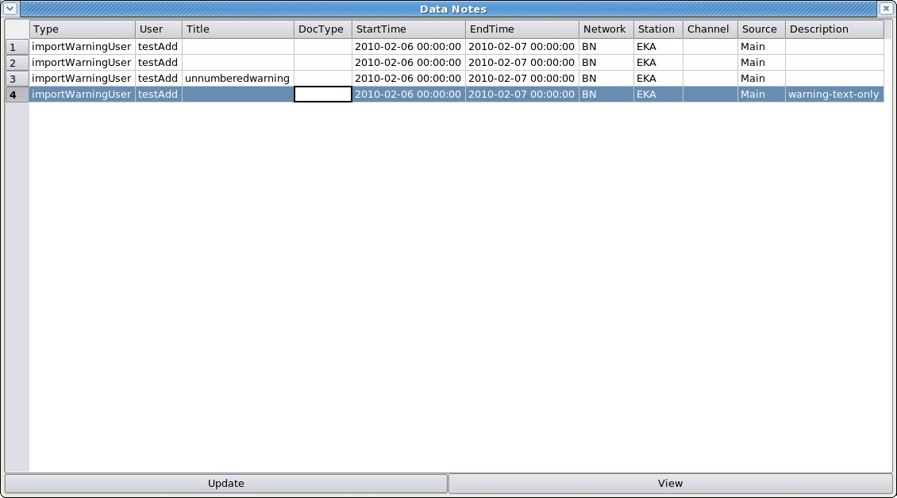Figure 21: "Data Notes" window showing entries created by "-addWarning" option of bdsImportData. The parameters given to "-addWarning" were, for 1., none (six commas); for 2., an error number only; for 3., an "errorstring" only (reproduced here as "Title"), and for 4., a description only. The error number is not shown in this window.
The format of the “-addWarning” option is “errorno,errorstring,fileName,startTime,endTime,network:station:channel:source,description,
e.g. -addWarning 99,earthquake,/remote/archive/2010/EKA/BHZ/EKR1/20100313_1500z.gcf, 2010-03-13T15:13:00.0,2010-03-13T15:14:00.0,BN:EKR1:BHZ:Main,”earthquake M6.9 offshore Camelot”
There is at present very little error checking on any of this input, so it is up to the user to ensure that the filename agrees with one of the filenames being imported, the timespan delimited by “startTime” and “endTime” lies within the span of the data file, and the channel specified is in the data file. The resulting warning is stored in two places: the header of the BDS-format data file in the BDS store, and an entry in the “Notes” database. Only the latter can be altered after import.

All of the above parameters can be omitted. If the error number is omitted it is set to zero. If the “network:station:channel:source” is omitted then the warning is taken to apply to all stations being imported and will be stored in the “Notes” table with the array name as the “station name” and a null “channel name”. If the times are omitted then the warning is taken to apply to the entire timespan of the imported file.

The resulting warnings can be viewed in the AdminGui or UserGui by pressing the “Data Notes” or “Data Info” button on the “Sensor Data” tab, or in the “Notes” tab, once the station and a timespan encompassed by the imported file have been entered at the top of the tab. The “Data Notes” button and “Notes” tab show some entries from the “Notes” database table (Figure 21), including all the input parameters except the error number. The window from the “Data Info” button shows all the details including the error number.

Figure 23: Data Notes window showing four warnings created by the "-addWarning" option of "bdsImportData". The first was for no parameters (6 commas), the second for an error number only, the third for an error name only and the fourth for a description only. The error number is not shown.
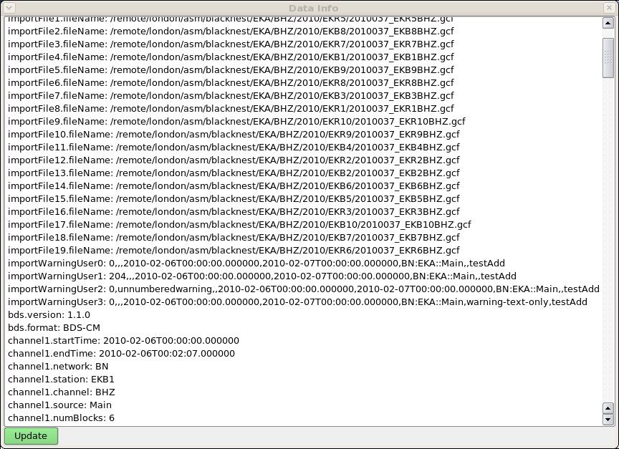Figure 22: Data Info window for the same four warnings added with "-addWarning" as for the previous figure. The parameters are in the order in which they were specified in the input command (see text). The error number is shown here (default zero because it was unspecified for all except the second warning). "testAdd" at the end is the name of the user that did the importing.
While at present there is no checking of the error number, there is a list in the BDS User Manual (BEAM 2010a) from which the appropriate error number should be drawn.

7.2 Adding note via Notes tab
In the “Notes” tab a note can be added by pressing the “Append” button at the bottom of the window. The default start time and end time of the new note (Figure 24) are set to zero and infinity and are not affected by the start time and end time entered at the top of the “Notes” tab. The “type” of the note can be chosen from a drop-down list: “note”, “warning”, “doc”, “importWarning”, “importWarningUser” and “exportWarning”. Type “doc” is for a note referring to a separate document filed with the data: this document can be in any format, for instance a “pdf” file containing a scanned logbook.

Because there is no checking of the consistency of items in a “Note”, it is possible to create a “Note” for non-existent or yet-to-be-loaded data. When data are present for the timespan and station/channel specified, and the timespan and station are specified in the “Sensor Data” tab, the “Note” will be found by pressing the “Data Notes” button. If you leave the station and channel empty and the dates at the default “zero” and “infinity”, then a note is created with a blank station and/or channel, and cannot be associated with any data.
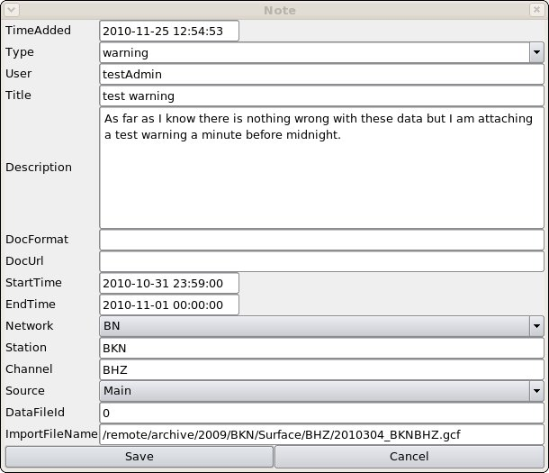Figure 24: Note edit window. The "StartTime" and "EndTime" default to infinity and should be set by the user; so should the ImportFileName, but there is no consistency check between them nor with the station/channel/source specified.

7.3 bdsNoteAppend
bdsNoteAppend allows you to create a note with (optionally) a reference to a separate document, of which a copy is loaded into the data store. The format of the command is:
bdsNoteAppend [options] note-type title
where “note-type” is “note”, “warning” or “doc” - use “doc” for importing documents. More-or-less it takes as options the same items as the Note edit window in Figure 23: start time, end time, network, station, channel, source, description, the format of the document to be imported and the path to the document. For example:

bdsNoteAppend -host bds -user testAdd:<password> -description tape\ logs -startTime 1977-03-23T00:00:00 -endTime 1990-09-08T00:00:00 -network BN -station EKA -channel SHZ -source TapeDigitiser -file /shareddata/documents/Digitisation/Tape_Logs/Batch\ 24/Batch_24_EKA.pdf -format pdf doc EKAlogsheets1977-1990

Again, some or all of the options can be left blank. Any file specified with “-file” must exist. The “note-type” can be any word, not just “note”, “warning” or “doc”, but applications that search for particular types of “note-type” might then not find it. The “format” can also be anything, but it is appended on to the filename of the file stored in the BDS data store (the filename might be in the form “note-0000000259.pdf”, for instance), so if the file is of a well-used format identified by a suffix, e.g. “doc”, “pdf”, “jpg”, “xls” or “txt”, then it would be as well to use the correct “-format” so that the document will be opened by the correct program by default.

8. User administration
The user's group membership determines the level of the user's access. Only users in the “admin” group can use the AdminGui, but further group memberships are required to carry out a number of tasks offered by the AdminGui. Users in the “userAdmin” group can modify the privileges of themselves and other users. “dataDelete” membership is required to delete data files and metadata. Loading of data can be done without “admin” membership for those with “dataAdd” membership. Modification of metadata (other than that done automatically when data are loaded) requires “admin” membership. “data.Blacknest” and “dataModify” are not at present used. A user to whom only AutoDRM access is to be granted should be excluded from all the access groups but must have a name registered in the list of users, with the exact email address from which AutoDRM requests will originate.
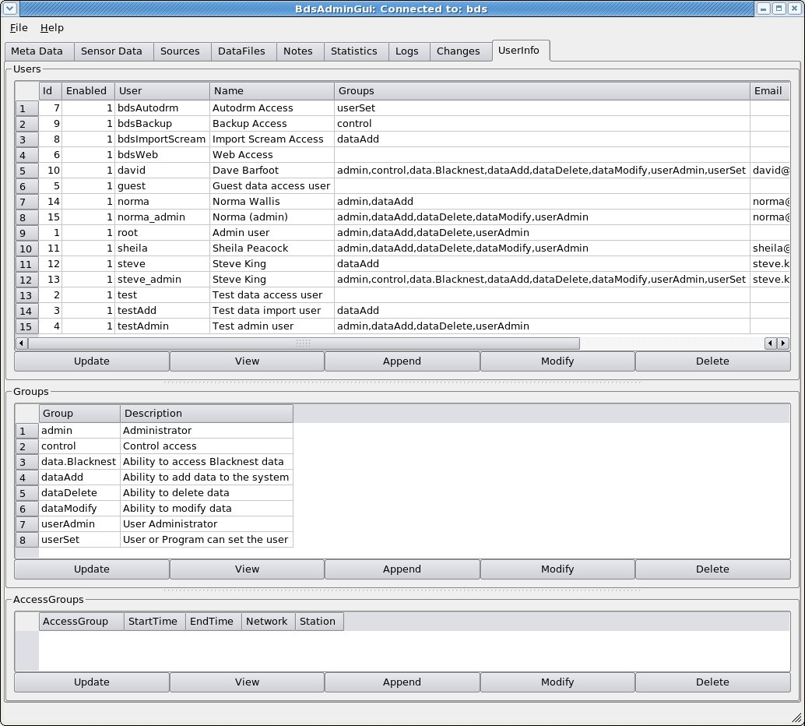Figure 25: UserInfo tab showing list of users with the groups to which they belong and the list of groups. NOTE I DON'T KNOW IF THIS HAS CHANGED SINCE V. 1.2.10 BECAUSE I NO LONGER HAVE ACCESS TO THIS TAB IN V 1.2.11

8.1 Access Groups – restricting access to data
“AccessGroups” are used to control access to particular data sets, specified by network, station, start and end times. Only a user belonging to the required Access Group (or groups) can gain access to the restricted data or metadata. To restrict access to a particular dataset using an Access Group,
- Create a new group by pressing “Append” below the “Groups” subwindow of the UserInfo tab (Figure 25);
- For each user to whom access to these data is to be granted, select their line from the Users list, press “Modify” and, in the User Edit window, tick the box next to the new group name;
- In the Access Groups window, press “Append”. In the Access Group Edit window (Figure 26), select your newly created group from the dropdown list of groups, then set the start time, end time, network and station (or array) of the restricted data. Leave the dates as 0001-01-01 and 9999-01-01 to restrict access to all data from the station;
- Test the AccessGroup by attempting to download data or response metadata from the restricted station in the “Sensor Data” tab. You will not be able to see the station name at all if the start and end dates are 0001-01-01 and 9999-01-01. If the start or end date is not either of these, then you will be able to see the station name but if you set a date/time span within the restricted range then you will get an empty channel list when you press “Update”. If you then press the “Responses” buttons you will get the error message “error – end time before or equal to start time” (even though this is not so). Data files from within the restricted time range cannot be listed in the “Data Files” tab, and in the AdminGui, a user with “dataDelete” privileges will have to be given membership of the group featured in the AccessGroup before they can see and delete data files from within the restricted time range.
- If you later wish to modify the AccessGroup, then you will need to include the (admin-privileged) user name by which you accessed the AdminGui as a user allowed to access the data covered by the AccessGroup (do this by choosing this user name from the “Users” list, pressing “Modify” and ticking the box to the left of the group name privileged to access the data). Otherwise your unprivileged admin user will not be allowed to see the station name in the dropdown list proffered by the “Modify Access Group” popup window.
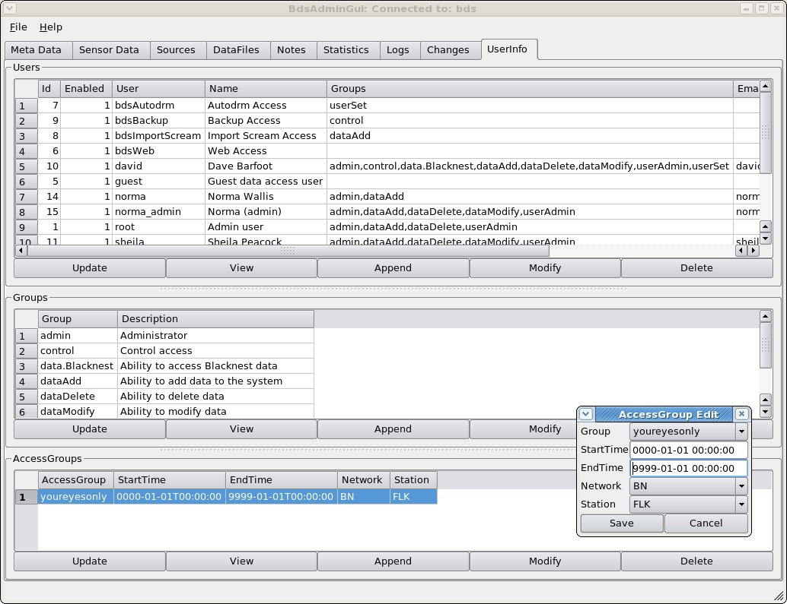Figure 26: UserInfo tab showing AccessGroup Edit window. To prevent access to data from a particular station for anyone not in the "AccessGroup", fill in this window with the AccessGroup name and the start time, end time, network and station to which access is to be restricted. In this example station FLK for all time is available to group “youreyesonly”. NOTE I DON'T KNOW IF THIS HAS CHANGED SINCE V. 1.2.10 BECAUSE I NO LONGER HAVE ACCESS TO THIS TAB IN V 1.2.11
It is possible to include a station in more than one Access Group, in which case users must be members of both Access Groups to have access to it. This can be used to restrict access to different timespans of data from the same station to different users. For instance an Access Group can be set up to have access to the entire data holding for one station, and a separate Access Group to have access to a short timespan of data from that station. Users must be in both access groups to access this short timespan. Users in the first access group but not also in the second will not be able to access the data from the short timespan, although they will be able to access all the other data from the station. Users in the second access group but not the first will not be able to access any data at all from the station.
The Access Group also restricts access to data via the command-line program “bdsDataAccess”: the “-command” options “dataInfo”, “dataInfoFull”, “channelInfo”, “channelInfoFull”, “responses”, “dataGet”, “dataGetFormatted” and “dataPlot” are all disabled if the user is not in the appropriate Access Group for the data specified in the “-select”, “-startTime” and “-endTime” parameters. The other options, including “dataSearch”, still work.
Users not in the Access Group for a station will not be able to obtain either data or responses for that station from the AutoDRM.

9. bdsMetadata command-line interface to database

9.1 Introduction
bdsMetadata is a program for querying and modifying the station metadata in the BDS database. It allows you to change several database items at once, and is thus more convenient than the AdminGUI for multiple changes, deletions or additions. Also, the commands for bdsMetadata can be preserved in scripts, for repeat running and reference. The definitive reference for bdsMetadata is the BEAM manual (BEAM 2011a).
The basis of bdsMetadata is the BDS API set for metadata handling, NOT the underlying database and SQL. Hence the object classes, not the database tables directly, are addressed and modified. For a user used to SQL, this is disconcerting. It is wise to run the bdsMetadata command “info <object>” on each of the object classes used by bdsMetadata and keep these handy while writing bdsMetadata programs.
Beware, particularly, that bdsMetadata treats a “start time” or “end time” in a search pattern as an instant (or, when you specify both start and end times, as a timespan) at which a set of metadata is valid, NOT as a pattern to be matched by start- or end-times in the database. So if you specify 'startTime=”2009-01-18T00:00:00.000000”' it will return all metadata with endTime greater than 2009-01-18, not just the metadata that happen to have startTime exactly 2009-01-18 00:00.000000. In fact it interprets “startTime=XXdate” as “endTime > XXdate OR endTime < 0000-01-01T00:00:00”.

9.2 Invocation
The command line for bdsMetadata for normal use is:
bdsMetadata -host <hostname> -name <bdsinstancename> -user <user:password>
and optionally, -maxChanges <n>, -v (for verbose), -d <variable>=<value>
then finally either -c '<command>' or -f <filename>
“host” and “name” should both be specified, in case there is more than one instance of bdsServer running on the host.
maxChanges is the maximum number of times a command will be executed if it changes the database. It defaults to one, and bdsMetadata will not execute the command at all if more than one execution would occur. This is a safety feature, very helpful to novice users given the ease of misinterpretation of date-matching described above. maxChanges doesn't quite equate to the number of table rows that would be changed (because of one-to-many relations between tables), but approximately to the number of channels that would be modified by the command. Set maxChanges to the number of channels you expect to change (or delete).
The command introduced by “-c” should be between single quotes because most of the command items include variable names, which in bdsMetadata are preceded by $ signs that have to be hidden from the shell by the single quotes. Commands in a file need not have quotes

9.3 Commands

9.3.1 Backup and restore
backup $<reference> and restore $<reference> back up and restore, respectively, the database. The “reference” should be a variable name preceded by $, e.g. $fridaybackup.

9.3.2 Variables
Variables are always preceded by “$”, as in Perl (and different from csh and bash). “set $<variable>” and “print $<variable>” let you set and view the value of a variable. “clear” clears the values of all variables. Think of variables as being C++ variables of various types; so you can do:
set $station = “H09N1”
which is a simple character variable, or
add PoleZero $pz0 {values of poles}{values of zeros} (see below for details)
which creates a variable $pz0 of type PoleZero (or an object called $pz0 of class PoleZero, if you prefer).
When you “print” a simple variable, it will print the value, but if you try to “print” a derived variable like $pz0, you will get a blank or zero. The “find” command initiates and fills an object of the named type, by searching the database according to the given “pattern” and assigns it a variable name: if you “print” that, it will print the “id” number of the relevant row in the database, e.g.
-c 'find Channel $ctest {station="EKB1", channel="BHZ", startTime="2011-07-31T00:00:00.000000"}; print $ctest;'
returns the number 241, which is the “id” of the row in BDS.Channels (the query below, which hinges on “endTime”, is equivalent to bdsMetadata's interpretation of the specified startTime, mentioned above).
mysql> select * from BDS.Channels where (station="EKB1" and channel = "BHZ" and endTime > "2011-07-31T00:00:00.000000");
+-----+----------------------------+----------------------------+---------+---------+---------+-------------+------------+----------+-------------+---------------------+
| id | startTime | endTime | network | station | channel | channelType | channelAux | dataType | description | lastUpdate |
+-----+----------------------------+----------------------------+---------+---------+---------+-------------+------------+----------+-------------+---------------------+
| 241 | 2008-12-02T00:00:00.000000 | 9999-01-01T00:00:00.000000 | BN | EKB1 | BHZ | BHZ | | seismic | | 2011-02-23 12:18:18 |
+-----+----------------------------+----------------------------+---------+---------+---------+-------------+------------+----------+-------------+---------------------+
1 row in set (0.00 sec)
When commands are introduced by “-c” on the command line, variable-setting commands have to be chained on to action commands that use the variables, because variable names are not preserved between invocations of bdsMetadata. For example, “-c 'set $station=”EKR1”; set $channel=”BHZ”; add Channel $c {};'” creates a Channel object with station and channel names as set and all the other items as default.
Variable names are of two types: names of elements within one of the objects, such as “$station” and “$channel”, and user-specified names, such as $myvariable and $x. See “Object types” and “Defaults” below.

9.3.3 Object types recognised by bdsMetadata
The object types recognised by bdsMetadata are:
Network, Station, Location, Channel, Sensor, Digitiser, ChannelInstrument, PoleZero, Calibration, Response, Source.
These correspond with database tables except that “Location” corresponds to the table StationLocations, and PoleZero (and FAP and FIR, in due course) is required to allow the user to input values into the “blob” within table “Responses” in which the actual values of instrument responses are stored.
The command “info <object>” returns a list of the elements of each object, e.g.
-c 'info Channel;'
#Channel Members
startTime
endTime
network
station
channel
channelType
channelAux
dataType
description
You need these names to access the elements, either in a pattern-match (e.g. startTime = “1998-05-01T12:30:00.000000”) or to specify values, in which case the values can be listed in the order in which the “info” command gives them, comma-separated, without needing to name the elements, e.g.
-c 'add Channel {“2011-08-17T00:00:00.000000”,,”BN”,”UGG”,”BHZ_20”,,,”seismic”, ”UnderGroundGrotto Z”};'
Omitted items are set to defaults. In particular, the default start time is “0000-01-01T00:00:00.000000” and the default end time is “9999-01-01T00:00:00.000000”. When specifying a channel with a location code, specify it as <channel>_<location-code> as shown above (“BHZ_20”) and leave “channelType” and “channelAux” as default.
The order of items in the object is not always the same as their order in the corresponding database table (as given by the SQL command “describe”), and some of the database table items are missing from the object, in particular, “lastUpdate” and “id”.

9.3.4 Regular Expressions
In those bdsMetadata commands that seek for an item or items of existing metadata, a “pattern” must be specified for matching key elements in these items (e.g. the station name). This corresponds more-or-less to the “where” clause of a “select” command in SQL. The “pattern” can include regular expressions: these are interpreted by the BDS API, but where they are converted into SQL they use the “regexp” command of MySQL, which uses “extended regular expressions”, so they should follow strictly the syntax required by that command. There is some guidance on acceptable regular expressions in the SQL v. 5.1 manual, section 11.5.2, “Regular Expressions”; and the pages accessed by the Linux commands "info gawk" and "info sed" include descriptions of regular expressions.
e.g. 'list Calibration {station = "WOL[1-7]", channel=".*_50"};' finds all the Calibrations for stations WOL1 to WOL7 with location code “50” (i.e. in the vault but unknown plinth).

9.3.5 Defaults
When items are not specified, bdsMetadata assumes the following defaults:
startTime 0000-01-01T00:00:00.000000
endTime 9999-01-01T00:00:00.000000
network “BN”
source “Main”
channelType and channelAux are filled in from the value supplied for “channel” (which should be of form XXX_YY where XXX is the channel name in FDSN standard form and YY is the location code; omit the “_YY” if there is no location code).
name “Main”
sourceMeta defaults to same as source(?)
Other numerical values that accept a default go to zero and character values default to NULL.
In a script file, a default can be changed or added by setting a variable, e.g.
set $station = “H08N1”;
add Station $newstation {,”station”,Diego Garcia North 1”}

9.3.6 Creating a new Station
A new station requires “Station” and “Location” objects. Although “list” says that the “Station” object has five elements:
-c 'info Station;'
#Station Members
name
alias
type
description
channels
only four may be specified: “name”, “alias”, “type” and “description”. “type” will not accept a default and must be either “station” or “array”, the latter only for the centre point of an array. “alias” is not needed and can be null unless the station name contains a non-standard character such as “#”; it is used to replace the true station name in the headers of output data.
add Station $H08N1 {"H08N1",,"station","Diego Garcia North 1"};
add Location $H08N1l {"2010-01-24T00:00:00.000000","9999-01-01T00:00:00.000000","BN","H08N1","WGS84",71.01430,-6.34210,0,0.0,0.0};
The final two elements of “Location” are the array offsets to east and north in km, and need not be included for a non-array station. H08N1 is an array station that happens to be at the centre of its array, so the offsets must both be set to zero as shown; for H08N2 they would be (1.8909,-1.5697). Beware that the longitude precedes the latitude, and the elevation is in metres (it is in km in the IDC database).
The centre point of the array H08N is set up separately with commands:
add Station $H08N {"H08N",,"array","Diego Garcia North"}{"H08N1”,”EDH_US”,”H08N2”,”EDH_US”,”H08N3”,”EDH_US"};
add Location $H08Nl {"2010-01-24T00:00:00.000000","9999-01-01T00:00:00.000000","BN","H08N","WGS84",71.01430,-6.34210,0,,};
The array stations/channels must all be listed in full between a second pair of braces as shown, i.e. <station name><comma><channel name><comma> (note commas not colons), and the channel name must include any location code in the form “YYY_ZZ” where YYY is the channel name and ZZ the location code.

9.3.7 Creating channels: Channel, Sensor, Digitiser and ChannelInstrument
(Beware that the company standard sans-serif font does not distinguish the lowercase “l” at the end of “Channel” from the uppercase “I” at the beginning of “Instrument” in the compound name “ChannelInstrument”!)
Creating a new channel of “dataType” = “seismic” for a station requires that objects of type “Channel”, “Sensor”, “Digitiser” and “ChannelInstrument” be created, and the instrument response requires objects of types “Response” and “Calibration”. “dataType” should be set as “seismic” if it is possible to deconvolve an instrument response from the data with the information in the database only, i.e. you have calibration factors and poles-and-zeros or a FAP or FIR table for the channel. This includes seismic, hydroacoustic and infrasound data, mass-position data from feedback seismometers, and the current and voltage data from the hydroacoustic installations. If the channel would be “seismic” except that you don't have the calibration or instrument information, e.g. pre-1999 three-component broadband data from WRA, “dataType” should be “seismicUnknown”. If it contains meaningful data that you don't want to deconvolve, e.g. temperature, wind-speed, and the time-code and “error” channels of TapeDigitiser digitised analogue data, “dataType” should be “data”; if it's known to contain no data , i.e. flat traces or open-circuit noise, e.g., the last twelve channels of WRA64 data, “dataType” should be “empty”.
The ChannelInstrument object is a three-way key connecting a “Sensor” and a “Digitiser” to a “Channel”. Its members are:
-c 'info ChannelInstrument;'
#ChannelInstrument Members
startTime
endTime
channelId
source
digitiserId
sensorId
When creating a new Channel it is necessary to create a “Channel, “Digitiser” and a “Sensor”, then use the variable names of these in the command to create a new “ChannelInstrument”, e.g.
add Channel $newchannel {<startTime>,<endTime>,<network>,<station>,<channel>,,,<dataType>,<description>};
add Digitiser $newdigitiser {<startTime>,<endTime>,<name>,<type>,<serialNumber>,<numberChannels>, <baseSamplingFrequency>,<initialSamplingFrequency>,<gain>,<shared>};
add Sensor $newsensor{<startTime>,<endTime>,<name>,<type>,<serialNumber>,<numberChannels>, <gainUnits>,<gain>,<oldId>,<shared>};
add ChannelInstrument $newCI {<startTime>,<endTime>,$newchannel, <source>, $newdigitiser, $newsensor};
Notes: 1. In the “Channel” specification above, “ChannelType” and “ChannelAux” have been left to defaults, as described above;
2. “oldId” should be set to the value used by Blacknest library subroutine “inst” to identify the seismometer, if possible, or to the value of “inst_id” in the 2006 AutoDRM database for instruments that appear there but not in “inst”, or to “inid” in the IDC database for instruments from there, or zero if no prior instrument ID number is associated with the instrument.

9.3.8 Creating a new Calibration
A new Channel requires one or more Calibrations unless it is of type “SeismicUnknown”. A Calibration is created from scratch with:
add Calibration $newcalibration {<startTime>,<endTime>,<network>,<station>,<channel>,<source>,<name>,<samplingFrequency>,<calibrationFrequency>,<calibrationFactor>,<calibrationUnits>,<depth>,<horizontalAngle>,<verticalAngle>};
Nearly all the items in this command should not be left to default. It is possible to create a Calibration completely on defaults (“add Calibration $newcalibration {};”) but this produces a table entry with empty station and channel, which cannot be associated with other items. It is important to choose startTime and endTime not to overlap with other “Calibration” entries for the same network/station/channel/source/name combination; bdsMetadata will reject this with a message like “Error: Line: 1: Time overlap in: Calibrations (id: 663 startTime: 2008-12-01T00:00:00.000000 endTime: 9999-01-01T00:00:00.000000) ”.
Beware that calibrationFactor is in metres per count, so “calib” in nanometres per count from the IDC and 2006 AutoDRM tables should be multiplied by 10⁻⁹, and that “calper” in seconds from the IDC and 2006 AutoDRM tables is 1/calibrationFrequency in Hz.
The “name” of the Calibration should usually be “Main”, which generally denotes a manufacturer-supplied calibration valid for the duration of the sensor/digitiser pair. The alternative is “Measured”, which denotes field calibrations. For these, startTime and endTime should be set equal to the time at which the field calibration took place. Exported data will generally be labelled with the “Main” calibration valid at the start of the timespan.

9.3.9 Creating a new Response: PoleZero
To create a new “Response” entry including new poles-and-zeros requires two stages, the first to set up the poles and zeros, the second to insert them into the “blob” in table “Responses”:
1. add PoleZero $newpolezero {p1r,p1i,p2r,p2i,...}{z1r,z1i,z2r,z2i...};
(where (p1r,p1i) is the first pole expressed as real and imaginary parts, (z1r, z1i) is the first zero, and so on);
2. add Response $newresponse {<startTime>,<endTime>,<network>,<station>,<channel>,<source>,<name>,”PoleZero”,<gain>,<gain frequency>,<decimation>,<symmetry>,$newpolezero};
Note that the name of the new PoleZero object has to be inserted as the final item, “response”, in the Response specification. The elements in “Response” are shown by the “info” command:
-c 'info Response;'
#Response Members
startTime
endTime
network
station
channel
source
name
type
gain
gainFrequency
decimation
symmetry
response
The “name” has to be “Sensor” and “type” has to be “PoleZero”. “gain”, “gainFrequency”, “decimation” and “symmetry” can often be left to be defaults. It is important to choose startTime and endTime not to overlap with other “Response” entries for the same network/station/channel/source/name combination; bdsMetadata will reject this with a message like “Error: Line: 1: Time overlap in: Responses (id: 599 startTime: 2008-12-01T00:00:00.000000 endTime: 9999-01-01T00:00:00.000000)”.

9.3.10 Creating a new Response: FAP
FAP responses have to be read from a file, with the “read” command:
read FAP $fapname {“fullpathtoFAPfile”};
(you need the inverted commas around the file pathname).
$fapname now refers to the FAP as a “blob” and can be inserted into the Response in the same way as for a pole-zero response:
add Response $newresponse {<startTime>,<endTime>,<network>,<station>,<channel>,<source>,<name>,”FAP”,<gain>, <gain frequency>,<decimation>,<symmetry>,$fapname};
Again the “name” has to be “Sensor”; and the “type”, FAP.

9.3.11 Cloning channels
The command for cloning a channel is:
clone Channel <variable-name> {pattern to identify channel to be cloned}{items in new channel that will be different from clone pattern channel} {list of objects to be cloned}
The <variable-name> is the name of the NEW channel (and must of course begin with a “$”). The names in the list of objects to be cloned begin with lowercase letters, so “calibration” not “Calibration”.
The following example clones a channel at one station to create a similar channel at another station. Hence it is desirable to clone, rather than share, all the items.
clone Channel $H10N3 {startTime="2010-01-24T00:00:00.000000", endTime="9999-01-01T00:00:00.000000", station="H10N1", channel="EDH"}{startTime="2010-01-24T00:00:00.000000", endTime="9999-01-01T00:00:00.000000", station="H10N3", channel="EDH"}{calibration, response, instrument, digitiser, sensor};
All the “Calibration”, “Response” and “Instrument” entries from the pattern channel that have timespans within or overlapped by the specified timespan of the new channel are duplicated for the new channel. If no timespan is specified for the new channel, it is assumed to be the default 0000 to 9999
The next example is to create a North horizontal channel by cloning an East horizontal channel from the same station. Here the Instrument, Digitiser and Sensor need not be cloned because they should be shared, but the Calibration and Response have to be cloned because they might in principle be different between the two channels.
clone Channel $H9N1N {startTime="2004-03-17T00:00:00.000000", endTime="9999-01-01T00:00:00.000000", station="H09N1", channel="EHE"}{channel="EHN"}{Calibration,Response};
It is then necessary to change the Calibration of the new channel to make the horizontalAngle zero (north) not 90 degrees (east) and insert the calibrationFactor if that is different:
change Calibration $c9N1N {startTime="2004-03-17T00:00:00.000000", endTime="9999-01-01T00:00:00.000000", station="H09N1", channel="EHN"}{calibrationFactor=0.00835e-9,horizontalAngle=0.0};
When you clone a Sensor, the new Sensor has the value “oldId” set to zero, not to the value of the pattern Sensor. It is UP TO YOU, but very important, to insert the correct “oldId” for the new Sensor – important because this allows the instrument response to be traced back to the 2006 AutoDRM and possibly to the “inst” responses used in pre-Linux Blacknest processing and hence in publications pre-dating about 2006. See the section on creating a new channel, above, for instructions on choosing the correct “oldId”. The bdsMetadata command to be issued is:
change Sensor <newsensor> {Station=<station>,Channel=<channel>,startTime=<startTime>,endTime=<endTime>}{oldId=<value>};
e.g., if there is only one Sensor entry for this station and channel, you can get away with a command like:
change Sensor $s8N2 {station="H08N2", channel="EDH_US"}{oldId=1115513};
If there are several and you want to change only one, then you need to specify startTime and endTime as well.
The other thing you need to change after cloning is the “description” of the new channel. This is easily changed with a command like:
change Channel $c8N2 {station="H08N2", channel="EDH_US"}{description="D.G.North element 2"};

References

BEAM, 2008a, Blacknest Tape Digitising System, File Format – Version2.0, https://portal.beam.ltd.uk/support/blacknest/files/tapeDigitiser/info/TapeDigitiserFileFormat-2.0.pdf, BEAM Ltd., Bristol.
BEAM, 2008b, Blacknest Tape Digitising System, Information File Format Version 1.1, https://portal.beam.ltd.uk/support/blacknest/files/tapeDigitiser/info/TapeDigitiserInformationFile-1.1.pdf, BEAM Ltd., Bristol.
BEAM, 2010a, Blacknest Data System (BDS) User Manual, https://portal.beam.ltd.uk/support/blacknest/files/bds/doc/BdsUserManual.pdf, BEAM Ltd., Bristol.
BEAM, 2010b, BDS Data Import Programs, https://portal.beam.ltd.uk/support/blacknest/files/bds/doc/BdsImport.pdf, BEAM Ltd., Bristol.
BEAM, 2010c, BDS Command Line Data Access Client, https://portal.beam.ltd.uk/support/blacknest/files/bds/doc/BdsDataAccess.pdf, BEAM Ltd., Bristol.
BEAM, 2010d, Blacknest BDS data file Overview, https://portal.beam.ltd.uk/support/blacknest/files/bds/doc/BdsDataFile.html, BEAM Ltd., Bristol.
BEAM, 2010e, Blacknest Tape View user manual 1.1.23, https://portal.beam.ltd.uk/support/blacknest/files/tapeDigitiser/doc/TapeView.pdf
BEAM, 2010f, Blacknest TapeDigitiser Processing, https://portal.beam.ltd.uk/support/blacknest/files/tapeDigitiser/doc/TapeDigitiserProcessing.pdf
BEAM, 2011a, Blacknest Data System (BDS), BdsMetadata Program 1.2.14, https://portal.beam.ltd.uk/support/blacknest/files/bds/doc/bdsMetadata.pdf
Blacknest, 2008, Blacknest (BKNAS) digital data formats, AG note 429, AWE.
Bowers, D., 2004, Practical digital anti-alias filters for the Eskdalemuir upgrade, EKA, AWE report 2/04.
Bowers, D., Wallis, N. W., Budd, T., and Bartholomew, P., 2008, Assessment of the prototype BEAM analogue-tape digitiser system, AWE report 393-08.
Güralp, 2010, Güralp Compressed Format (GCF) Quick Reference, http://www.guralp.net/articles/20060404-howto-gcfformat/support, Güralp Ltd., Aldermaston.
Holdsworth, B, 1969, VELA and Hutchins time code converter, AG note 95, AWRE.
Key, F., 1968, YKA time code, AG note 91, AWRE.
Key, F., 1983, BDDS facilities for handling LP data recorded on the Blacknest DRS, AG note278, AWRE.
IDC 2004, Formats and Protocols for Messages, IDC-3.4.1 Revision 6, 2004, International Data Centre, Vienna.
IFDSN/IRIS/USGS, 2006, SEED Reference Manual, Standard for the Exchange of Earthquake Data, SEED format Version2.4, Incorporated Research Institutions for Seismology (IRIS), Seattle, WA, USA
IRIS, 2010a, SAC Users Guide, webpages at http://www.iris.edu/software/sac/manual.html
IRIS, 2010b, Rdseed v5.0 Manual, webpages at http://www.iris.washington.edu/manuals/rdseed.htm
Trodd, H., 1986, Summary of processed data types and their formats, AG note 304, AWRE.

