Blacknest Tape View
User Manual – 2.0.37

Project | Blacknest/TapeDigitiser
Date | 2016-11-02
Reference | TapeViewUserManual
Version | 2.0.37
Authors | Martin Thomas, Terry Barnaby
Contents
Introduction 1
Overview 1
Starting The Application 2
Usage of GUI Application 2
1. The View Session Info Window 3
2. The View Session Data Window 4
3. Timecode Reprocessing 7
4. Data Ranges and Data save 7
5. The export of Data 8
6. Data Filters 8
6.1. The Setup Window 9
6.2. The View Results Window 9
Multi Recording Tapes 10

Introduction
The tapeview application is designed view the data files created by the Tape Digitiser system.

Overview
Blacknest use the tapedigitiser application to digitise seismic data tapes. The digitising of a single tape is termed a 'job'. A job may comprise a number of recording 'sessions'. The data for a single tape resides is a directory named /data/job_<hostname>_xxxxxxxx where the x's indicate the job number. This directory contains the job information file jobInfo.tdi and a number of session data files named data_xxxxxx.bs where the x's indicate the session number. The tapeview application allows a user to read the text data saved in the .tdi file and view the waveform data of a .bs file.
Data from remote machines can be accessed from the base directories :-
/tapeDigitiserData /<hostname>

Starting The Application
The tapeview application supports a number of optional command line arguments. Invoked without any arguments the application presents a GUI. The supported options are :-
Usage: tapeView [-d n] [filename.bs]
-d n : Debug level n
-o <filename> : Output file path
-t <fileType> : Output format either CSV or OMS2V0CM6
-s <timestamp> : Ouput Start time
-e <timestamp> : Output End time
-ph : Print the file header. Includes start and end times
-ps : Print start timestamp
-pe : Print end timestamp
-enableDefaultEdits : Enable info file edit by default
-defaultDir : Set base dir for open dialog (Default is cwd)
Examples:-
- Startup the Gui with the specified session file.
tapeview /tapeDigitiserData/Tape6/job_Tape6_00000002/data-000000.bs
- Export 10 mins of data into an Ascii csv file suitable for a spreadsheet. Output is into the file /tmp/1.csv (Note: The following command is contained on a single command line)
tapeview -t CSV -o /tmp/1.csv -s 1988-07-31T09-56-43-350 -e 1988-07-31T10-06-43-350 /tapeDigitiserData/Tape6/job_Tape6_00000002/data-000000.bs
- Print the data file header information.
tapeview -ph /tapeDigitiserData/Tape6/job_Tape6_00000002/data-000000.bs
- Print the data start time from a session file. This together with the end time option can be used to script the export of data
filetapeview -ps /tapeDigitiserData/Tape6/job_Tape6_00000002/data-000000.bs
- Export 10 mins of data into an IMS2.0 CM6 format file. Output is into the file /tmp/1.ims (Note: The following command is contained on a single command line)
tapeview -t IMS2V0CM6 -o /tmp/1.ims -s 1988-07-31T09-56-43-350 -e 1988-07-31T10-06-43-350 /tapeDigitiserData/Tape6/job_Tape6_00000002/data-000000.bs

Usage of GUI Application
The GUI, tapeview application allows a user to open a session via the main menu File->openJob. Firstly select a Job directory and then the required session data file. The application has two tabbed windows. The “Job View Info” tab simply displays the contents of the jobInfo.tdi data file, the “View Session Data” tab enables the viewing of the session waveform data.
Note:
A useful startup option to use with the GUI is -defaultDir this can reduces the number of clicks required to select a job. For example to access the exported USB drive on a tapedigitiser system the following command can be used.
tapeview -defaultDir /media/tapedigitiser
On other systems the above mount point may not exist.

The View Session Info Window
This window displays and enables the editing of the Job information file. To enable editing the user must first check the Enable Edits checkbox. To save the edits click the Save button. Before each edit is saved the original version of the info file is saved as jobInfo_1.tdi_1, jobInfo_2.tdi etc

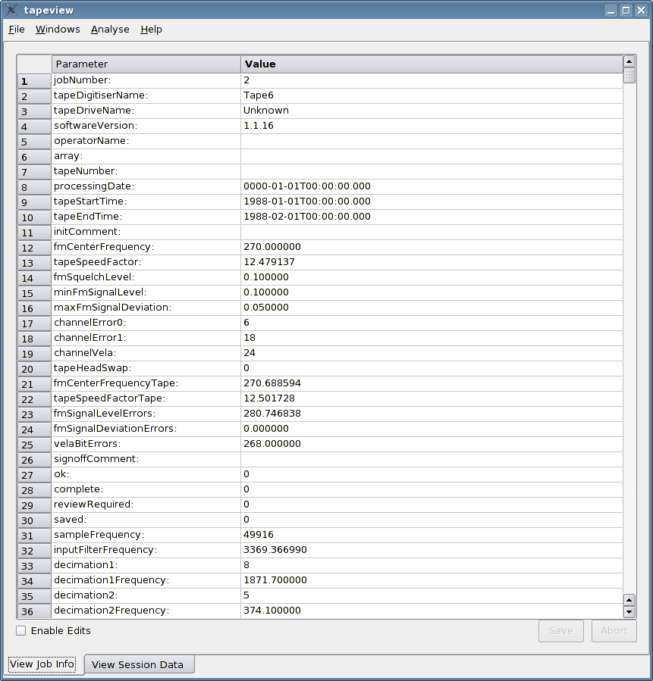

The View Session Data Window
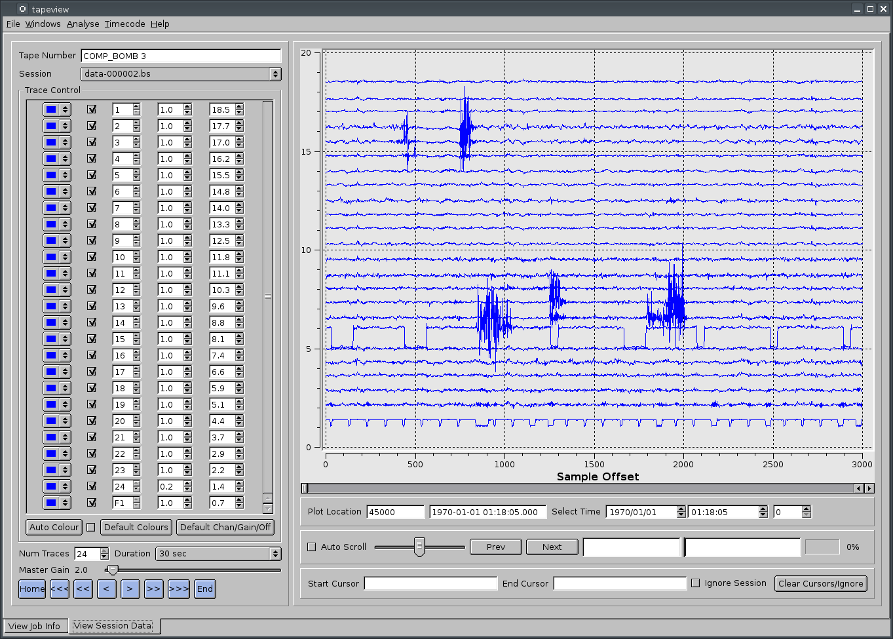

If the Job contains a number of sessions the Session combo box can be used to quickly view the alternative sessions.
The chart plotter window displays up to 24 channels of data.
Scrolling the plot area can be performed by various means :-
- Horizontal scrollbar located below the plot area.
- Mouse Wheel (The mouse cursor must be within plot area).
- The blue buttons on the lower left of the display also control the scrolling of the graph.

With the mouse cursor in the plot window the following actions can be performed :-
Control | Action
Mouse Wheel | scrolls the plot forward and back
Mouse Wheel + Shift | zooms the plot in and out
Mouse Wheel + Control | changes the gain on all plot channels
Mouse Left Button + Control | Drops a start export marker
Mouse Right Button + Control | Drops an end export marker

The plot location can also be moved by entering a data and time in appropriate fields and using the Auto Scroll facility. The last field is millseconds.
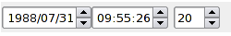
Auto Scrolling is enabled using the Auto Scroll checkbox. Moving the slider a greater distance from the centre increases the speed of scroll. With the slider selected the keyboard space bar will return it to the centre location and quickly stop scrolling. Alternatively move the slider with the centre mouse button pressed; on button release the slider will return to centre and stop. To simply pause the scrolling toggle the Auto Scroll checkbox.
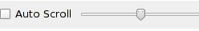
The Next and Previous Buttons will move to the next and previous analyse results.
The sample number within the data file and the tape time of the first viewable data sample in the plot is given below the plot.

The area to the left of the plots is reserved for control. It can optionally be switched off to give a greater display area for the plot traces. To toggle the visibility use Ctrl+T or from the main menu Windows -> Toggle Setup View
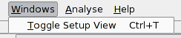

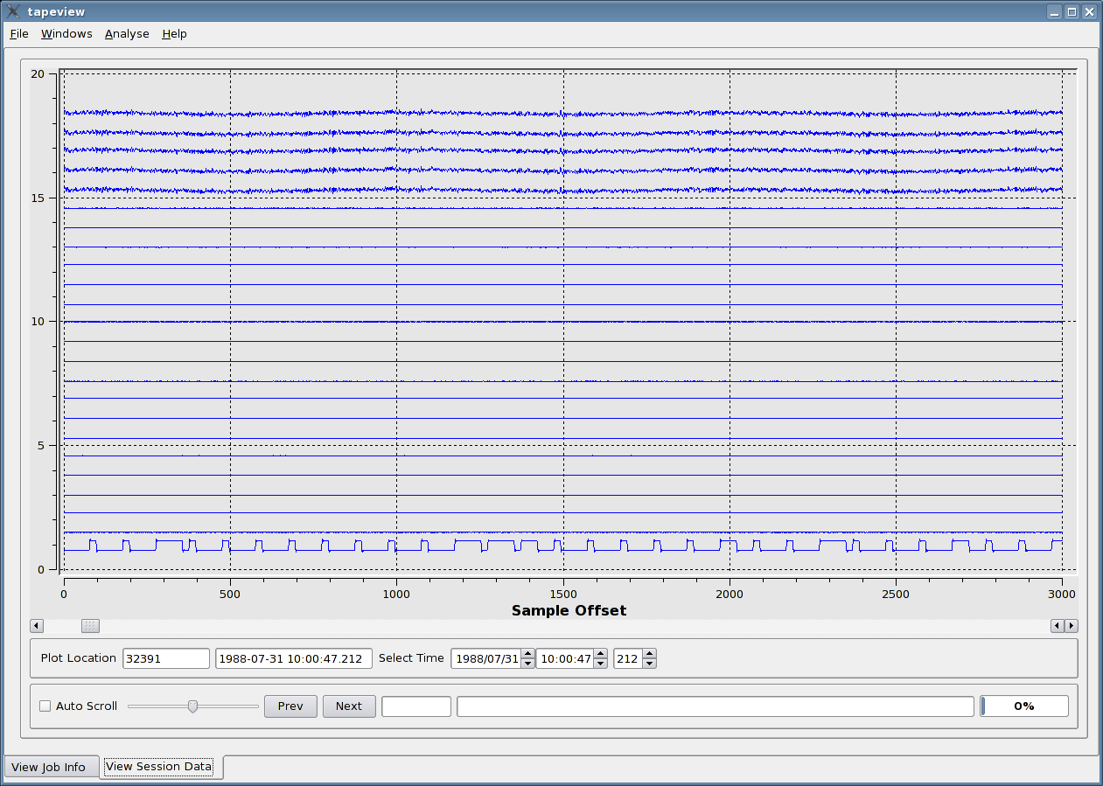
Individual plot traces can be controlled :-

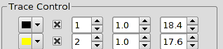
The trace colour can be selected
Enabled and disabled
Set to plot any of the 24 data channels
Amplification factor
Vertical displacement in the display. Can be used to overlay two or more traces.

Additionally a number of controls can be applied collectively to all traces :-
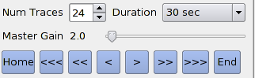
Control | Function
Num Traces | Sets the number of displayed traces. A maximum of 24 traces can be displayed.
Master Gain | This slider controls the gain applied to all channels. It is additional to the individual channel gain.
Duration | The duration of tape time displayed in the plot window. Zooming in and out can be performed using the mouse scroll wheel together with the shift key.
Horizontal Shift Buttons | These buttons move the current view forwards or backwards in time.

Timecode Reprocessing
The TapeView program has the ability to re-process the timecode track and modify the data's block timestamps for viewing the data. The system uses a phase locked loop time decoder .
In order to use this the “Timecode Reprocess” menu item under the “Timecode” menu entry needs to be used. This presents a dialog box allowing Timecode type configuration and re-processing of all the data sessions linked with the current data session open. Clicking on the “Start” button starts off the process. Once completed the “Close” button can be pressed to exit the dialog. The “Stop” button allows the processing to be aborted.
The Timecode's configuration can be set at the top of this box the following configuration items are supported:
- TimecodeType: The timecode type (Manual,Vela,Hutchins)
- TimecodeChannel: The timecode channel (0 – 24, 0 means use the timecode channel specified in the file).
- TimecodeStartTime: The start time for the Timecode. The Manual option uses all of the fields, while the Vela uses just the year and the Hutchins the year-month-day fields.
- TimecodeInvert: Inverst the timcode track.
The Dialog boxes status area will display information on the decoding and final statistics for each data session processed. See the BDS manuals for more information on the statistics values.
Once complete the “Plot Location” box will be coloured green to indicate that VELA re-processing has been performed.
The data view and analyse will now use the updated block time stamps. Note that the data files remain unchanged.

Data Ranges and Data save
TapeView provides the ability to select ranges of data for TimeCode processing and for future import into the BDS or other system. This allows bad data at the beginning and end of sessions to be ignored.
You can set start and end cursors on each sessions data by clicking with the left and right mouse buttons + control key in the data graphs of the “View Session Data” tab. The start cursor is green and the end cursor is red. These can be dragged into position by holding the respective mouse button down and dragging the mouse cursor. The Start and end cursor sample numbers are shown in the information below the graphs. Either both or just one cursor can be set. There is also an ignore tick box here to mark this session to be completely ignored. There is also “Clear Cursors/Ignore” button which will clear all of these settings for the currently displayed session.
Once cursors have been set or modified, subsequent TimeCode preprocessing will only occur between the selected sample numbers. The system will round the sample numbers up/down to the nearest block boundary when processing the data.
If the cursors are set, the program will provide the ability to save this information in the Jobs jobInfo.tdi file. The “File/Save” button can be used to achieve this. The save function will backup the existing jobInfo.tdi file into jobinfo_x.tdi (Where the number x is incremented on each backup) and append/modify the cursor settings. The following information is saved :-
JobInfo.tdi Data Field | Description
jobSessionX¹_startSample | Sample number within the data at which to start importing into bds
jobSessionX¹_endSample | Sample number within the data at which to end importing into bds
jobSessionX¹_startSampleTime | Time in ISO 8601 format eg (2015-01-01T12:13:11.000) associated with the startSample. This time will be used as the basis of the start time for Bds import. Certain timecodes do not encode day and year so when Bds system imports such data the day and year come from this field.
Notes
¹ X is the session number 0,1,2 …

The export of Data
The tapeview application has the ability to extract portions of the data and export into an alternative file format. Two formats are supported :-
- CSV Comma separated signal values suitable for reading into a spreadsheet.
- IMS2.0 CM6 A compressed ascii format that includes some meta-data.

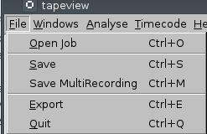
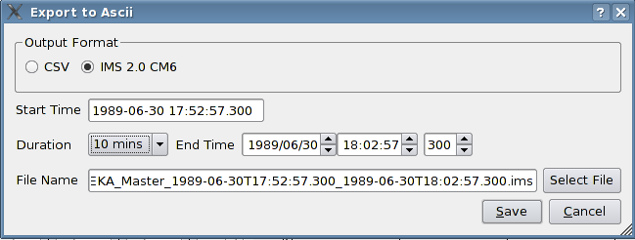

Data Filters
With release 1.1.17 the ability to perform some basic analysis of the data has been added. These are intended to aid the validation of the tape digitisation process. The setup screen is invoked from the main menu.

The Setup Window
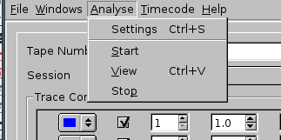
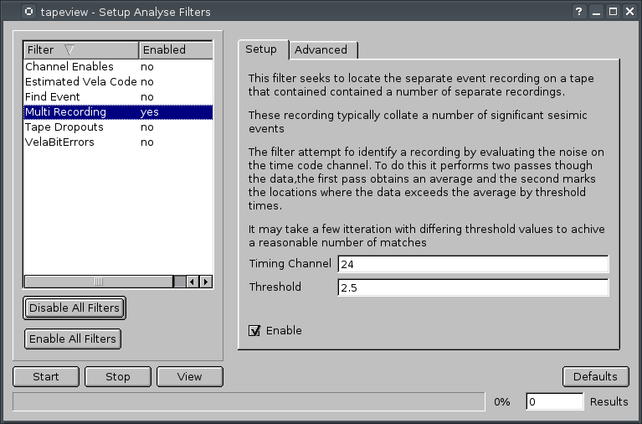
The available filters are displayed in a list. Analysis may started and stopped and the results of viewed within the results viewer. To enable a filter either double click on the filter in the filter list or check the enable checkbox. Start the analysis by clicking on the start button. When complete click the view button to view the results. The Setup tab displays the options available to each filter.

The View Results Window
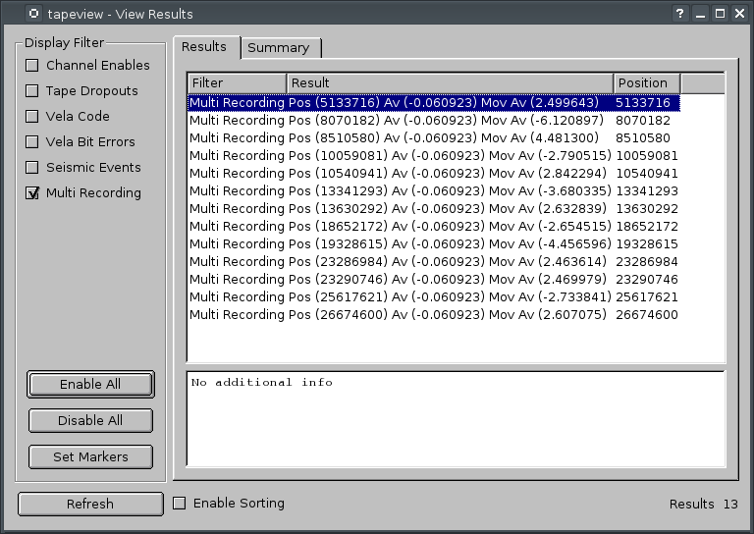
The view results window displays the filtered results of an analysis. Selecting an item from the results list will pan the plot to the data can be inspected. Clicking the Set Markers button will transfer the results as makers into the plot windows. These markers are intended for use only with with Multi Recording tapes to indicate the start and stop locations of each recording.

Multi Recording Tapes
As of release 2.0.35, support has been added for Multi recording tapes. These are tapes where snippets of other recordings have all been added to a single tape. TapeView now supports a marker system that allows a user to identify the separate recordings suitable for import of the data into the BDS system.
The plot window now supports a number of marker operations :-
CTRL+MIDDLE_MOUSE_BUTTON | Drops a marker at the current location
SHIFT+MIDDLE_MOUSE_BUTTON | Deletes a marker
MIDDLE_MOUSE_BUTTON | Move nearest marker. Marker being moved is highlighted in grey.

The markers identify regions for export within the data. The window “Multi Recording Markers” accessed via -main_menu_bar>windows→view_multi_session_export_markers show the interpretation of the markers and allows the user to navigate, add meta-data and delete markers. Once a user us happy with the location of the markers and the metadata they should save the information using main_menu_bar→File→Save. This appends the export information to the end of the jobInfo.tdi file.
JobInfo.tdi Data Field | Description
jobSessionX.multiRecordingY.valid | Identifies if the export is valid
jobSessionX¹.multiRecordingY².array | Name of data source array
jobSessionX¹.multiRecordingY².start | Start sample of recording
jobSessionX¹.multiRecordingY².startTime | Start time associated with the start cursor. On tapes that contain multiple recordings it is necessary to manually associate a start time with each export region.
jobSessionX¹.multiRecordingY².end | End sample of recording
Notes
¹ X is the session number 0,1,2 …
² Y is multi-recording number 0,1,2 ...

In addition to manually adding the markers, a new MultiRecording Filter has been added. Run this filter to generate suggested marker locations. It will be necessary to adapt the threshold in an iterative manner to improve the suggestions. The suggested markers can all be added at once using the Set Markers button from the ViewResults window. Fine tune the locations in the plot display using the mouse middle button.

