Blacknest Data System (BDS)
BdsImportGui User Guide–version 2.0.24
Table of Contents
1. Introduction 1
2. Introduction 1
3. Starting The Application 1
4. Using the Application 1
5. The Info Tab 1
6. The Data Tab 2
7. The Edit Menu 3
8. The View Menu 3
9. Further Information 4

Introduction
The bdsImportGui application is designed to view seismic data contained in BDRS and LAC_BDRS formats.

Data Sources
BDRS
The expected source data for the bdsImportGui program is created during the reading of data from a BDRS encoded digital tape. Blacknest have developed a procedure system for the capture of the data from such digital tapes. The capture of the data from a single tape is termed a Job. On the completion of a Job the data comprises a job directory containing one jobInfo.tdi file and a number of BDRS data files named with the extension .bs for example data-000000.bs and ,data-000001.bs. The bdrs files are typically the result of reading the original data tape several times. Each BDRS file is termed a session.
The jobInfo.tdi file contains metadata pertaining to the original tape and data. The file is ASCII and contains data saved as simple <NAME>: <VALUE> pairs. The bdsImportGui program requires that the tapeStartTime: value in the jobinfo.tdi file be set appropriately.
LAC_BDRS
The program can read LAC_BDRS (.lac) data files. The data files for a single digitised tape are expected to reside in a directory together with a ASCII metafile called jobInfo.tdi. The jobInfo.tdi file is a simple list of <NAME:<VALUE> pairs. The following fields should be defined.
tapeStartTime: | 1920-12-02T00:00:00
initComments: | Comments regarding the tape
tapeNumber: | The Blacknest tape number for the original tape

Starting The Application
The application can be started from the application->Bds menu

Using the Application
To open a Job use the File->Open menu and select the Job directory. The program will load the jobInfo.tdi file and the data from the first session file. The log file is displayed in the Info Tab and the waveform data display under the Data tab.

The Info Tab
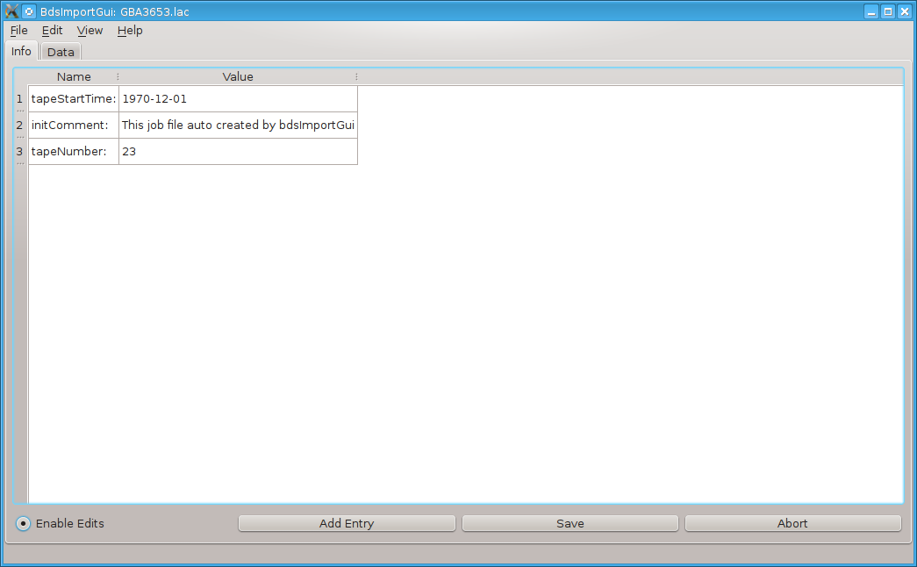
The program displays the contents of the jobInfo.tdi file in a tabular form. It is possible to edit the fields of this log file by enabling the “Enable Edits” checkbox. To save any changes click the save button. On each save a backup of the the previous log file will be saved in the job directory as jobInfo-<x>.log (Where x increments with each save). Saving will also cause a reload of the data file to reflect any changes made.

The Data Tab
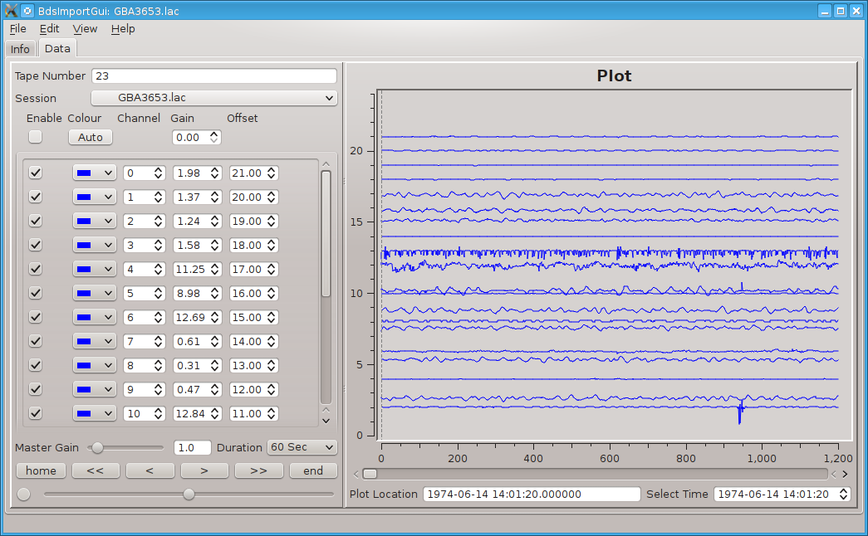
The data tab display the waveform data channels of the bdrs session file. Controls are provided to navigate the data. The “Plot Location” time shown below the waveforms is the sample time of the leftmost sample currently displayed.
The session combobox enables the user to select additional bdrs session files within the current Job directory.

The File Menu
The file menu has a number of actions associated opening data files and the export of data.
Open BDRS job Opens a directory containing a BDRS job. This directory contains a jobInfo.tdi file and a number of session files where each session is an alternative digitisation of the original tape..
Open LAC job Opens a directory containing a LAC job. This directory should contain a jobInfo.tdi file and a number of session files where each session is an alternative digitisation of the original tape.. If there is no jobInfo.tdi file present in the directory then the program will give the user an option of creating this file.
Export to ASCII Exports a user selected portion of the data into an Ascii format file.
Export to IMSI Exports a user selected portion of the data into an IMSi format file.

The Edit Menu
The menu has a number of actions :-
Clear export markers Clears any currently defined data export markers.
Auto scale Traces Autoscale all the traces.
Save Trace Settings Saves the current trace settings to in a user specified file. These settings can then be loaded and used later for other Jobs. This can be useful if the user wishes to review jobs expected to contain similar data value ranges.
Load Trace Settings Load a saved trace settings file.

The View Menu
List Errors When a session bdrs file is loaded a number of checks are performed on the data integrity. The List errors dialog simply lists these errors.
List Missing The list missing dialog displays a list of start to end times where data is missing in the bdrs file. This missing data is also shown in the wave form display as null data between two vertical red cursors.

Further Information
For further information please look at the BDS system documentation at: https://portal.beam.ltd.uk/support/blacknest.

